Inward Letters
CORRESPONDENCE – 2015

329. Wimalanath Wickremesooriya has sent December 07, 2015

“Dear Lakshman,

It appears that you have missed my contact details in the Contact List.

I give below my details. Could you please update the list.

S. Wimalanath Wickremesooriya (1962 - 1967) wimalanath@dwesrilanka.com

Thanks & Kind Regards,

Wimalanath.

328. Sanath Jayatilaka has sent us the following e mail on December 07, 2015
“Please change my email address”

327. AHM Razeek has sent us the following e mail on December 07, 2015

“Thanks Lakshman,
We have to add Late Mr. O.N. Peiris. He was at prep Colpetty towards the end. Better known as Peera
Also. D. Jayasooriya. He was the cricket coach cum staff member. He taught me Practical Sinhala, a subject all those who were in the English or Tamil medium had to follow. Check on this from Nihal Wanni or Ananda Gallatachchi.
Regards
Razeek.

326. Jayatilaka Nimal has sent us the following e mail on December 05, 2015

“Gamini Sellahewa was in my class and a good friend. He invited me for a function at his parents place I think in Dehiwela or Bambalapitiya a long time ago. I lost contact with him.
Love
Nimal”

325. Brian Wickremasinghe has sent us the following e mail on December 05, 2015

“I remember Jayantha who was my vintage. Probably Upananada was elder.”

324. Don Gazara has sent us the following e mail on December 05, 2015
“From:don gazara
Please accept my deep condolences.
Don”

323. Jayantha Sellahewa has sent us the following e mail on December 05, 2015

“Thanks Don. Much appreciated.
Regards
Jayantha”

322.Jayantha Sellahewa has sent us the following e mail on December 05, 2015
“Dear Lakshman
Please circulate obituary notice below. Thank you
Jayantha
Upananda Sellahewa(Guru old boy)brother of Jayantha, Lal(PB)Gamini & Vudyanada passed away body remains at 83 Tangalle Rd Devinuwara. Funeral on 7th Dec at 5pm”

321. Merril Auwihare has sent us the following e mail on November 28, 2015

you will be sad to know Prof Dayasiri Fernando is no morer. Funeral arrangements will be notified.

320. Sriyan Jayasekera has sent us the following e mail on November 28, 2015

To, The Prefects Group.

It is with sadness we note the death of D P A Fernando better known as Prof., Dayasiri Fernando.

He was the Manager of the College and was a School Prefect in the late nineties.

His remains at A F Funeral Parlour and cremation this evening General Cemetery Borella.

Kind regards

Sriyan
on behalf of The Prefects Group.

319. Channa Asela has sent us the following e mail on November 13, 2015

“Dear Mr. Jayathilake

The staff club of S. Thomas' College has organised an unique event called 'Back to STC' exclusively for Old Thomians and past teachers.

Visit www.b2stc.com for more details and to submit your details.

This will be held on Saturday, 19th December.

Recall your good old days @ 'the School by the Sea'

Past teachers of '50s and '60s and the old kitchen staff will be present.

Free traditional lunch @ the dining hall and free 12"x8" batch photo with your past teachers will be given on that day for each and every participant.

Please forward this to your batch mates and known od Thomians.

Closing date : Friday, 4th December
Entry Fee - Rs. 1000/-

Esto Perpetua !
Channa Asela
0755 27 93 18”

318. STC Mt. Lavinia, OBA has sent us the following e mail on August 22, 2015

View this email in your browser

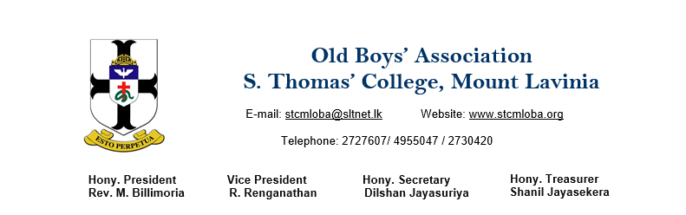

“Dear Fellow Thomians;
As you are aware the STC OBA is celebrating 130 years of meaningful existence in the year 2016. It is perhaps the oldest alumni association in the world with a recorded/documented history. The OBA has lined up a series of events to commemorate this important milestone in life of the OBA. The celebrations are due to begin with the "Thomian Walkathon 2015" scheduled to be held on Saturday, 7th November 2015.
The Annual Report of the OBA, due to be released for the 130th AGM scheduled to be held in February 2016, will carry a few/selected articles of Old Boys. Hence, all Old Boys are hereby invited to indicate their willingness to contribute articles to be published (upon selection) in the said Annual Report. Please be kind enough to revert back to us with details/outline of the article/s you wish to contribute to the Annual Report.
I have no doubt that Old Boys would have numerous memories of life at the 'school by the sea', big match experiences and other memorable events regarding which they could pen a few paragraphs to be published in the Annual Report. Please communicate your willingness to contribute an article for the Annual Report on or before 23rd August 2015.
Your support and assistance in this regard is much appreciated.
Thank you,
Yours sincerely,
Dilshan Jayasuriya
Hony. Secretary
STCML OBA”

317. Merril Aluwihare has sent us the following e mail on August 12, 2015

“My dear Lucky.
When I was at Guru in 1956 the school population wouldhave been about 130 of these a large number whom I have known personally are no more. i have maintained these statics which may not be 100 percen accurate but I am passing onto you

C.V.Fernando was an athlete as he left school either on his way to australia or as he got there he passed away.
Edward de dombal British origin, diabetic whilst in school passed away in nuwera eliya ata very young age.
Athula Rodrigo
K.D.K.Perera ex head prefect disappeared during 1971 JVP insurrecion last seen at Hatton Railway station.
Elmo William a gentleman to his fingertips hailed from a very wealthy family.
Upali de Fonseka.
UpaliPerera died in a motor accident at Mt.Lavinia in mid 1980s
Nanda Ellawala ex membe of parliament.
Senaka Ellawala
Mohan Ellawala
Alexis Ellawala.
N.R.P.de Silva was a surgeon died very young.
S.R.E.Fernando
Patrick Pillai
Duncan Munesinghe brother of Brigadier.
INDRA jAYETILLEKE AIR FORCE OFFICE.
sHELTON KOTTACHI
dAVID sILVA.
Norman Karunaratne
Kirthi Wijeywardena was a judge
Jimmy Samaraweera was a judge
HARID jAYESUNDERA WAS A GYNACOLOGIST.
aMIRTHALINGAM USED TO WORK FOR VAZEER.
mAHENDRA wEERETUNGA
eSMAILJEE sAIFUDEEN WAS A LAWYER.HANIFFA
gALABODA
a.sAMARASINGHE OF tARZAN kEGLALLE KILLED BY HIS OWN ELEPHANT.rAJENDRAN WAS AN AIRFORCE PILO.
dINGO dHARMAPALA ARMY OFFICER.
jEGANATHAN
n.t.s.pERERA
Mohan Dias poisoned by eating fruit salad stored overnight in aluminium container
Tont Sitlani
[Pinka of sisira garagr bandarawela
Jphn de VOS IN AUSTRALIA
s.k.aLAWWA WAS A LAWYER.sAMSON PERERA A LONG TIME AGO.n.kURUTUMPALA
gAMINI DESARAM
MOHAN aLUWIHARE RGDS mERRIL”

316. The Headmaster of STC Gurutalawa Fr. Nihal Fernando has sent us the following e mail on August 11, 2015

“Dear Lakshman
Photographs are beautiful.I thank you for covering our Prize Day 2015.

Esto Perpetua!

Fr.Nihal Fernando”

315.Bandu Wanigasekara has sent us the following e mail on August 11, 2015

“Excellent work. Very praiseworthy.”

314. Vudyananda Sellahewa has sent us the following e mail on July 13, 2015

“Dear Mr. Lakshman

Please find the attached STC OBA Bandarawela event calendar for 2014/2015

Best Regards
Vudyananda Sellahewa

S. Thomas’ College, Bandarawela – Old Boys’ Association
2014/2015 – Committee year
Calendar of Events
- THE WAY WE WERE – Annual Family Get together.

This was held on the 30th of November 2014 at the Rock House Army Camp Banquet. The participation was around 200.

- Leadership training and Guidance programme for Prefects

This was held on the 20th January 2015 (Founder’s Day). Three past prefects, Mr. Vishwa Kumarasinghe, Mr. Rumi Reyal and Mr. Dinesh Wijekannan, conducted this programme. It was conducted well and the college has requested this program be conducted every year.

- Donation of Equipment to set up an English Audio Visual Lab

An English Audio Visual Lab was a long felt need and this was fulfilled when the class of ’99 came forward to donate the required equipment. The equipment was handed over to the college on the 20th of January 2015 and the ceremonial opening of the lab was on the 27th of June 2015.

- Stage Play – Sergentge Nandamma

A CSR project was carried out by staging the play at the Nawarangahala Hall in March 2015. Over 800 armed forces personnel and the police were in attendance. The heartening feature of this event was the participation of over a hundred disabled soldiers.

- UVA THOMIAN CRICKET ENCOUNTER

The Bandarawela Sub Committee of the OBA together with STCB and STCG organized and conducted this event in a grand style. The vehicle parade with the participation of 135 vehicles was held on the 10th of May and the Match was played at the Bandarawela Esplanade on the 24th of May. Mr. Sanath Jayasuriya was the chief guest and Mr. Lahiru Thirimanne was the guest of honour. A notable feature of this event was the two captains along with the trophies being flown to the ground by a helicopter.

- Annual College Prize Giving

The 2014 prize giving of the college was held on the 19th of June. The chief guest for the event was the Chief of Defence staff, Air Vice Marshall Kolitha Gunathilake an old boy
Of STC Bandarawela.

- Career Guidance Seminar
An industry based career guidance seminar was conducted for the O/L and A/L student on the 27th of March 2015 at the Keble Memorial Hall. This will be conducted every term. The areas covered this time were Banking, Accounting & Finance. The resource personnel were old boys from relevant industries.

- Installation of GAVEL Club

A GAVEL Club (Toastmaster Junior) was installed at college on the 27th of June 2015. There will be a ten week leadership programme and then the college will handle the club with the assistance of the OBA.

Up Coming Events

- ANNUAL CRICKET SIXES

Date : 4th July 2015 (Day Night event commencing at 2.00 pm)
Venue : Bloomfield Cricket Grounds

- IN TOWN AGAIN – Dinner Dance 2015

Date : 25th July 2015 – 8.30 pm onwards
Venue: Grand Monarch – Talawathugoda
Tickets : Rs 5000/= (Spouse Rs 3,000/=)

- ANNUAL GENERAL MEETING/OBA WEEK END/FELLOWSHIP DINNER

15TH August 2015 at 9.30 am at College
Fellowship Dinner at Bandarawela Hotel at 7.30 pm.”

313. Dilshan Jayasuriya Hony. Secretary of STC Mt. Lavinia OBA has sent us the following e mail on June 26, 2015 7:46 AM

View this email in your browser

Dear Fellow Thomians;
It is with profound sadness that I announce the passing away of Mr. Lasantha Perera, better known as L.S., on Monday morning after a brief illness.

The Late Mr. Perera opened batting for College in 1962, 1963 and 1964 and was the Vice Captain of the College First XI Team in the year 1964 under the Captaincy of the Late Mr. Premalal Goonesekera. It is with gratitude the contemporaries of the Late Mr. Perera remember the pivotal role played by him in the STC Victory in the Battle of the Blues in the year 1964.

The Late Mr. Perera, whilst in UK in the late 1960's, was actively engaged in UK Chapter of the STC OBA, when he served as President for 3 years and a Committee Member for several years. His contribution to the needs of College was much appreciated by the Past Wardens.

The remains of the Late Mr. Perera will lie at the A F Raymonds Funeral Parlor from 12.00 noon Friday, 26th June 2015.

Cremation will take place on Saturday, 27th June 2015 at 5.00 pm at the General Cemetery, Borella . Prior to the Cremation, the remains of the Late Mr. Perera will be taken to the Chapel of the Transfiguration on Saturday, 27th June 2015 at 3.00 pm for a Service of Thanksgiving.

Thank you,

Yours sincerely,

Dilshan Jayasuriya
Hony. Secretary
STCML OBA

312. Roger Aldons has sent us the following e mail on May 23, 2015

“Sad news indeed. RIP Lorensz. Sympathies to his family. Fond memories of a great athlete at STC.

Roger

Hello Friends,

Just sharing some sad news that our dear friend & fellow Thomian passed away this morning. Having had many complications over these past few years. e.g kidney, heart problems. The family are having a private funeral.

Kind Regards
Denis “

311. Roger Aldons has sent us the following e mail on May 23, 2015

“Sad news indeed. RIP Lorensz. Sympathies to his family. Fond memories of a great athlete at STC.

Roger

Hello Friends,

Just sharing some sad news that our dear friend & fellow Thomian passed away this morning. Having had many complications over these past few years. e.g kidney, heart problems. The family are having a private funeral.

Kind Regards
Denis “

310. Ruwan Weerasuriya Asst. Secretary of STC Gurutalawa OBA has sent us the following e mail on May 10, 2015
Dear Old Boys ,
Attached below is the Calendar of events May-August ,Appreciate your participation to support our Alma mater

STC - Guruthalawa Calendar events May - August 2015
- 73rd Anniversary General Assembly - on 12 May 2015 at 10.30am at STC Guruthalawa.
- Guru Day at Mount - Chapel service will be held on 20 May 2015 at 7.30a.m . followed social and Annual under 15 Cricket Encounter between Mount Vs Guru for the De Seram Trophy at STC Mount Lavinia.
- Annual Prize Giving - 08 August 2015 at 10a.m. at Foster Memorial Hall Gurutalawa.Chief Guest Fr.Marc Bilimoria Warden STC and former Headmaster at Gurutalawa.
ESTO PERPETUA

Ruwan Weerasuriya
Asst. Secretary
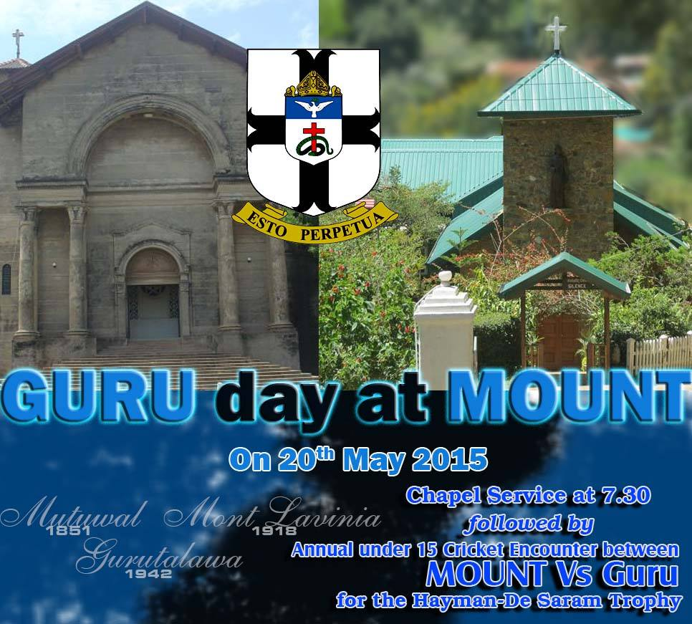

309. Nimal Jayatilaka has sent us the following e mail on May 08, 2015

Thanks. He was a nice quiet priest. Sad to see another hitting the dust.
Love
Nimal

308. Prasad Jinasena has sent us the following e mail on May 05, 2015
> ​A MOST AMAZING
> TRIP KEEP AN EYE ON THE ELEVATION, LEFT
> SIDE OF YOUR COMPUTER SCREEN, AND THEN MOVE MOUSE AT THE
> END, TO SEE
> EVERYTHING. This is amazing…it’s almost like
> being there and there's a 360 degree view from the top
> if you rotate the cursor! <http://everestavalanchetragedy.com/mt-everest-journey.html> http://everestavalanchetragedy.com/mt-everest-journey.html “
307. Prasad Jinasena has sent us the following e mail on May 05, 2015

Hello Fellow Thomians,

On behalf of the Dance committee and your Executive committee, I wish to thank all the members and their spouses who attended our 22nd annual dinner dance on Saturday.

We had a great turn out of Thomians and again it was thanks to your promotion and participation that we had over 400 guests at the dance.

For those who were not able to attend, I strongly suggest to mark your calender and book your tickets now for next year. It is, in my humble opinion, the best dance in town!!

The dance committee led by our hard working Chairman Ashok Senadeera, Music Director P.K.Gunaratne, Technical Guru Thamal Perera, Communication Director Pradeep Shakespeare (name says it all), Mark Daswani and Indhiran Sunderalingam with the full support of our Ex-Co members, put on another memorable event. Thanks to their efforts, I have received nothing but accolades from members and guests that were present.

There are a few video clips on Facebook, posted by non-Thomians. They will be available on our web site next week.

Please click the link below to view some pictures courtesy of our official photographer Mr. Daya Ginige who is always there with his camera. Thank you Daya.

www.flickr.com/photos/113337829@N03/sets/72157652332966662/

Trevor Fernando
President - STC OBA Canada
Email: president@stcoba-canada.com
www.stcoba-canada.com
Phone: 416-305-5527”

306. S. Kaviharan Hon.Secretary of STC Gurutalawa OBA has sent us the following e mail on April 22, 2015
“Dear Members,
It is with deep regret that we inform that Mr.Jayampathi Bernard (J.B.Peiris), Ex- Staff at S.Thomas'College, Gurutalawa & Mt.Lavinia. Beloved husband of Mrs.Virginia, had passed away on 20th April 2015. cortege leaves residence No.10/8, 1st Lane, Abeyratne Mawatha, Boralesgamuwa @ 3.00p.m on 24th April 2015 to General cemetery,Boralesgamuwa.
S.Kaviharan
Hony.Secretary
STC Gurutalawa OBA”

305. Rajendran Kandiah has sent us the following e mail on April 21, 2015
“Dear Lakshman,

Mr. J. B. Peiris, former tutorial staff at Guru during early 70's had passed away last night.

RAJ KANDIAH”

304. Nimal Bhareti has sent us the following e mail on April 21, 2015
“Thanks a lot. Much to reflect on.”

On Mon, Apr 20, 2015 at 8:49 PM, LAKSHMAN JAYATILAKA <mail@lakshmanj.com> wrote:
>>MY FELLOW THOMIANS, ENJOY THE JOURNEY IN YOUR MIND BACK TO ANOTHER TIME
>IN ANOTHER LAND WHERE BESIDES LEARNING WE ALL GREW TO BECOME THE PEOPLE
>OF THE WORLD.

303. S. Kaviharan Hon.Secretary of STC Gurutalawa OBA has sent us the following e mail on April 04, 2015
“Dear Members,
It is with deep regret that we inform of the passing away of Mrs.Manel Hettiarachchi, Beloved mother of Mr.Milinda Hettiarachchi. cortege leaves residence No.10, Simon Abeywickrema Avenue,Mt.Lavinia @ 1.00p.m today the Saturday, 04th April 2015. Cremation at General cemetery, Mt.Lavinia.
S.Kaviharan
Hony.Secretary”
302.Roger Aldons has sent us the following e mail on March 26, 2015

“Hi Lakshman!

Thanks for your email and attached links. It is wonderful to see photos with names identifying the subjects – at long last! Please keep up the good work!

Thanks and kind regards,

Roger”

301. Fr.Nihal Fernando Headmaster of S. Thomas' College at Gurutalawa has sent us the following e mail on March 25, 2015
“Dear Laksman,
Thanks for adding new photos of Guru in 62 group website.
I will send you more information tomorrow.
Esto Perpetua!

Fr.Nihal Fernando”

300. Merril Aluwihare sent us some photos on March 21, 2015

Visit to the S. Thomas' College campus - December 2014

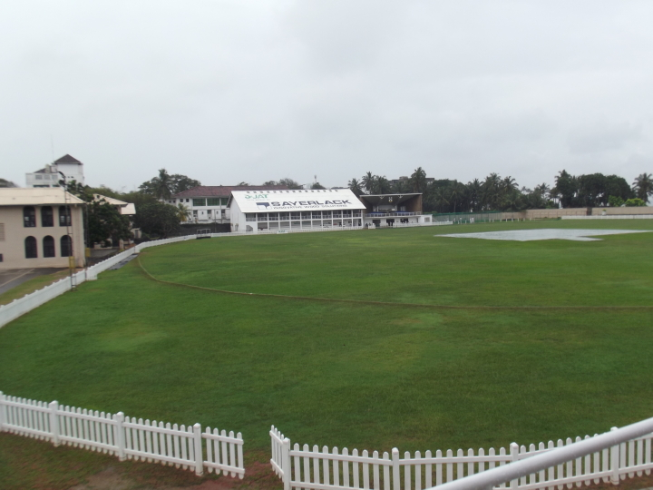 | 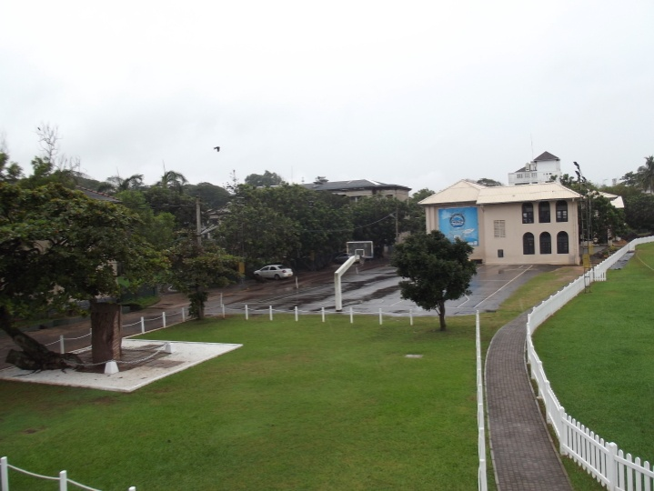
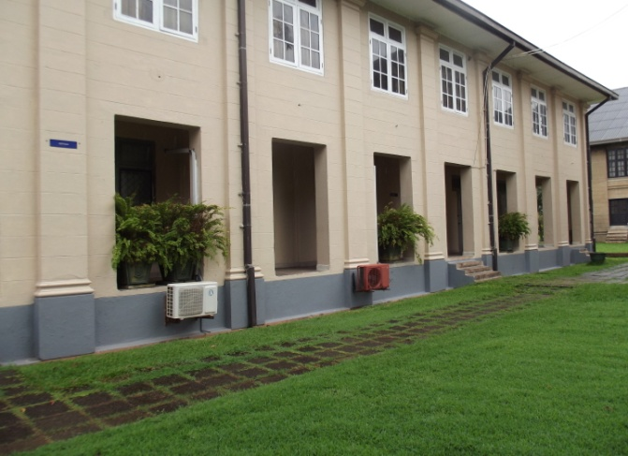 | 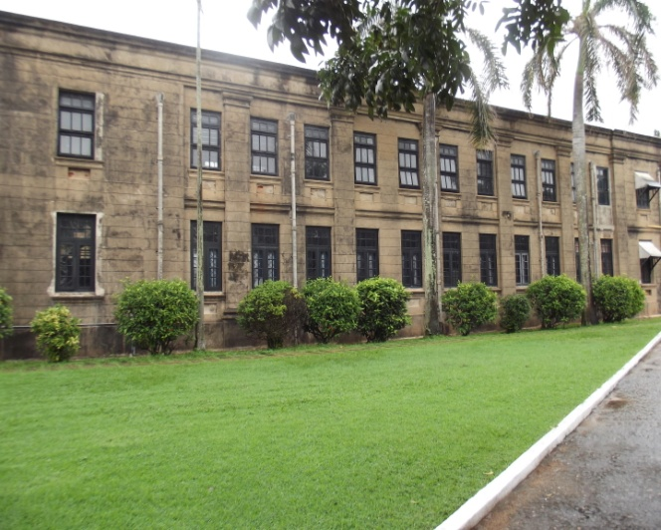
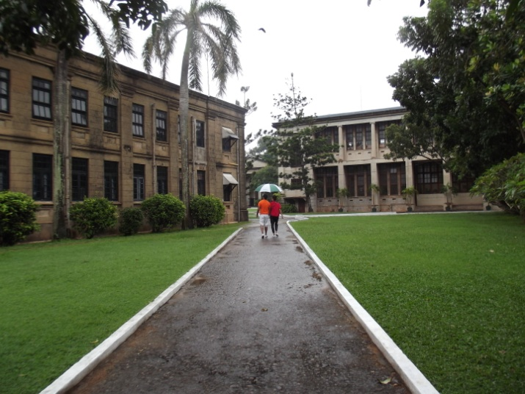 | 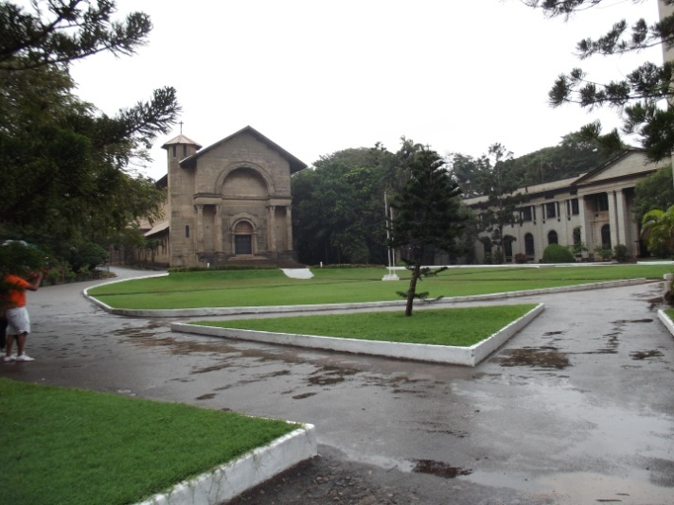
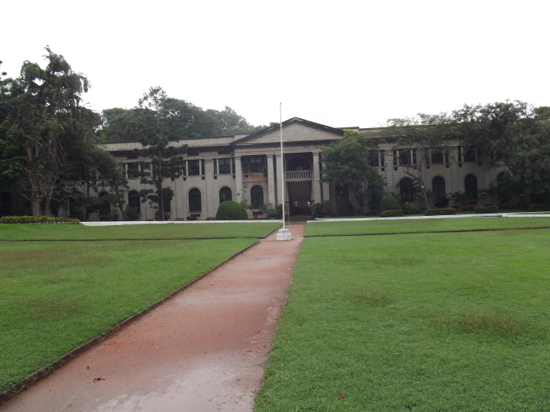 | 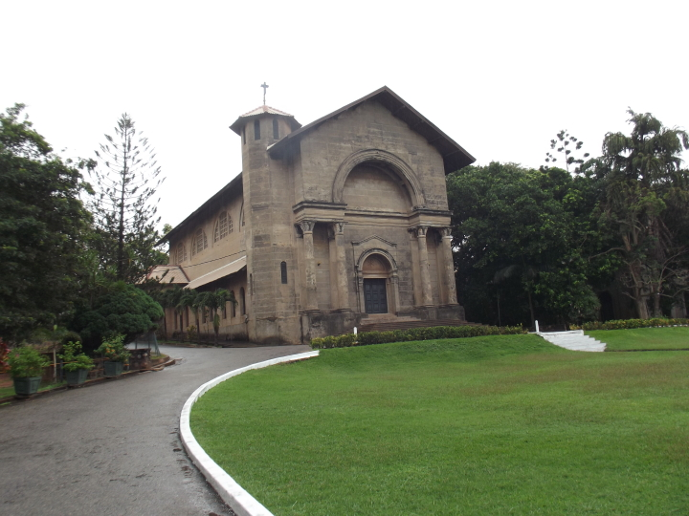
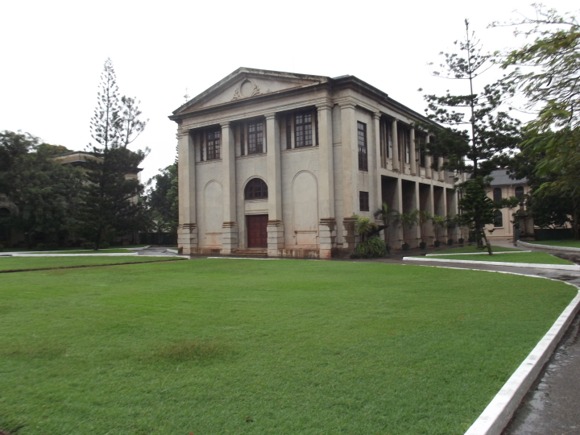 | 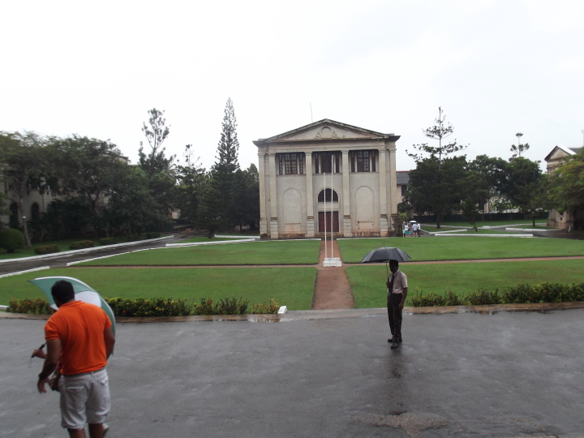

299. Ziard Sinnen has sent us the following e mail on March 20, 2015

“EXCO 2015-16

From: S. Kaviharan [mailto:kaviharans@gmail.com]
Sent: Thursday, March 19, 2015 9:35 PM
Subject: Notice of Meeting No.1

Dear Fellow Thomians,

I herewith attached the contact list of the OBA Executive Committee 2015/2016 & the Notice of meeting No.01.
Please be kind enough to amend if there is any error in the given address list and advise me if there is any change occurs in future.

ESTO PERPETUA

--
S.Kaviharan
Hony.Secretary
S.Thomas' College,
Gurutalawa.
Old Boys'Association
e-mail: kaviharans@gmail.com
Mobile: 0773 260439”

To view attachment use following link:- http://stcg62group.org/PDF/OBA/New_Ex-Co_2015_2016.pdf

298. Milinda Hettiarachchi has sent us the following e mail on March 13, 2015

“Dear Sriyan ,
For circulation to our Freshman 59 batch .
Thank you +

---------- Forwarded message ----------
From: Milinda Hettiarachchi <rpmilinda@gmail.com>
Date: Thu, Mar 12, 2015 at 9:48 PM

---------- Forwarded message ----------
From: Thush
Date: Thu, Mar 12, 2015 at 5:54 PM
Subject: Royal - Thomian 136th Battle of the Blues ~ DAY 01
STC won the toss and asked Royal to bat .
Royal were 87 for 5 and recovered but were all out for 199 runs .
The last pair held on for a rather long time .
STC batted very cautiously to be 50 for no loss , planning for a big score tomorrow probably and then to declare .”

To view attachments use following links:-
http://stcg62group.org/PDF/1ST_INNINGS_OF_FIRST_XI_S_THOMAS_COLLEGE_Mount_Lavinia.Pdf
http://stcg62group.org/PDF/1ST_INNINGS_OF_FIRST_XI_ROYAL_COLLEGE_Colombo.Pdf

297. STC Mt. Lavinia, OBA has sent us the following e mail on March 09, 2015
View this email in your browser

Dear Fellow Thomians;
Thomians who are living overseas and who are unable to attend the136th Battle of the Blues scheduled to be played on the 12th, 13th and 14th of March 2015 at the SSC Grounds could now follow the latest updates of the game, including scores, by logging on to the following website:-
www.livescoreboard.lk
We sincerely hope that Thomians would make use of this facility in abundance this year, which is made available to them at no cost.
Thank you,
Yours sincerely,
Dilshan Jayasuriya
Hony. Secretary
STC ML OBA

Copyright © 2015 STC ML OBA, All rights reserved.
STC ML OBA Newsletter
Our mailing address is:
STC ML OBA
The Administrative Office of the S. Thomas' College
Old Boys' Association
Mount Lavinia, Western 10370
Sri Lanka

296. STC Mt. Lavinia, OBA has sent us the following e mail on March 06, 2015
View this email in your browser

To: All Old Boys’ of S.T.C
Royal Thomian Cricket Match Tickets.
Limited Tickets are now available for the following SSC Pavillions at the Old Boys’ Association Secretariat at College open from 8.30am to 5.00pm inclusive of Sunday: 8th March 2015.
SSC Upper – Rs. 2,950.00 per Ticket
SSC Lower – Rs. 2,900.00 per Ticket
Kindly bring with you the OBA Membership Card or at least your Member Number for identification purposes.
Thanking You.
Hiran D. Molligoda
Chairman
STC OBA Secretariat
Exco: 2015/2016.

Copyright © 2015 STC ML OBA, All rights reserved.
STC ML OBA Newsletter
Our mailing address is:
STC ML OBA
The Administrative Office of the S. Thomas' College
Old Boys' Association
Mount Lavinia, Western 10370
Sri Lanka

295. Daya Ginige has sent us the following e mail on March 04, 2015

“Thx Prasad for the article. I heard the sad news yesterday. I hear Colon cancer is what took his life. He was my classmate and used to carry away all the academic prizes in College. He was born Feb 29, 1944, hence his name Oleap.

He has visited Toronto many times to attend conferences on Chemistry and stayed with me a few days on one occasion. Last July he and his wife came home for dinner. His only child, a son lives in Hamilton, Ontario, and gave them their first grandchild last year. He has done so much for Chemistry education in SL. Great loss for SL.
Regards”

294. Nimal Bhareti has sent us the following e mail on March 04, 2015
“Dear Lakshman
Thanks. It is nice to see the new Keble House and the new gate.
Nimal B”

293. STC Mt. Lavinia, OBA has sent us the following e mail on March 03, 2015
View this email in your browser

Dear Fellow Thomians,

It is with profound sadness that I announce the death of a Thomian Legend, Mr. M. Balasubramanium (known and referred to as Bala), in Australia last afternoon. He was one of the most active and celebrated Members of the OBA. Whenever, the OBA needed his support he came forward to support the OBA unhesitatingly and willingly. He was at all times a pillar of strength to the OBA. Whilst residing in Sri Lanka he took part in all the activities of College as well as the OBA. Despite living overseas during the last few years of his life, Mr. Balasubramanium made it a point to visit the College and the OBA Secretariat when ever he was visiting Sri Lanka. His demise will undoubtedly be a significant loss to the OBA.

Mr. Balasubramanium is the loving father of Prajeeth Balasubramanium, another committed and dedicated Thomian, who is functioning as the Joint Chairman of the Royal Thomian Match Organizing Committee this year. I wish to extend my sincere condolences to the Members of the family of the late Mr. Balasubramanium, particularly Prajeeth, in their hour of grief. Undoubtedly, the pleasant memories of the late Mr. Balasubramanium would remain alive in the hearts of many generations of Thomians, who looked up to him as a Thomian Legend who lived an exemplary life of a true Thomian.

Thank you,
Yours sincerely,

Dilshan Jayasuriya
Hony. Secretary
STCML OBA

Copyright © 2015 STC ML OBA, All rights reserved.
STC ML OBA Newsletter
Our mailing address is:
STC ML OBA
The Administrative Office of the S. Thomas' College
Old Boys' Association
Mount Lavinia, Western 10370
Sri Lanka

292. The Headmaster of STC Gurutalawa has sent us the following e mail on March 02, 2015

“



S.Thomas’ College,
Gurutalawa

25th June 2014

QUOTATION FOR CONSTRUCTING 60 METERS DEEP WELL 8 INCH DIAMETER AT GURUTALAWA DRILLING METHOD

Drilling soil cap 25 meters by 300 mm and casing with 225 mm
T 600 @ Rs. 10,800.00 m Rs. 270,000.00
Drilling hard rock 35 meters 160 mm diameter @ Rs. 4,800.00 m Rs. 168,000.00
Mobilization of Machinery Rs. 30,000.00
Total Rs. 468,000.00
Given rates are excluding VAT & NBT
CONDITIONS
1. Machine will be mobilized to the site after receiving 75% of the advance of the quotation.
2. Lanka Deep Wells are guaranteed of any construction faults for the period of one year.
3. Lanka Deep Wells refund 75% of contracted amount in the event of dry well or well
Yielding less than 10,000 LPD (Pumping 16 hours)
4. Extra Soil cap drilling more than 25 meters (in case the soil cap is more than 25 meters)
will be charged at Rs. 10,800.00 per meter.
5. Extra drilling more than 60 meters will be charged @ rs. 4,800.00 per meter.
6. Quality of the water is not liability of thee Lanka Deep Wells (Pvt) Ltd.
7. In the event of type 1000 PVC 225 mm used an additional Rs. 1,000.00 will be charged
per meter.

S.Thomas’ College,
Gurutalawa

25th June 2014

QUOTATION FOR SUPPLYING & INSTALLATION OF SUBMERSIBLE PUMP UNIT AT S THOMAS’ COLLEGE, GURUTALAWA

1. Pump
Pump Model : Franklin EPS 4400 – 1 H.P
Single phase – Stainless Steel
KW 0.75 kw
Country of Origin : America
Head/Capacity 50 mt / 50 lpm Rs. 74,500.00
2. Electric panel Board Rs. 22,500.00
3. Wire 3 core 1.5 mm 60 meters @ Rs. 150.00 m Rs. 9,000.00
4. Wire 1 core (1044) 240 mters @ Rs. 17.00 m Rs. 4,080.00
5. Safety rope and Well Cap Rs. 5,500.00
6. Socket, Bends, non return valve, union,
Earth rod, gum, thread seal etc. Rs. 6,000.00
7. Drop Pipe 1.25” 50 mt. @ Rs. 350.00 m Rs. 17,500.00
8. Tube well to tank pipe line 1.25” PVC 20 le @ Rs. 665.00 le Rs. 13,300.00
9. Conduit 2 @ Rs. 180.00 per length Rs. 360.00
10. Installation charges Rs. 15,000.00
11. Transport charges Rs. 15,000.00
Total Rs.182,740.00

Tube well drilling charges Rs. 468,000.00
Pump installation charges Rs. 182,740.00
Total Rs. 650,740.00

Given Rates are Excluding VAT & NBT”

291. The Headmaster of STC Gurutalawa has sent us the following e mail on March 02, 2015

“Dear Eksath,
I express my sincere thanks for the contribution made for our deep well project.However,I need to collect some more funds to complete the project.I believe that our old boys would definitely contribute towards this worthy cause.
Once I complete the project I will provide you with a report.I will also acknowledge the receipt of this donation.
Thanking you all once again!
Esto Perpetua!

Fr.Nihal Fernando

On 2 March 2015 at 14:21, Eksath Perera <eksath@bigpond.net.au> wrote:
Dear Fr Nihal

Let on behalf of STC OBA NSW make a sincere apology for the delay in sending this contribution.

We are aware that we should have sent this last year when we indicated that the committee had agreed to fund part of the ‘well project’.

We hope that with our contribution towards this project could be completed as planned.

When possible we would appreciate if you could send a short write-up about the project with a few photos. We will have this published on our website.

My apologies again for the delay.

Best regards
Eksath

From: "Headmaster S. Thomas' College at Gurutalawa" <hmstcguru@gmail.com>
Date: Friday, 27 February 2015 11:28 am
To: Eksath Perera <eksath@bigpond.net.au>
Subject: Deep well project

Dear Eksath,
What is the progress on this project?

Fr.Nihal Fernando”

290. The Headmaster STC at Gurutalawa has sent us the following Photos on March 01, 2015

“Dear All,
The front view of the new building.The last photo depicts the old building.
Esto Perpetua!

Fr.Nihal Fernando”

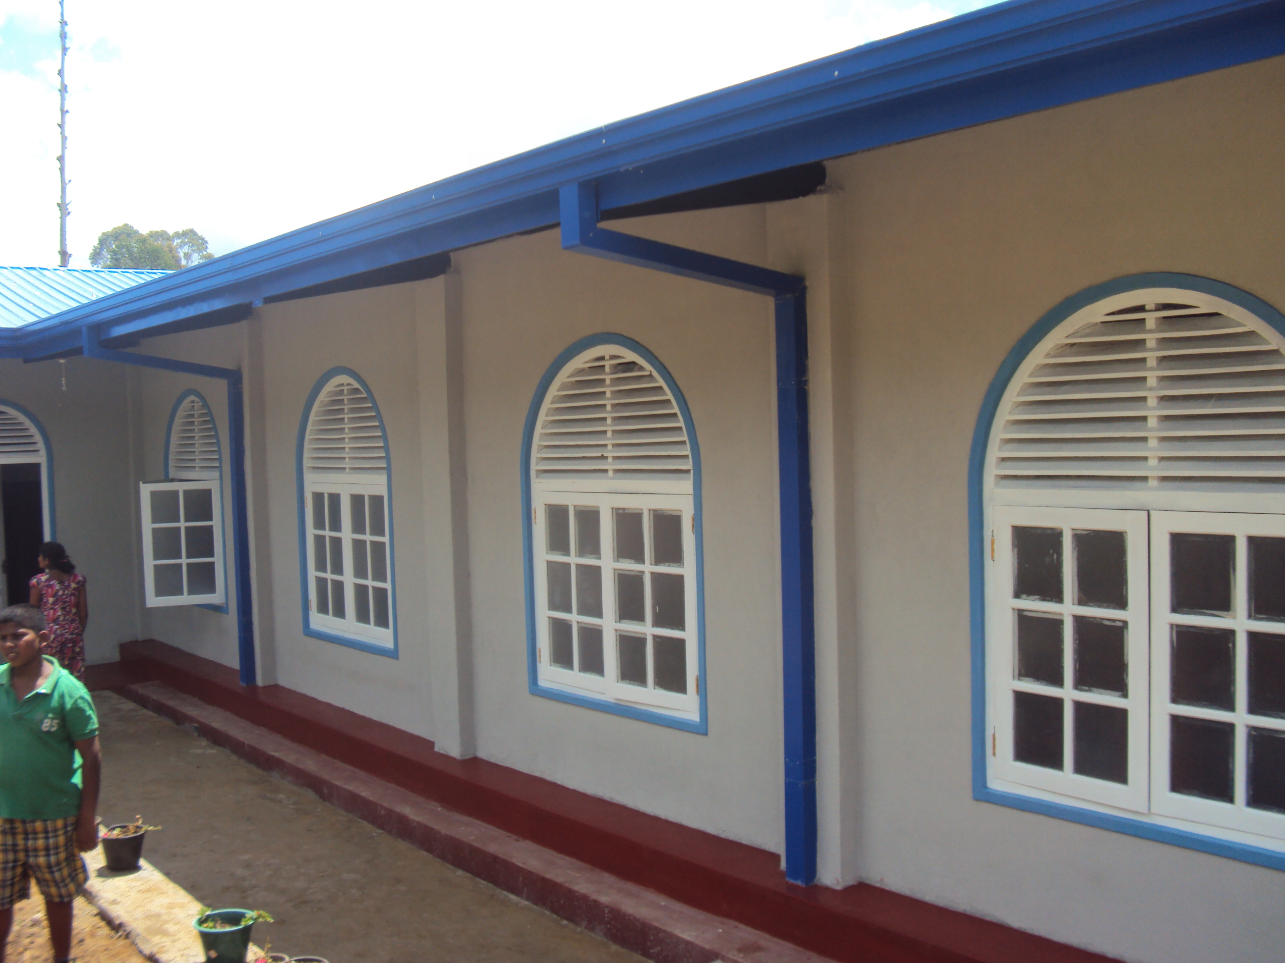
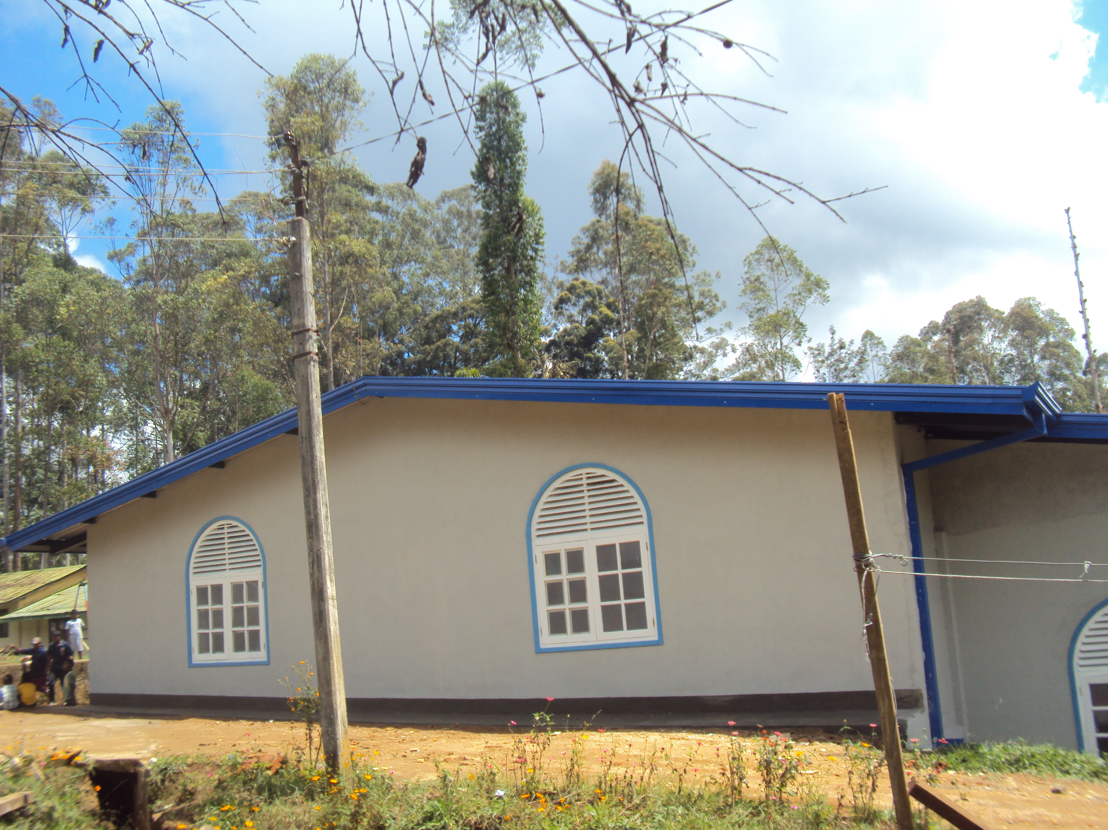
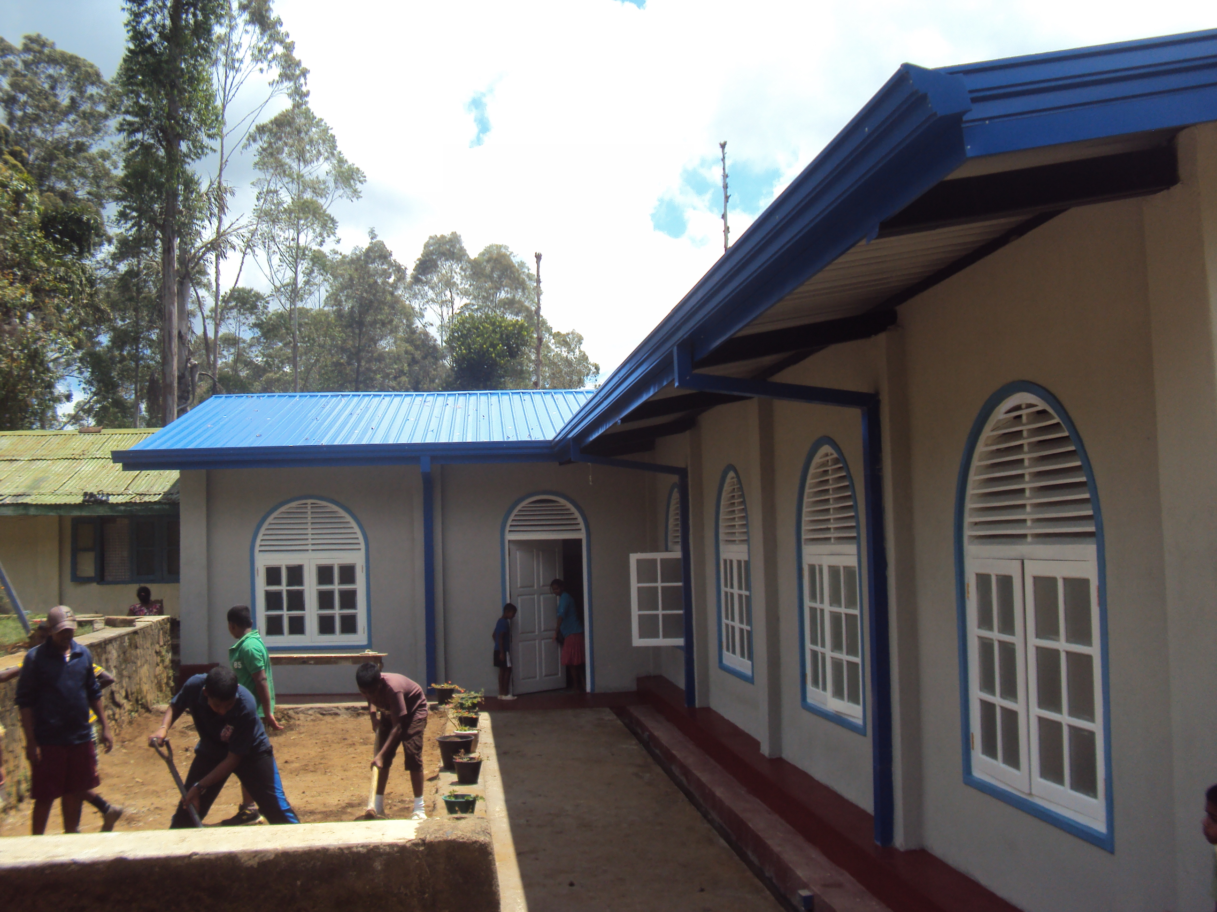
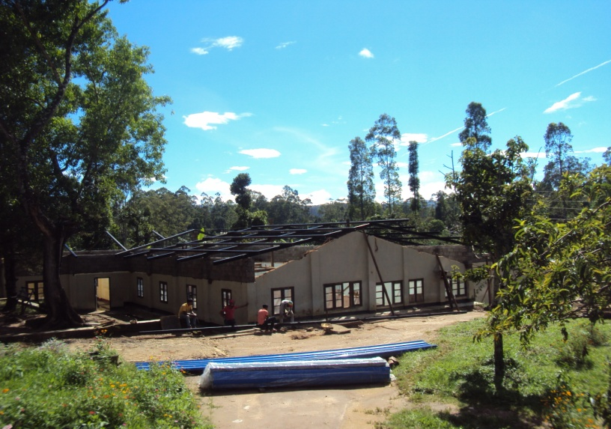

289. Senaka De Fonseka has sent us the following e mail on February 28, 2015

“Dear Father Nihal,
The entrance looked great. First impression counts a lot.
Regards,
Senaka”

From: "Headmaster S. Thomas' College at Gurutalawa" [hmstcguru@gmail.com]
Sent: 02/27/2015 10:58 PM ZE5B
To: Muditha Dissanayake <mudithaa@gmail.com>; Ziard Sinnen <ziard@virgincmb.com>; "S. Kaviharan" <kaviharans@gmail.com>; Krishantha Weerawardane <krishanthaweerawardane@yahoo.com>; Senaka Fonseka; Gamini J <gamini.31150@gmail.com>; LAKSHMAN JAYATILAKA <mail@lakshmanj.com>
Subject: College New Entrance Gate

288. STC Mt. Lavinia, OBA has sent us the following e mail on February 28, 2015

View this email in your browser

Obituary Notice
Dear Fellow Thomians;
It is with profound sadness that I announce the death of an eminent Old Thomian, Dr. A. Tissa Munasinghe, Consultant Chest Physician, Chest Hospital, Welisara.
The Late Dr. Munasinghe had attended College from 1961 to 1972 and was a College Prefect, Junior Librarian 1970-72, Asst., Secretary, Senior Science Association-1970, Lower School & Middle School Prefect. He represented College in U14, U17 & 1st X1 Hockey; U12, U14, U16 & 2nd X1 Cricket; Swimming, Water Polo and Primary School Athletics.He has also won the following prizes- Class prizes 1963 & 1971, Special prizes 1963 & 1964, Practical Tamil 1967, Agriculture 1967 & 1968, Biology 1968, Physics 1968, Sinhalese 1969, Botany and Zoology 1969 & 1971.
The Late Dr. Munasinghe entered the Faculty of Medicine, Colombo, where he continued to excel both in studies and sports. He was elected as the President of the prestigious Medical students Union.
The funeral arrangements are as follows:-
The remains of the Late Dr. Munasinghe will lie at his residence at No: 19/2, Atampolawatte Road, Hendala, Wattala, on 26th and 27th February and thereafter at the A.F. Raymond Funeral Parlour on 28th February, prior to the cremation on the same day (28th February) at 4pm at the General Cemetery, Borella.
Our sincere condolences are offered to the members of the family of the Late Dr. Munasinghe.
Thank you,
Yours sincerely,
Dilshan Jayasuriya
Hony. Secretary
STCML OBA

Copyright © 2015 STC ML OBA, All rights reserved.
STC ML OBA Newsletter
Our mailing address is:
STC ML OBA
The Administrative Office of the S. Thomas' College
Old Boys' Association
Mount Lavinia, Western 10370
Sri Lanka
Add us to your address book
unsubscribe from this list update subscription preferences


287. Siri Munasinghe has sent us the following e mail on February 27, 2015

“The First Party- is marked Dropbox Gurutalawa, was 2 years back and you will see SL Wickremasinghe and Arthur Perera of the 1940 Vintage and Vazeer, Sanath and Nimal jayatilleka, Donal Jayasinghe, Gamini Meemaduma, Ananda jayasinghe, Dr Vedanayagam, Stanly Perera, Nikky Kurutumpala, SN Rodrigo, B Munasinghe,
The second party at Chadra Tennakoon place .”

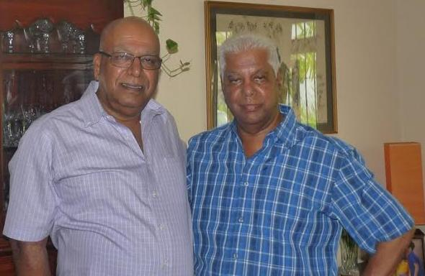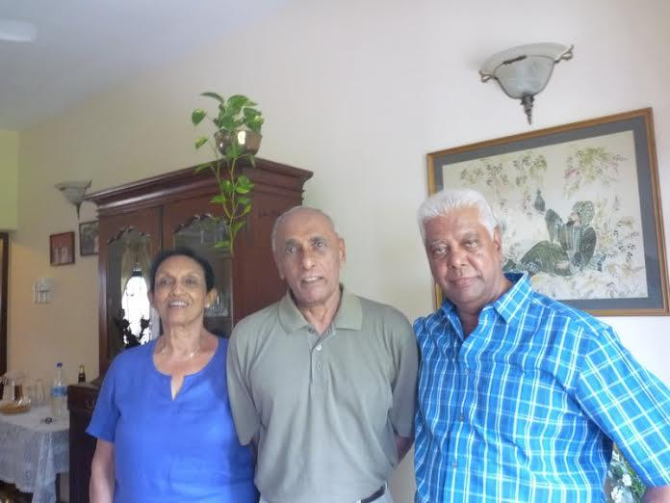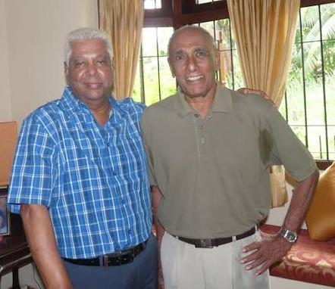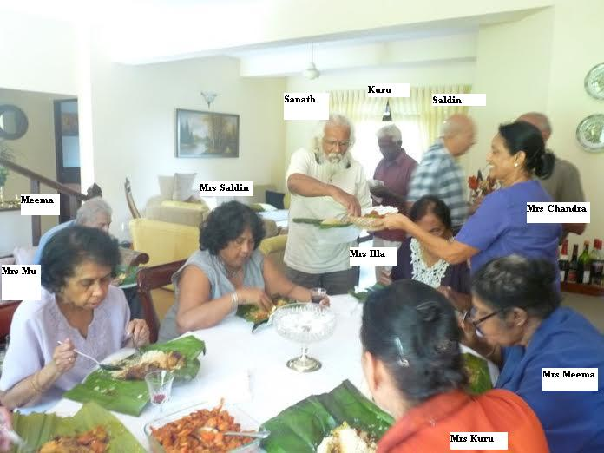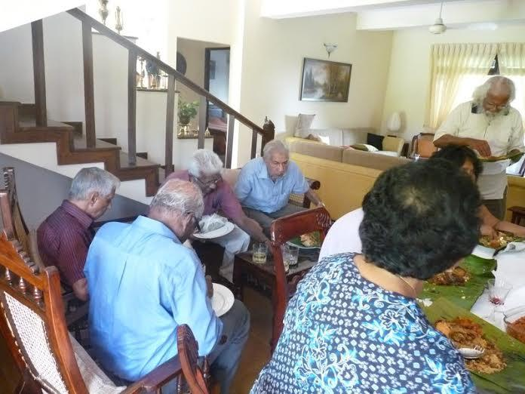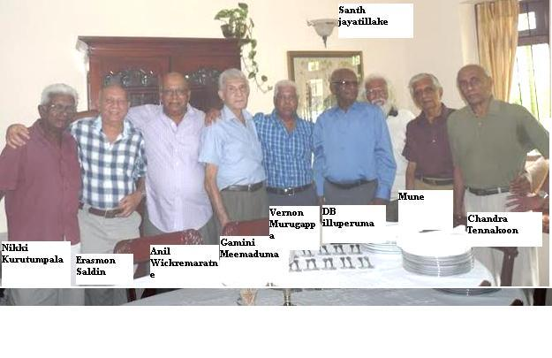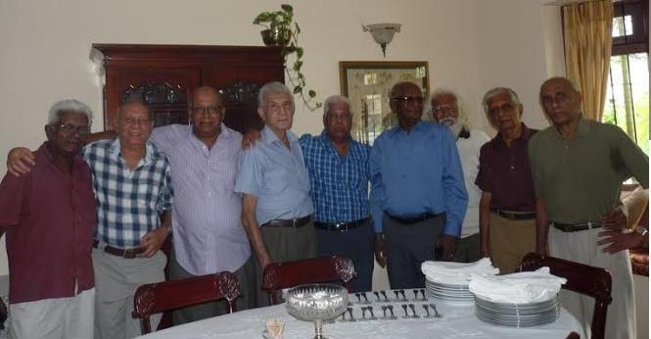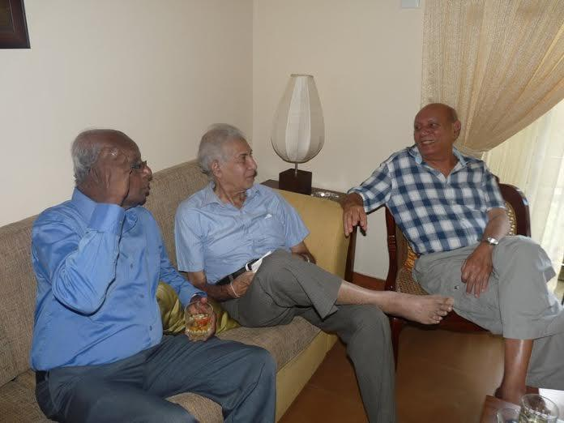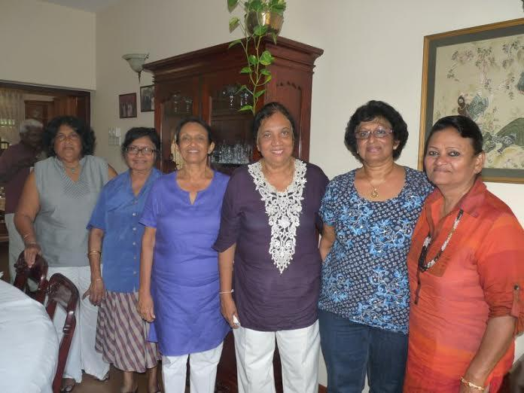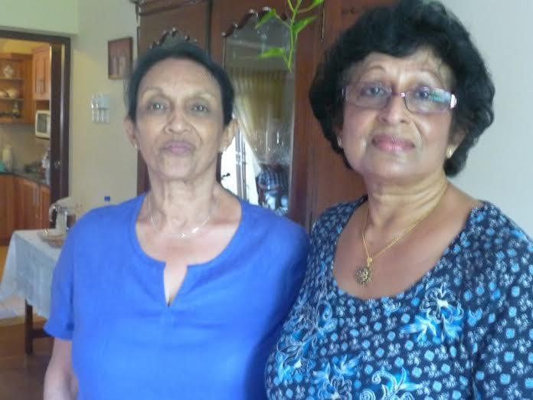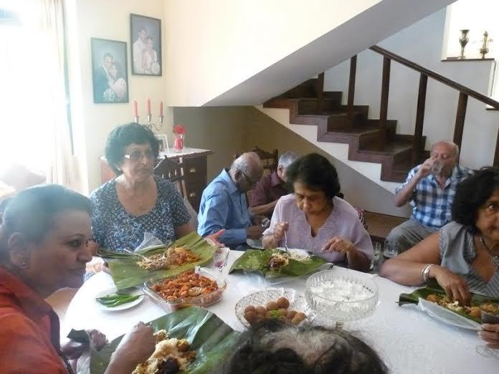

286. The Headmaster STC at Gurutalawa has sent us the following Photos on February 27, 2015

“Chief Guest-Rev.Christopher Balraj-the headmaster of S.Thomas' College,Bandarawela
Guest of Honour-Hon.Harin Fernando-The Chief minister of Uva Provincial Council
Held on the 19th of Feb.2015.

Fr.Nihal Fernando”
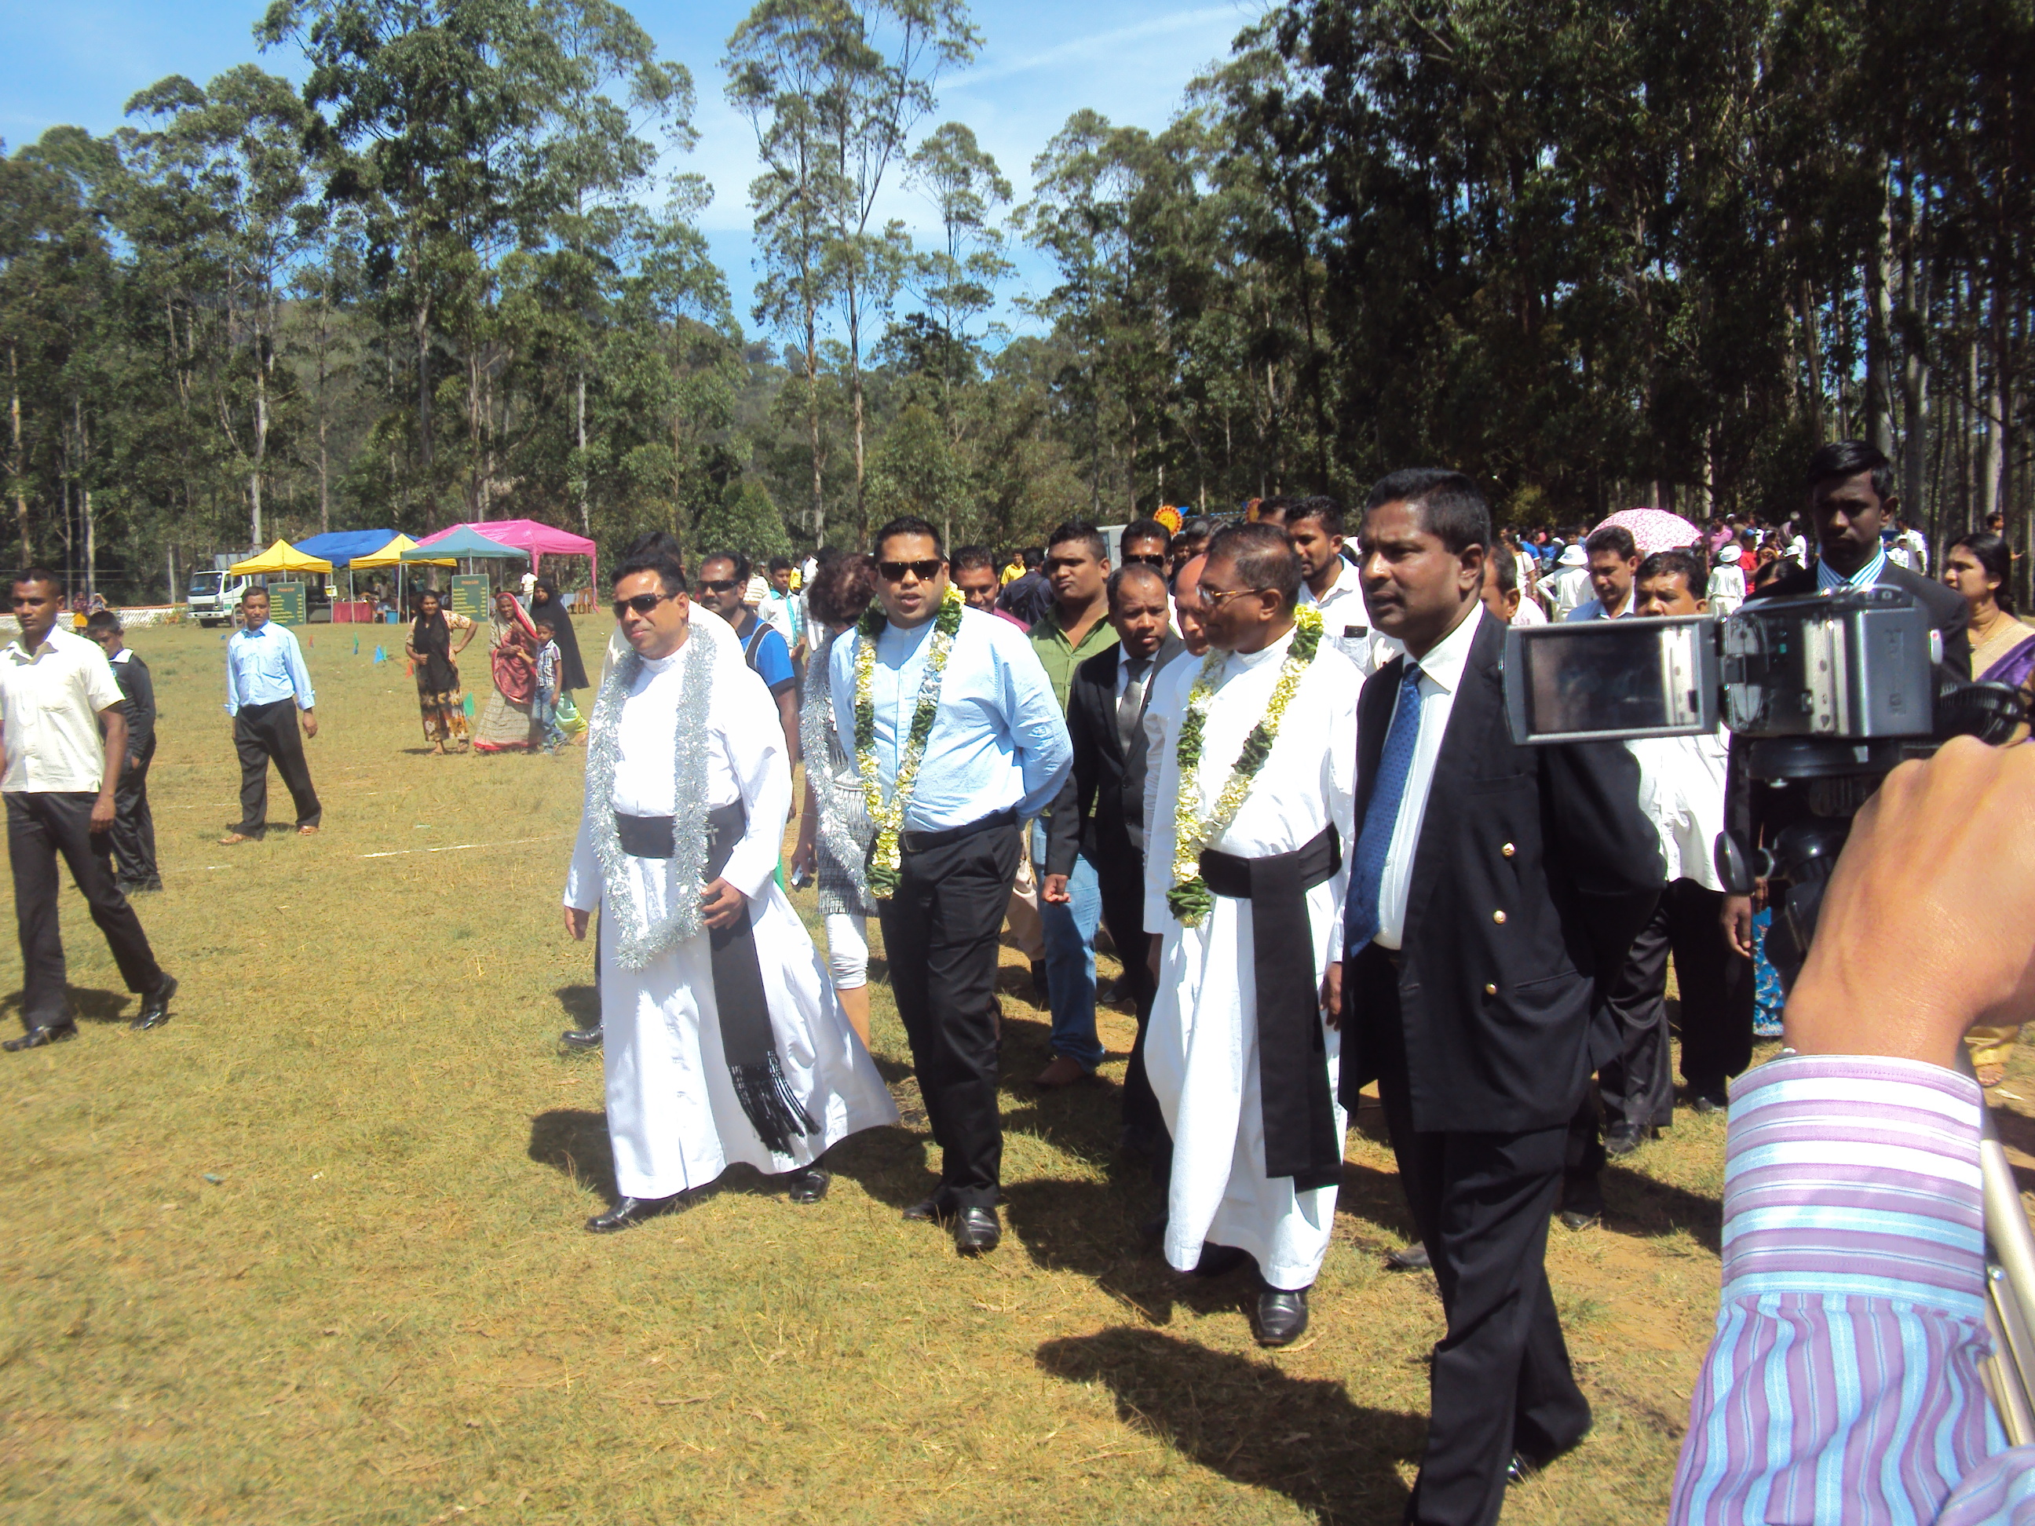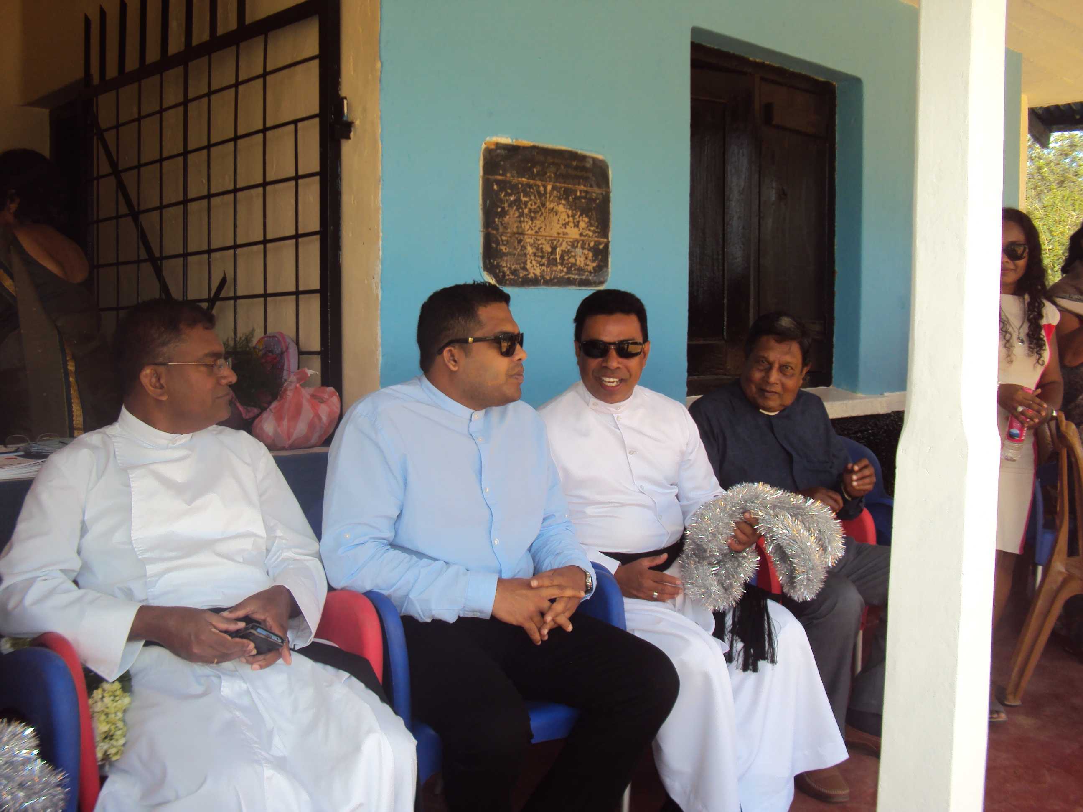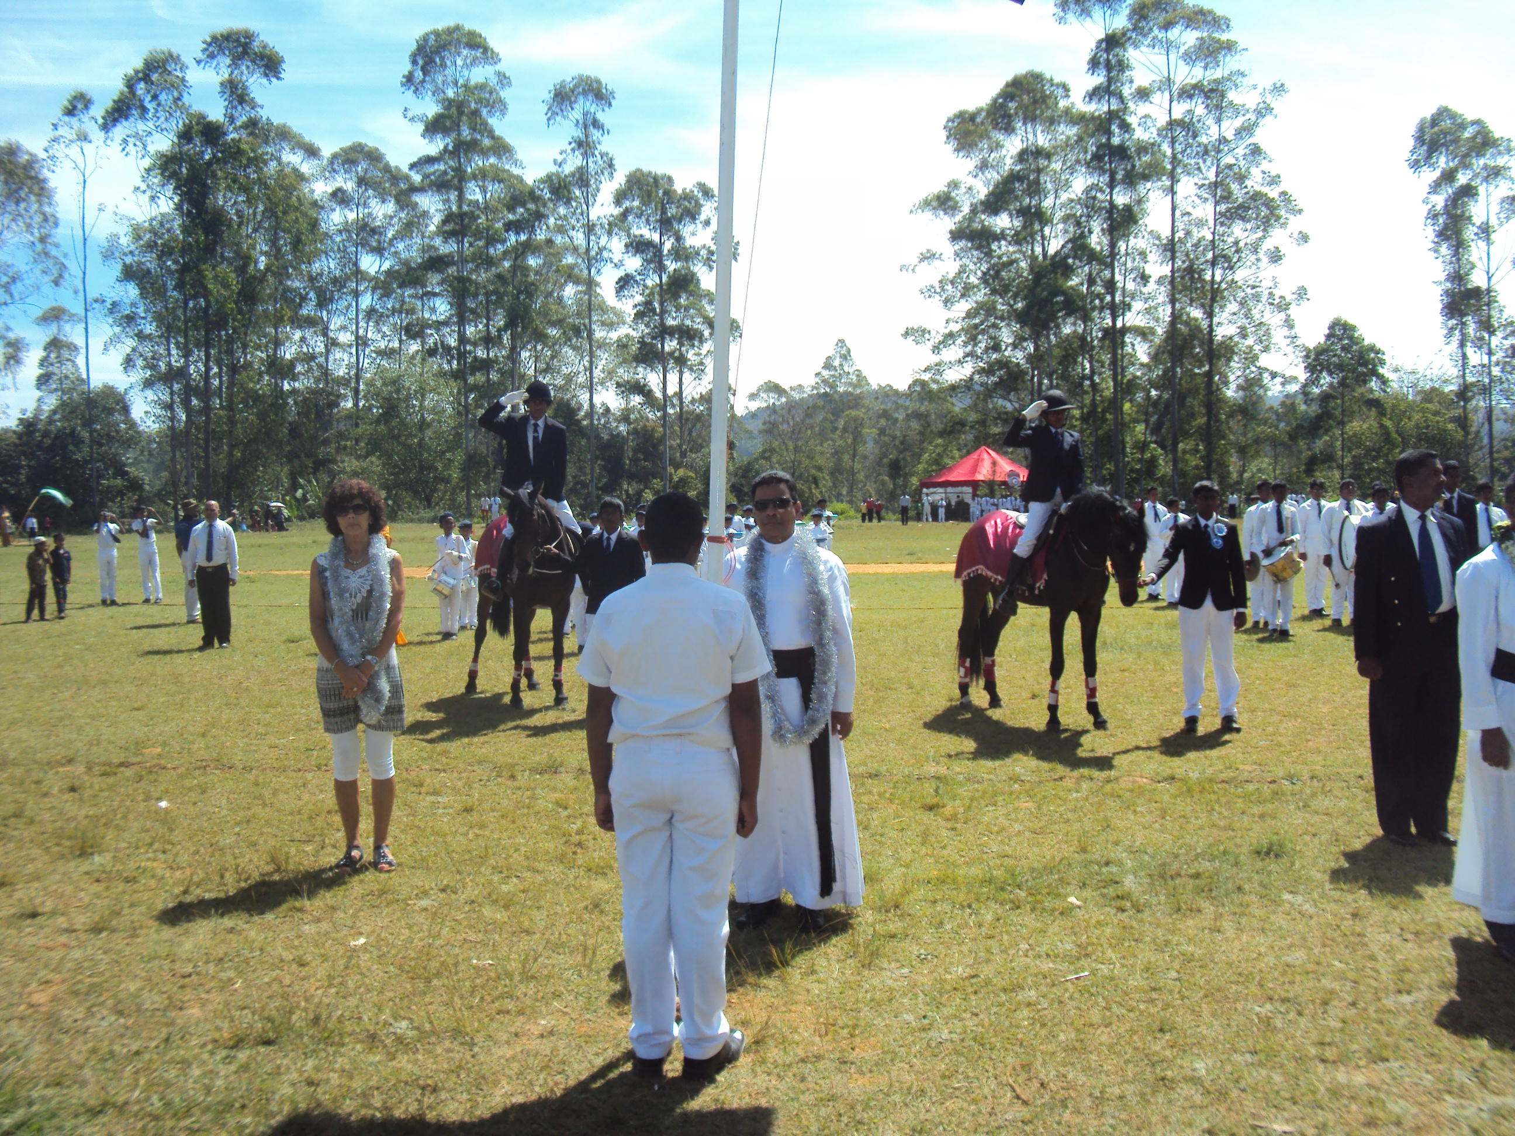

285. The Headmaster STC at Gurutalawa has sent us the following Photos on February 27, 2015
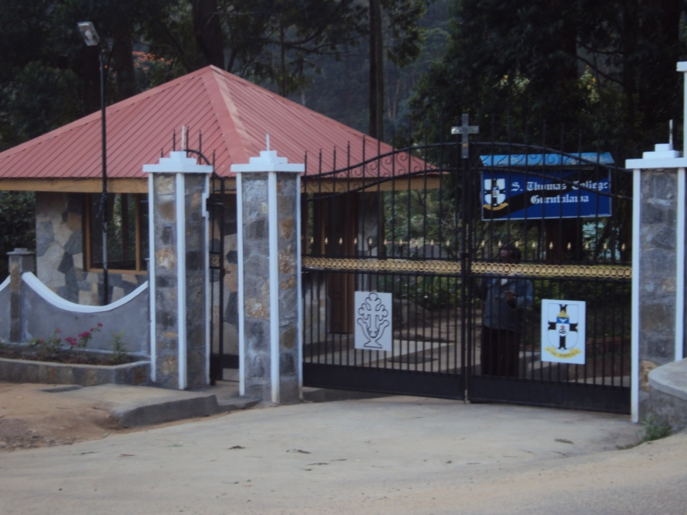

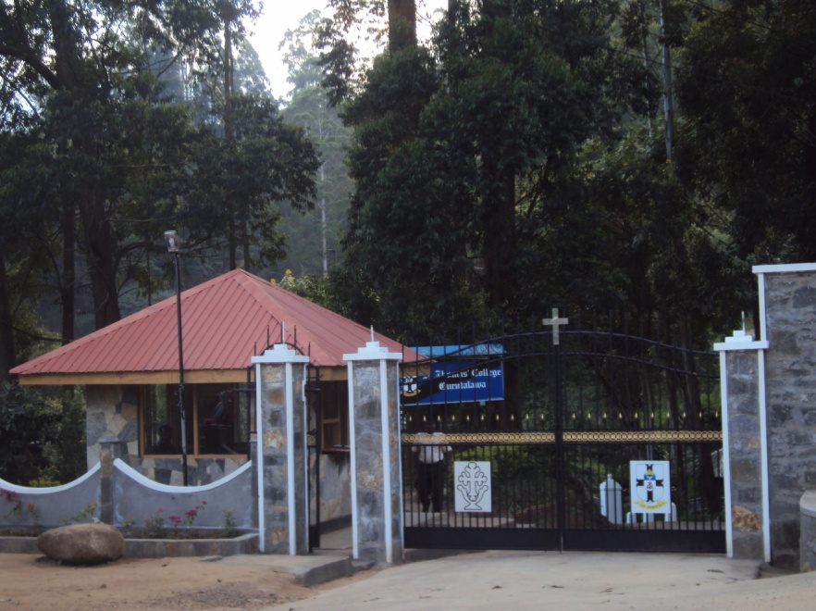

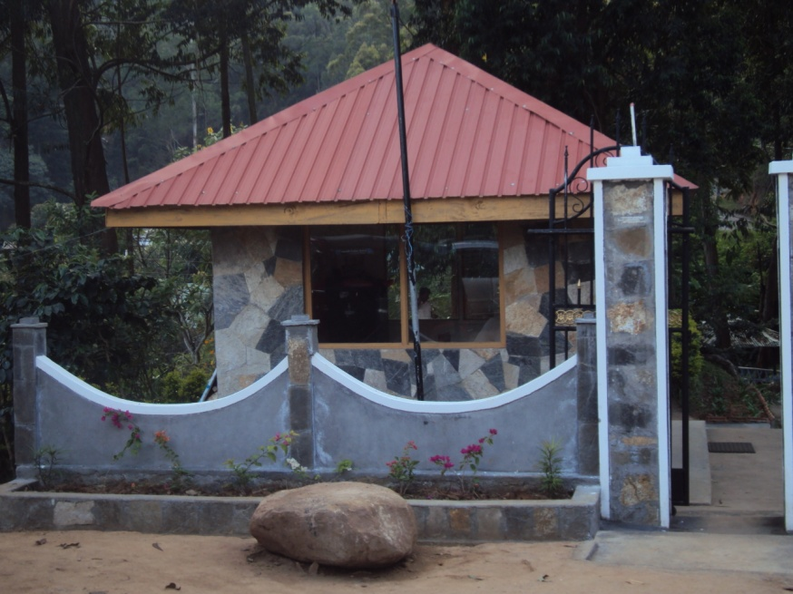

284. STC Mt. Lavinia, OBA has sent us the following e mail on February 13, 2015

View this email in your browser

Dear Fellow Thomians,
Please note that the newly refurbished STC Heritage Museum will be ceremonially declared opened by Warden Rev Marc Billimoria on Saturday 14th February at 9.30 am . All Old Boys are cordially invited for this momentous occasion.
Thanking You,
Yours sincerely

Dilshan Jayasuriya
Hony. Secretary
STCML OBA

Copyright © 2015 STC ML OBA, All rights reserved.
STC ML OBA Newsletter
Our mailing address is:
STC ML OBA
The Administrative Office of the S. Thomas' College
Old Boys' Association
Mount Lavinia, Western 10370
Sri Lanka
Add us to your address book
unsubscribe from this list update subscription preferences

283. STC Mt. Lavinia, OBA has sent us the following e mail on February 10, 2015

View this email in your browser

MEMORIAL SERVICE OF MR E.H.FERDINANDS
Please be informed that a Special Memorial Service in memory of the late Mr E.H. Ferdinands will be held at the Chapel of the Transfiguration on Wednesday, 11th February 2015, at 6.00pm. Friends and Well Wishers of the late Mr. Ferdinands are cordially invited to participate in the above Special Memorial Service.
Thank you,
Yours sincerely,
Dilshan Jayasuriya
Hony. Secretary
STCML OBA

Copyright © 2015 STC ML OBA, All rights reserved.
STC ML OBA Newsletter
Our mailing address is:
STC ML OBA
The Administrative Office of the S. Thomas' College
Old Boys' Association
Mount Lavinia, Western 10370
Sri Lanka

282. STC Gurutalawa OBA has sent us the following e mail on February 07, 2015
“Dear Fellow Thomians,
Herewith I have attached the draft accounts for the year 2014. Please note this is subject to final approval at AGM.
Esto Perpetua.

S.Kaviharan
Hony.Secretary
STC Gurutalawa OBA.”

281. STC Mt. Lavinia, OBA has sent us the following e mail on February 02, 2015

View this email in your browser

Dear Fellow Thomians,
It is with profound sadness that we announce the death of one of the most distinguished Old Thomians of recent times Mr G.K. Mandawala who went on to serve his Alma Mater for over 21years on the tutorial staff, interacting with the community life of the College, which no other member had done during the long history of over 160years. During his illustrious period at College was an outstanding teacher, ( This is not a mere statement but is what we were made to understand by our other teachers of the caliber of Messes C S Weerasinghe, R Arsiriwaden,O A Abeynaike, Arisen Ahubudu, Victor Walatara, Warden S J Anandanayagam and D S Jayasekera to name a few ) extraordinary Cadet Master and stern disciplinarian.
Mr Mandawela was at College from June 1959 to August 1980.
Service to college for 21years 2 months.
To substantiate all what we have said above, given below the Responsibilities and Positions held by Mr GARDIEKARIYAWASAM KIRTISENA MANDAWALA during the years 1959 to 1980 at St Thomas' College, Mt Lavinia.
1. Asst. Librarian, Chief Librarian, Asst Teacher, Senior Teacher 1959 to 1980
2. College Hostel Master 1960 to 1966.
3. Junior and Senior Cadet officer, holding the rank of
Lieutenant- Ceylon Volunteer Force 1960 to1970
4 .Master in charge of Physical Training 1960 to 1977
5. Master in charge of Sinhala Music & Drama Society 1962.
6. Master in charge of Government Food Drive 1962 & 1967.
7. Master in charge of The Miniature Rifle Club 1964 to 1972.
8. Master in charge of STC, OBA celebrations, PT Display. 1964 to 1977
9. Master in charge of The College Orphanage 1965 to 1980.
10. Master in charge of The Royal Thomian Cricket match
Boys Tent 1968 to 1980
11. Master in charge of The Royal Thomian Cricket match Souvenir
1968 to 1980
12. Elected to the Games Committee of the STC OBA 1968.
13. Business Manager & Distribution Manager of the College Magazine
1970 to 1980
14. Master in charge of College discipline at important College Functions
1970 to 1980.
15. Master in charge of The Arasu Thuraiappa All Round Shield. 1974 to 1980.
16. Asst House Master De Saram House 1972.
17. Master in charge of The Government Republic Day Celebrations 1972
18. At the request of College, Author of " Waikalpa Sinhala" A guide book of Sinhala Language and optional Sinhala for G C E O/L students.1974
19. President, STC Tutorial Staff Trade Union 1976 to 1980.
20. Committee member of the Upper School, PTA 1979.
21. Asst. Secretary, STC OBA 1979 &1980.
22. President, College Staff Club. 1977
23 Member of The Dehiwela-Mount Lavinia Municipal Council Library Advisory Committee appointed by the Mayor Maj. L V. Gooneratne in consultation with the Warden 1970.
The remains will lie at Mahinda Funeral Parlour, Mt Lavinia from 4.00 p.m.today Monday, February 2nd 2015.
The Body will be taken to St Thomas' College, Mt Lavinia at 10.00 a.m. on Tuesday the 3rd for the Thomians to pay their last respects to the Legend up to 2.00 p.m.on this day.
Cortege leaves Mahinda Funeral Parlour, Mt Lavinia at 4.00 p.m. on Wednesday the 4th for Cremation at 5.00 p.m General Cemetery Mount Lavinia.
STC ML OBA SECRETARIAT

Copyright © 2015 STC ML OBA, All rights reserved.
STC ML OBA Newsletter
Our mailing address is:
STC ML OBA
The Administrative Office of the S. Thomas' College
Old Boys' Association
Mount Lavinia, Western 10370
Sri Lanka

280. Ziard Sinnen has sent us the following e mail on January 29, 2015

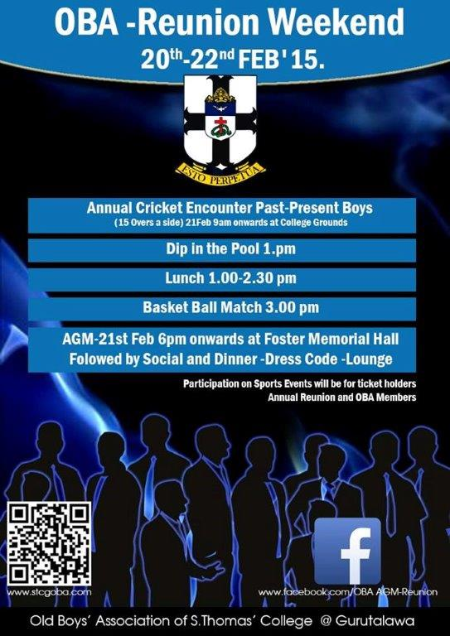

279. Sanath Jayatilaka has sent us the following e mail on January 26, 2015

“Can you get this accross to the Old Boys. I will send to my contacts.
Aiyah

---------- Forwarded message ----------
From: Pearlyn De Silva <desilvap@optusnet.com.au>
Date: 26 January 2015 at 16:46
Subject: RE: MEMORIAL SERVICE FOR MR ERNEST HARRY FERDINANDS (BERTIE)
To: Sanath Jayatilaka <sanathjayatilaka@gmail.com
Dear Sanath
I am writing to inform you that the College will be holding a Memorial Service for my dad on Wednesday the 11th February 2015 at 6.00 pm in the College Chapel and I would appreciate if you could kindly inform the Old Boys’ who would have known my father.
Also, your wife advised me to insert an advertisement in the Daily News or Daily Mirror – I could organize my cousins in Sri Lanka to do this but I need to know whether people are still buying the newspaper or obtaining news and information via the internet. Please advise.
Look forward to meeting you in Sri Lanka
With sincere thanks
Pearlyn de Silva

From: Sanath Jayatilaka [mailto:sanathjayatilaka@gmail.com]
Sent: Tuesday, December 02, 2014 9:30 AM
To: undisclosed-recipients:
Subject: Fwd: VIDEO - PORTUGAL
---------- Forwarded message ----------
Date: 29 November 2014 at 00:03
Subject: VIDEO - PORTUGAL
To:
Hello
VIDEO - PORTUGAL
click on link
speakers on
Chula / Charles Wick

http://www.youtube.com/embed/Ku32HBnAEEg”

278. STC Gurutalawa OBA has sent us the following e mail on January 20, 2015

“Dear Fellow Thomians,

Please refer to the attached Notice of 56th Annual General Meeting.

ESTO PERPETUA

S.Kaviharan
Hony.Secretary
STC Gurutalawa OBA”

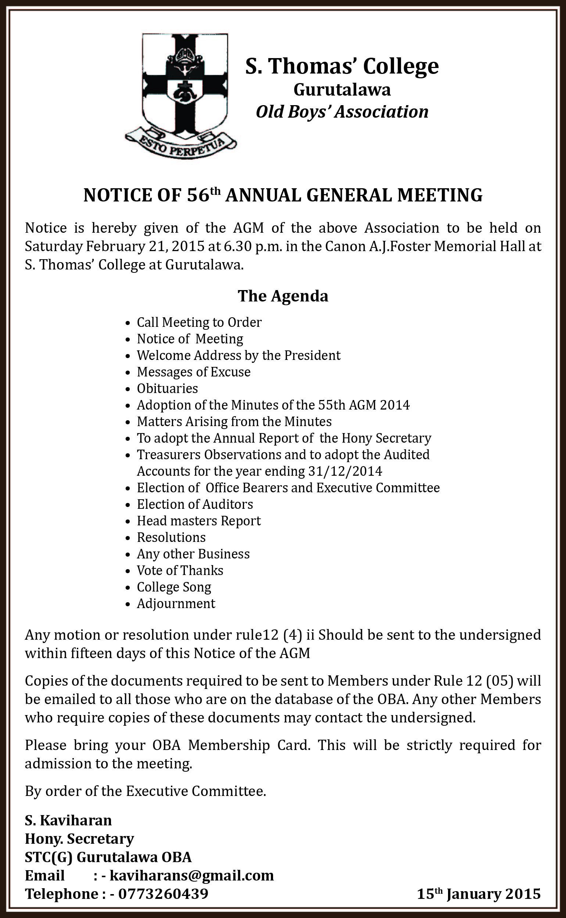

277. STC Mt. Lavinia has sent us the following e mail on January 05, 2015



Old Boys’ Association
S. Thomas’ College, Mount Lavinia

E-mail: stcmloba@sltnet.lk Website: www.stcmloba.org
Telephone:-2727607/ 4955047
Hony.President Vice President Hony.Secretary Hony.Treasurer
Prof. Indra De Soysa Rev.M.Billimoria Dilshan Jayasuriya Shanil Jayasekera

“ Dear Fellow Thomians,
Find attached herewith the proposed Agenda of the 129th Annual General Meeting of the STCML OBA scheduled to be held on Friday, 13th February 2015 at 6.30 pm at the College Hall. The details regarding the Nominations for the election of Office Bearers s contained in the attached proposed Agenda.
Also find attached herewith the Notice setting out details of the OBA Week Celebrations. Your participation at the said events is much appreciated. Please note that Warden Rev. Marc Billimoria would be chairing the 129th AGM for the first time after being inducted as the 19th Warden of S. Thomas' College, Mount Lavinia.
Please disregard our earlier E mail on the above subject
Thank you ,
Yours sincerely,
Dilshan Jayasuriya
Hony.Secretary
S. Thomas’ College Mount Lavinia
Old Boys' Association”
***************************************************************************


S. THOMAS’ COLLEGE, MOUNT LAVINIA
OLD BOYS’ ASSOCIATION
NOTICE IS HEREBY GIVEN THAT THE 129TH ANNUAL GENERAL MEETING OF THE STC OBA WILL BE HELD ON FRIDAY, 13th FEBRUARY 2015 AT 6.30 PM, AT THE COLLEGE HALL,
S. THOMAS’ COLLEGE, MOUNT LAVINIA.

PROPOSED AGENDA
- Prayer prior to commencing the proceedings of the AGM.
- The 129th Annual General Meeting (AGM) called to order.
- Read the Notice convening the 129th AGM, if not resolved to be taken as read.
- Obituaries and the customary observance of two minutes silence in memory of the departed.
- Adoption of the Minutes of the 128th AGM held on Friday, 21st February 2014.
- Matters arising out of the Minutes of the 128th AGM.
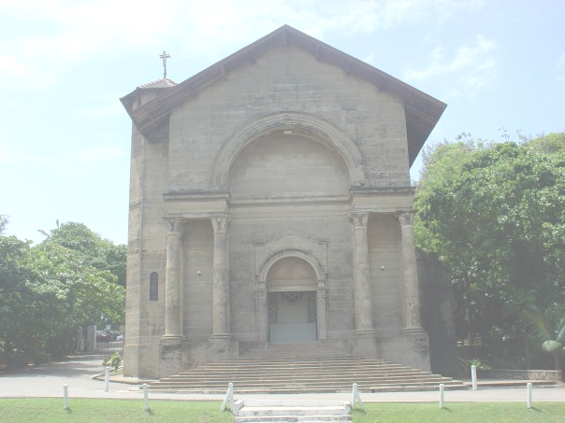
- Address by the Warden/Ex-Officio President of the STC ML, OBA.
- Review and adopt the 2014/2015 Secretary’s Annual Report.
- Review and adopt the 2014/2015 Audited Balance Sheet & Accompanying Financial Statements of the Association.
- Motions/Resolutions (If any) of which due and proper Notice has been given to the Members as per the Rules/Constitution of the OBA.
- Announcements.
- Any other business of which due Notice has been given.
- Election of the following Office Bearers and other Members to the Executive Committee of the OBA for the year 2015/2016
- Honorary Vice President
- Honorary Secretary.
- Honorary Assistant Secretary
- Honorary Treasurer
- Honorary Assistant Treasurer
- Honorary Auditor
- FORTY Members to be elected to the Executive Committee representing:
- Ten (10) Members who are under 30 years of age.
- Ten (10) Members who are between 30 to 40 years.
- Ten (10) Members who are between 40 to 50 years.
- Ten (10) Members who are over 50 years.
As at the date of the AGM.
- Adjournment.

Note on the Agenda Item 13:
Nominations for the election of Office Bearers and those representing the Executive Committee as stipulated in Item 13 above, shall be received in sealed envelopes at the Warden’s Office, S. Thomas’ College, Mount Lavinia, no later than 17.00 Hours, Friday 23rd January 2015, having given 14 clear days Notice before the Annual General Meeting. Nomination Papers must be duly Proposed and Seconded by two (2) separate Members of the Association, together with the written consent of the Member so nominated. No Member who has served on the STC ML, OBA, Executive Committee for Five (5) successive years (without an interruption) shall be eligible for re-election until a lapse of two (2) consecutive years.
As there is no particular format prescribed by the Rules, Nomination Papers can be prepared by the prospective candidates by including the names/addresses/membership numbers of the Proposer and Seconder respectively and the name/address/membership number of the candidate along with his consent, evinced by his signature. Nomination Papers which do not contain the above particulars or which are otherwise not duly perfected and/or incomplete may be rejected.
BY ORDER OF THE 2014/2015 EXECUTIVE COMMITTEE
Friday, 2nd January 2015
Dilshan Jayasuriya STCML OBA SECRETARIAT
Honorary Secretary S.THOMAS’ COLLEGE
STCML OBA MOUNT LAVINIA

***********************************************************************************


S. THOMAS’ COLLEGE, MOUNT LAVINIA
OLD BOYS’ ASSOCIATION

ANNUAL OBA WEEK CELEBRATIONS

The customary sporting encounters between the present boys and the old boys will be worked out from the 10th to the 13th of February, 2015 at STC sporting facilities in accordance with the schedule given below. Old Boys who wish to participate in the encounters set out herein below should contact the relevant coordinator designated for each sporting event.

Event Date Time Contact Person Contact Number

Badminton Tuesday 10th, Feb. 6.00 p.m Janseh Ratnadasa 0777766924
Hiran Siriwardena 0727334458
Table Tennis Wednesday 11th, Feb. 5.00 p.m Janesh Ratnadasa 0777766924
Hiran Siriwardena 0727334458

Tennis Wednesday 11th, Feb. 4.00 p.m Gihan Perera 0777865939
Hiran Siriwardena 0727334458

Hockey Thursday, 12th Feb. 5.00 p.m Amitha Abeynaike 0778578817
Squash Thursday, 12th Feb. 4.00 p.m Hiran Siriwardena 0727334458
Basket ball Friday 13th , Feb. 8.00 p.m Sanjith Kularatne 0777780014
Water Polo Friday 13th, Feb. 8.00 p.m Zaffar Zanudeen 0772017969
Cricket Friday 13th & Saturday 14th 9.00 a.m Nisal Fernando 0777590617
Debating Tuesday, 10th Feb. 6.00 p.m Dilon Ranaweera 0776852573

As notified previously, the 129th AGM of the STC OBA would be held on Friday, 13th February 2015, at 6.30 pm, at the College Hall. Members are hereby kindly requested to carry their OBA Membership Cards, as it would be mandatory to produce either the OBA Membership Card or any other accepted form of proof of identity, in the event of an election being conducted to elect office bearers for the year 2015/2016.

The traditional OBA lunch would be held on Saturday, 14th February 2015, at the College Dining Hall.

The High Tea Party would be held on Saturday, 14th February 2015, at 5.00 pm at the College Quadrangle. All Old Boys and their Spouses are invited for these much awaited events. There would be outstanding performances of the College Western Band, Hewisi Band, Orchestra and the Karate Club at this evening of entertainment at fellowship.

The celebrations pertaining to the Annual Old Boys Week would conclude with a Service of Thanksgiving at the Chapel of the Transfiguration on Sunday, 15th February 2015 at 7.30 am, followed by a fellowship.

All Old Boys are cordially invited to take part in the above events, which afford an ideal opportunity to relive your memories at the School by the sea.

Dilshan Jayasuriya
Hony. Secretary
S. Thomas’ College Mount Lavinia
Old Boys’ Association.

CORRESPONDENCE – 2014

276. SSJ Associates has sent us the following e mail on December 10, 2014

“Dear All,

It is with great sadness that I wish to inform you of the demise of the beloved wife of our Patron, Dr. Vijaya Corea this morning.

Her body will lie at A.F. Raymonds Funeral Parlour from 8.30 am. tomorrow 11th December. A Service will be held at 4.00 pm. in the Parlour and thereafter, the cortege will leave for Jawatte Cemetery for burial.

Please inform any members of The Thomian Society you may know. I will make arrangements to keep the general membership informed.

Let us all condole with Vijaya in his moment of grief.

Best Regards.

Lohan.”

275. Bandu Wanigasekara has sent us the following e mail on December 10, 2014

“Dear Lucky,
Kindly place this in your advices/website.
I have informed Guru OBA main persons - Pres., Senior VP & Sec informed.
Regards
Bandu
............................................................................................................................................................
I have received the following from Valerie - Peter's wife. Kindly keep all informed. Thanks.
------------------------------
I am having a Memorial Service for Peter on the 30th Dec: 2014,at 4.00PM, at the Chapel of St Francis Of Assisi, Mount Lavinia.
The Rev'd Mark & Rev'd Joshua Ratnam of St Francis will together take the Service.
Kindly inform all concerned.
Valerie Weerakoon.”
------------------------------

274. Ananda Amaranath has sent us the following e mail on December 12, 2014 7:37 PM
“Dear Lucky,

Check this out. It has photos of the STC OBA Carols.
You are depicted.

http://www.ozlanka.com/photoindex/2014/dec/stc-carols.html

Regards
Ananda Amaranath”

273. Rev. Marc Billimoria has sent us the following e mail on December 11, 2014
“Hi Lakshman,

Thank you for this notice. I wonder if you would be able to upload the e invitation for my institution and installation as Warden for the benefit of the STCG OBA fraternity?

I attach it in case it will be possible.

I am sending a separate invitation for you and your wife. Hope you'll be able to make it.

Thanks and Best Regards,

Marc”

272. Bandu Wanigasekara has sent us the following e mail on December 10, 2014

“Dear Lucky,
Kindly place this in your advices/website.
I have informed Guru OBA main persons - Pres., Senior VP & Sec informed.
Regards
Bandu
............................................................................................................................................................
I have received the following from Valerie - Peter's wife. Kindly keep all informed. Thanks.

------------------------------
I am having a Memorial Service for Peter on the 30th Dec: 2014,at 4.00PM, at the Chapel of St Francis Of Assisi, Mount Lavinia.
The Rev'd Mark & Rev'd Joshua Ratnam of St Francis will together take the Service.
Kindly inform all concerned.
Valerie Weerakoon.”
------------------------------

271. J H Marikar has sent us the following e mail on November 26, 2014

“http://www.tyretracks.com/showthread.php?t=1247

Motto Matters !
Tuesday, November 25, 2014
Ishara Jayawardane

A school motto embodies the spirit of a school. It unites the school under a common goal and vision. It provides the students with an ideal to follow and strive for. It gives them hope and strength. Daily News spoke to some leading schools in Colombo to find out how their school motto has molded them and inspired them.

Daily News first spoke to the Sub Warden of S. Thomas’ College Mount Lavinia, the Rev. Marc Billimoria who provided some insights into the Thomian motto - ESTO PERPETUA

Good values

“The origins give us the meaning. It is a Latin term from Eton College in England which was introduced to S. Thomas’ College by our Founder, Bishop James Chapman. Before coming to Sri Lanka as the first Anglican Bishop, he was a Fellow of Eton College, having also studied there. He wanted to start a school in Sri Lanka that was modeled on Eton and so among the many features from Eton that he introduced here was this motto that was a traditional motto of Eton - ESTO PERPETUA, that basically means - May it last forever, Last thou forever or as every Thomian today understands it Be thou forever. Although the present motto of Eton College is FLOREAT ETONA, meaning ‘May Eton flourish,’ ESTO PERPETUA is said to have been the motto from about 1635. At S. Thomas’ the motto became part of the present college crest in 1947 under Warden R S de Saram. What is interesting is, that it is also the State motto of Idaho in the United States of America where the translation is ‘Let it be eternal.’

We sing the motto every time we sing the College Song, which interestingly was written in 1916 by Edmund De Livera an old Royalist! In the College Song there is a chorus in which we repeat the term ESTO PERPETUA three times. Thus it almost becomes a part of a student’s life for the period of time he spends at STC.

Well, the more he sings it, the more he has to realize that what he is being asked to do, is to be part of this institution which is going to last forever or flourish forever and prosper. So the student has to realize that he is part of the flourishing or the prospering of the institution. Beyond that while he receives the best education that is possible from the school, he also has a duty to give back to the school, in order that it may flourish. And the school may only flourish, if its products contribute positively towards that flourishing. For the students, it is therefore an important if not vital symbol of the school and the more they reflect on its meaning, they have to realize that they are part of an institution that is long lasting and that needs to flourish, and from which they also get something for their lives in order for their lives to blossom and flourish when they leave its portals. ‘Be thou forever’ what? Be thou forever- loyal, faithful, honest, true and compassionate. To me the motto encompasses all the good values the school promotes in a child that need to last forever, that need to flourish.

“There are two lines of one of the verses that go like this: ‘We rejoice in victory when our foes we beat and we know when fortune frowns how to take defeat.’ This has to be hit home over and over again at a time when competitive sports are in danger of becoming more of an obstacle than a support to education as a whole. Today it’s all about winning at any cost and at all costs. Our children must learn how win but also how to lose and to know how to handle and face defeat on the sports field. Life is not about winning all the time. There will be victories and there will be defeats. School prepares you to face both.

The school is not just as an institution with buildings and facilities but the school is a living entity which flourishes forever as long as the children are getting the best from it. The spirit that is fostered by the motto is something that will never be outside the Thomian psyche, because it is part of our song and crest. It is always in front of us and we cannot forget it. What we need to constantly remind ourselves is - what does it mean for us today? If you just come to school at 7.30am and leave at 1.30pm and don’t really take a part in the life of the school, you are not contributing to the flourishing. You are just playing lip service to the motto. But if you are part of the system and you are learning from the system and giving back to the system by way of doing well in your studies or doing well in your sports/ extra curricula activities then you are contributing to the motto becoming a reality,” said Rev. Billimoria. S. Thomas’ College is 163 year old. It was opened at Mutwal on February 3, 1851. It was transferred to and opened in Mount Lavinia on January 26, 1918 and will be celebrating 100 years at Mount in 2018.

http://dailynews.lk/?q=archives/2014....FDF25hLL.dpuf”

270. Upali Jayatilaka has sent us the following e mail on November 18, 2014

“FOOD FOR THOUGT -

Dear Class of ’62 / O/L ’70 Mates,
As you would recall, at one of our recent fellowships, the matter of having some Medical Insurance for our group was discussed.
The attached policy proposal was arranged through our Classmate SA Dias of the College OBA Secretariat.
This is, what I understand, the Policy taken by the Centenary Group of College.

Please have a look at it , read the contents carefully, and let me know what your views are.
If you wish to get further details or decide to proceed, please let me know and I can coordinate accordingly.
Best regards,
DJ”

269. Upali Jayatilaka has forwarded us the following e mail on October 30, 2014

“27 October 2014
Miller - Copleston Revival
Dear all,
Members of the Miller-Copleston committee visited college on Sunday 19 October and met the Sub-Warden and House Masters. It was in connection with the Miller-Copleston revival efforts, at which the Warden would like the Miller-Copleston Association to play a role.
We were walked through the existing hostel (and memory lane), and were briefed on the immediate and long term plans College has for this revival. It was truly impressive.
State of the art showers and toilet facilities in the new block, (to say the least) was an indication of things to come. The planning that seems to have gone on already, was even more evident in the conversations that followed.
We “The Miller-Copleston Association” have undertaken the following:
A) In the short term provide fans, washing machines, television sets and other such utility items that are needed to the existing and new dormitories being reclaimed from classrooms. Our events will essentially become fund raisers for this with the monies we can raise through sponsorship banners etc to be displayed at these events, to other donations which can be solicited from members in cash or kind.
Cost estimate is attached.
B) Our members will play a role in the regular programs organized by the housemasters to inspire and build the greater personalities of hostellers. Eg: Sarath Mahadivulwewa will be conducting a session in table etiquette by courtesy of a new hotel school he heads, and Shavindra Fernando as Secretary of the Association will deliver the first in a series of after dinner speeches, at formal dinner organized each term in the dinning hall for hostellers in formal dress and table etiquette.
C) The committee is happy to inform of the above which will indicate to the membership the kind of effort the school authorities are taking in these efforts which will become matters close to our heart, as we see the emergence of an institution we called home, soon to become of greater stature than we ever knew. For instance there are plans for the dinning hall to be re-furbished/furnished to be greater setting as the numbers grow.
D) College has also obtained the dedicated services two old Thomians to serve as Senior Housemasters, one a former First X1 Cricket captain and the other teaching Mathematics in the senior forms. All of this we witnessed indicated the qualitative nature the revival of the school hostel aims to achieve.
E) The revival of house names, flags and crests and some aspects of the past will be discussed as we engage on these supportive functions. Its dynamics will be left entirely in the hands of the school authorities who will best know how it could be done as the number keep growing.
F) In the long haul, as the Warden indicated when he first addressed us at the OTSC, this effort will need the raising of larger sums of capital to “re-build” Miller-Chapman and Copleston-Claughton Houses. That is up to those of you who are leaders in the financial and commercial sector to undertake in consultation with the Warden and probably the goodwill of our brotherhood who are resident abroad.
Determined, Dared & Done Omnia Vincit Durus Labour
For:
The Miller-Copleston Association Committee.
Shavindra Fernando (MSP) Senaka De Fonseka
Secretary Treasurer

AWAIT:
Miller - Copleston Yuletide Eve 2014
Planned for:
December 13 Saturday at 7.00 PM at the OTSC
Listen to a few carols and oldies with drinks and conversation.
(A fund raiser)”

268. Neville Athukorala has sent us the following e mail on October 27, 2014

“Dear Mr Jayatilaka

Thank you for the Message received regarding the death of Mr Peter Weerakoon. Mr Peter Weerakoon and I started learning planting in 1957 at Hayes Group, Deniyaya, under late Mr Gunam Thambipullai, who was a well known personality in the Plantation community in the Sothern Province. After our learning work period, Peter joined Harrions and subsequently with the nationalization of Plantations I was appointed as a Visiting Agent to Ouvketawelle Estate, Hali-ela where Mr Peter Weerakoon was the Manager. Peter Weerakoon’s wife Valery was known to my parents even before I met Peter.

I carry very fond memories of my association with Peter and his wife Valery and their children.
I would be very grateful if you could please convey to Vallery and other members of the family our deepest sympathies.

Yours sincerely
Neville Athukorala”

267. Christo Gonawela has sent the following e mail on October 27, 2014

“Dear Bandu,

Very sad news.

His demise will certainly be felt By STCG and all of us as he was always supportive in funding the various needs of STCG .

Rgds;Christo “

266. Dinusha de Costa has sent us the following e mail on October 27, 2014

“Dear Mr.Jayatilaka,

Thank you for your message, and very sad to hear it.
He used to be a dedicated Guru Thomian and I have chat and emailed many times when I was the secretary. On top of all he was a good gentlemen and he did what he can for the alma mater even when he’s so far away!

Kindly note my condolences of his demise.

Best regards,
Dinusha de Costa
0773312131”

265. Chandana Weerasinghe has sent us the October 27, 2014

“I am deeply saddened by the news of MR PETER WEERAKOON'S passing. My thoughts and prayers are with his family.”

264. Gamini Jayasuriya has sent us the following e mail on October 27, 2014
“Thanks-for the sad news. Peter was a planter too.”

263.Bandu Wanigasekara has forwarded us the following e mail on October 26, 2014

“Subject: OBITUARY - MR PETER WEERAKOON
From: "Webmaster - STC OBA \(Australia\)" <webmaster@stcobaaust.org.au>
To: "undisclosed-recipients:"
It is with deep regret that we inform members of the death on Friday the 24th October of Mr Peter Weerakoon, a former Editor and Vice-President of the STCOBA in Melbourne.
The funeral will be held on Wednesday 29th October, 2014 with the church service being held at St. David's Anglican Church, Moorabbin and the cortege leaving for the Cheltenham cemetery thereafter. The exact time of the funeral will not be known until Monday 27th October.Â Further details will then be advised.Â
While Peter was also an old boy of STC Mount Lavinia, his first love was for STC Gurutalawa where he spent his formative years, and he took a very keen interest in its affairs.Â A few months ago, on the occasion of the visit of the sub-warden of STCML, Rev. Marc Billimoria, to Melbourne, Peter was invited to deliver the welcome address as he had had close contact with Rev. Billimoria when the latter was Headmaster of STC Gurutalawa.Â Peter was quite frail at the time, having to lean on the back of a chair for support, but he spoke quite firmly.
In August, Peter and his wife Valerie went on a vacation to Sri Lanka, and shortly before his departure, he was asked to ascertain a few more details about a request for funding of a well at Gurutalawa so that there would be ample supplies of water for the school.Â We were informed that during dry spells, the existing wells go dry and water supplies are critically low.Â Unfortunately, shortly after Peter's return from Sri Lanka, he took ill and we were unable to receive a report from him.Â The respective committees of STCOBA Australia, Melbourne and STCOBA in NSW will both be considering contributions to the funding of a new well as it is a worthwhile cause.
On behalf of the members of the STCOBA in Melbourne, we extend our sincere condolences to Peter's family. Â
Trevor Meares
President
STC OBA (Australia)
PO Box 2337
Mt Waverley, VIC 3149
Australia.”

262. Headmaster S. Thomas' College at Gurutalawa has sent us the following e mail on October 26, 2014
“Dear Bandu and Lakshman,
Thanks for informing us about the demise of an old Thomian,Mr Peter Weerakoon.He wanted to come and see me in last August when he was in Srilanka,but due to some reason he could not make it.I have contacted him through Lakshman.He was indeed a true Thomian who wanted to support Guru.
However, My humble prayer is that he may meet his creator in Heaven!
May he rest in peace!

Fr.Nihal Fernando”

261. Prasad Jinasena has sent us the following e mail on October 25, 2014

“Thank you Krishan. This person happens to be Mr. Bradman. Weerakoon's brother.

Prasad”

260. Rev. Marc Billimoria has sent us the following e mail on October 25, 2014

“This is indeed very sad news. I was able to meet Peter in Melbourne in May and he did look weak. May he rest in peace .”

259. Milinda Hettiarachchi has sent us the following e mail on October 25, 2014

May he rest in peace +

258. Bandu Wanigasekara has sent us the following e mail on October 25, 2014
“Dear Lucky,
Just heard the very sad news that a lover of Guru, a benefactor and
persistent supporter of our OBA, Peter Weerakoon, passed away last
night in Melbourne Australia. He was ailing for a couple of weeks.
Regards
Bandu”

257. STC Mt. Lavinia, OBA has sent us the following e mail on October 15, 2014

Dear Fellow Thomians

'SPIRITS ON FIRE' GALA DINNER FOR FELICITATING WARDEN, PROF. INDRA DE SOYSA
SATURDAY, 22ND NOVEMBER 2014
MOUNT LAVINIA HOTEL, MAIN BALLROOM.

The Annual ‘Spirits on Fire' Gala Dinner organized by the Old Boys’ Association is scheduled to be held on Saturday, 22nd November 2014 at the Mount Lavinia Hotel – Main Ballroom, commencing with cocktails at 7 p.m. followed by dinner.

This year's ‘Spirits on Fire' Gala Dinner, which is eagerly awaited by all our Members to revive the camaraderie established and nurtured at the “School by the Sea”, affords us an ideal opportunity to bid farewell to our much respected Warden, Prof. Indra de Soysa, who is leaving us at the end of this year after a brief but nevertheless a splendid tenure of 3 years of guiding the destinies of the "School by the Sea".

Tickets for the Gala Dinner will be available at the OBA Secretariat, and also at the Ceylinco Life Tower (7th Floor), 106, Havelock Road, Colombo 5, from Friday, 17th October 2014, each priced at Rs.6,000/-. Please ensure that you reserve your table early to avoid any disappointments. Several artistes will perform at this event including the ‘De Lanerolle Brothers’and the ‘Revelations’ . The College Orchestra will be in attendance, thereby giving a complete Thomian flavour to this much awaited event.

Thank you,
Yours sincerely,

Dilshan Jayasuriya
Hony. Secretary
STCML OBA

256. Nihal Wanniarachchi, J H Marikar & STC Gurutalawa OBA have sent us this e mail on October 11, 2014

“Fernando, Lucian (L.W.A). Husband of Ranjini. Father of Rukmali, Rehan and Ruwan. Cortege leaves residence, “Situruwana”, Marawila-Nattandiya Road, Nattandiya (opposite Dhammissara Vidyalaya) at 2.30 pm on Sunday 12th October for burial at the Church of the Holy Cross Cemetery, Marawila at 3.00pm.”


255. Mahes Heenetigala has sent us the following e mail on October 06, 2014

254. STC Mt. Lavinia, OBA has sent us the following e mail on October 03, 2014
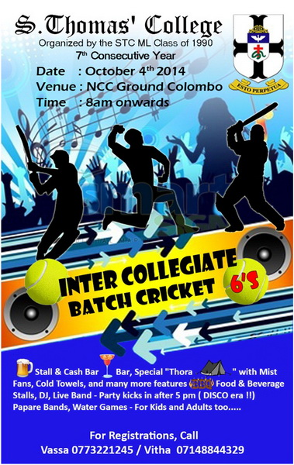

253. STC Gurutalawa OBA has sent us the following e mail on September 30, 2014
“Dear All,

Please be informed that the GALA DINNER DANCE 2014 will be held on 08th November 2014 at Empire Ball Room,Mount Lavinia Hotel.
refer to the attached flyer for further details.

ESTO PERPETUA.”



252. Muditha Dissanayake has sent us the following e mail on September 28, 2014
Dear All

Davidson Block before we replaced it with Amano sink sheets.

Fr.Nihal Fernando”

251. Muditha Dissanayake has sent us the following e mail on September 28, 2014

Dear All,
I send herewith latest photos of the roof repair we did at STC Gurutalawa.It is Winchester Hostel Roof repair near college basketball courts.

Thanks for all who assisted our school.

Fr.Nihal Fernando”

250. Muditha Dissanayake has sent us the following e mail on September 28, 2014

Dear All,
Some more photos of the newly renovated Winchester Hostel

Fr.Nihal Fernando”

249. Muditha Dissanayake has sent us the following e mail on September 28, 2014
Dear All,
I am happy to announce that the boys moved to newly renovated Winchester Hostel ( now known as Illangakoon Hostel ) today.These photos were taken inside the hostel.

Fr.Nihal Fernando”

248. Muditha Dissanayake has sent us the following e mail on September 28, 2014

Dear All,
Today I am shifting the boys to this hostel.They are cleaning the dorm with their headmaster but I am not in the scene,since I took the photos.
Esto Perpetua !

Fr.Nihal Fernando”

247. Muditha Dissanayake has sent us the following e mail on September 28, 2014

Winchester Hostel

When the repair was in progress

Fr.Nihal Fernando”

246. Ziard Sinnen has sent us the following e mail on September 26, 2014

“Dear Kavi ,
Please send the flyer to the OBA membership and advise them to circulate among friends without any delays.

Dear Herath,
Please publish same on OBA website

Regards

Ziard”

245. STC Mt. Lavinia, Old Boys' Association has sent us the following e mail on September 23, 2014

Copyright © 2014 STC ML OBA, All rights reserved.
STC ML OBA Newsletter
Our mailing address is:
STC ML OBA
The Administrative Office of the S. Thomas' College
Old Boys' Association
Mount Lavinia, Western 10370
Sri Lanka
Add us to your address book
unsubscribe from this list update subscription preferences

244. STC Mt. Lavinia OBA has sent us the following e mail August 30, 2014

“Dear Fellow Thomians

It is with profound sadness that I announce the death of one of the most distinguished Old Thomians of recent times, Mr. Sam Wijesinghe, a former Secretary General of Parliament. The late Mr. Wijesinghe also held the posts of Ombudsman of Sri Lanka and Chancellor of the Open University of Sri Lanka. Funeral arrangements would be notified in due course. Our heartfelt condolences go out to the Members of the family of the Late Mr. Wijesinghe

Thank you,
Yours sincerely,

Dilshan Jayasuriya
Hony. Secretary
STCML OBA”

243. STC Mt. Lavinia OBA has sent us the following e mail August 30, 2014

“Dear Fellow Thomians,

As you are aware the much anticipated 'Thomian Night Dinner Dance 2014' is scheduled to be held on Sunday, 7th September 2014 at the Grand Ball Room of the Colombo Hilton (Please note that Monday, 8th September is a Public, Bank and Mercantile Holiday). The 'Thomian Night Dinner Dance' has earned the deserving reputation of being the Dinner Dances of Colombo attracting the best of crowds. It has throughout been a complete sell out much to the disappointment of a considerable number of Thomians who are left out due to the non-availability of tickets.

This year too, all the tickets were booked well in advance thus living up to its reputation of being a complete sell out. However, owing to a couple of unexpected last minute cancellations, a few tickets are remaining unsold. Hence, don't miss this opportunity of purchasing the available tickets and participating in the Dinner Dance of the year. Those who are interested in purchasing tickets may contact Raajiv on 0770778855 or the OBA Secretariat on 0114955047.

Thank you,

Yours sincerely,

Dilshan Jayasuriya
Hony. Secretary
STCML OBA”

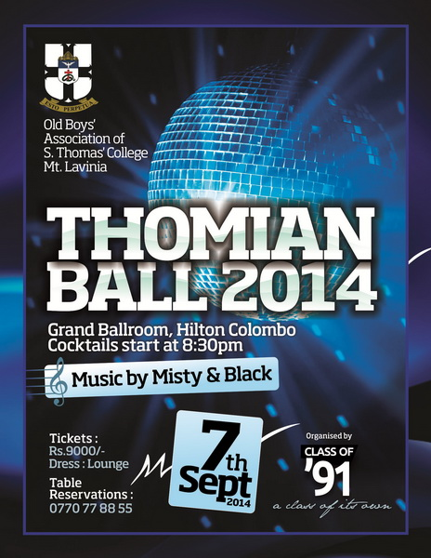
242. STC Mt. Lavinia OBA has sent us the following e mail on August 25, 2014

“Dear Fellow Thomians,

It is with profound sadness that I notify the untimely deaths of twopast Thomian Rugby Players, brothers, Sadeva Dharmadasa (2005 to 2007 STC Rugby) and Avendra Dharmadasa (2009 & 2010 STC Rugby) under tragic circumstances on 23.08.2014. Sadeva and Avendra are the sons of Arjun Dharmadasa, a distinguished Old Thomian who played a pivotal role in the recent revival of STC Rugby.

The funeral took place on Sunday, 24th August 2014, at the General Cemetery, Borella (Buddhist Section), at 11.30 am. On behalf of the STC OBA I wish to express my sincere condolences to the Parents and other Members of the family of the late Sadeva and Avendra Dharmadasa. Thank you,

Yours sincerely,

Dilshan Jayasuriya
Hony. Secretary
STCML OBA”

241. J H Marikar has sent us the following e mail on August 20, 2014

“Dear TSOC Member,

The TSOC has once again come forward to put on a show as a Fund Raiser and great entertainer with a brand new edition of “Pusswedilla” in the form of a Dinner Theatre. Details in Flyer attached. Tickets for TSOC members are priced at Rs. 6,500/= each. You could contact me on 0777718694 for any further details.

Best Regards.

Lohan Goonewardene

President TSOC.”

***************************************************************
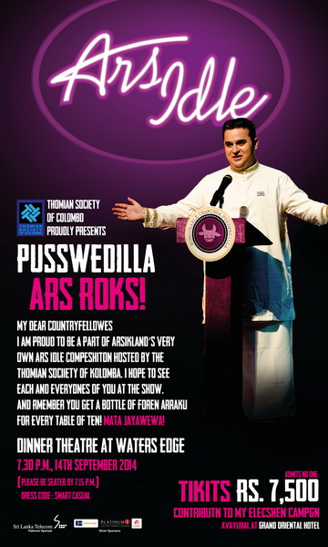

240.Gamini Jayasuriya has sent us the following e mail on August 16, 2014
“Such a moving message. I remeber in STC but was not a friend of his.
Thank you
The attendance at Tiny Reid’s funeral service today (Wednesday August 13) was one of the largest I have witnessed at a gathering of this kind throughout my 42 years in Australia. It was a fitting testament to someone we can call a friend, who also touched so many other people’s lives in so many positive, kind, caring, loving and thoughtful ways.
The entire service, as detailed on the attached pdf, had been meticulously planned by Tiny himself a few weeks before he died. He chose everything - from the hymns, Bible readings, prefaces and explanations of Bible readings (!), and speakers/eulogists to officiating clergymen.
Before the service commenced, I paid my last respects to Tiny at a private viewing of his body in a small ante room. At Tiny’s request, he was dressed in his cricketing flannels and STC Cricket blazer.
Something else that Tiny could not have chosen better was the group of pall-bearers: his four brothers (Claud, Ronnie, Buddy & Barney), his brother-in-law Milroy de Vos, and Sanjiva. The perfect combination to carry Tiny’s mortal remains at the beginning of their final journey.
As Tiny’s STC flag-draped coffin was carried out of the church, I was privileged to be part of a large guard-of-honour formed by all the Old Thomians present. Then, before the coffin was placed inside the hearse, we all sang the College Song. Needless to say, it was a hugely emotional and stirring moment that I will cherish for the rest of my days.
Interestingly, this last honour to Tiny was the only ‘unscripted’ part of the service. It was a last-minute decision on the part of Trevor Meares, the President of the STCOBA Melbourne Branch, with the approval of the four remaining Reid brothers. Knowing Tiny as we all do, for the modest, self-effacing chap that he was, someone who shunned ostentation and fuss without seeking to draw attention to himself, he would never have wanted to suggest such a thing. He would have not wished to be deemed presumptuous, or ‘up himself’, for asking for a guard-of-honour, or even the singing of the College Song at his funeral. But, again knowing Tiny as I did, he would have greatly appreciated and been massively ‘chuffed’ by this small token of our esteem and love for one of nature’s - and God’s - finest gentlemen.
He is now surely Resting in Peace.
RT”

239. Brian Wickremasinghe has sent us the following e mail on August 15, 2014

“Tiny was my class mate and we sat next each other in the lab. I heard about the loss of his wife and tried to contact him in AU when I was there but could not get a contact number. It was most unfortunate. May he rest in peace.”

238. Merril Aluwihare has sent us the following e mail on August 15, 2014

The attendance at Tiny Reid’s funeral service today (Wednesday August 13) was one of the largest I have witnessed at a gathering of this kind throughout my 42 years in Australia. It was a fitting testament to someone we can call a friend, who also touched so many other people’s lives in so many positive, kind, caring, loving and thoughtful ways.

The entire service, as detailed on the attached pdf, had been meticulously planned by Tiny himself a few weeks before he died. He chose everything - from the hymns, Bible readings, prefaces and explanations of Bible readings (!), and speakers/eulogists to officiating clergymen.

Before the service commenced, I paid my last respects to Tiny at a private viewing of his body in a small ante room. At Tiny’s request, he was dressed in his cricketing flannels and STC Cricket blazer.

Something else that Tiny could not have chosen better was the group of pall-bearers: his four brothers (Claud, Ronnie, Buddy & Barney), his brother-in-law Milroy de Vos, and Sanjiva. The perfect combination to carry Tiny’s mortal remains at the beginning of their final journey.

As Tiny’s STC flag-draped coffin was carried out of the church, I was privileged to be part of a large guard-of-honour formed by all the Old Thomians present. Then, before the coffin was placed inside the hearse, we all sang the College Song. Needless to say, it was a hugely emotional and stirring moment that I will cherish for the rest of my days.

Interestingly, this last honour to Tiny was the only ‘unscripted’ part of the service. It was a last-minute decision on the part of Trevor Meares, the President of the STCOBA Melbourne Branch, with the approval of the four remaining Reid brothers. Knowing Tiny as we all do, for the modest, self-effacing chap that he was, someone who shunned ostentation and fuss without seeking to draw attention to himself, he would never have wanted to suggest such a thing. He would have not wished to be deemed presumptuous, or ‘up himself’, for asking for a guard-of-honour, or even the singing of the College Song at his funeral. But, again knowing Tiny as I did, he would have greatly appreciated and been massively ‘chuffed’ by this small token of our esteem and love for one of nature’s - and God’s - finest gentlemen.

He is now surely Resting in Peace.

RT

237. Andy Jayasinghe has sent us the following e mail on ent: Wednesday, July 02, 2014 8:32 PM
To: 'LAKSHMAN JAYATILAKA'
Subject: FW:

Hi Lakshman,
Heres an old photo of doc and mrs Hayman which I found in an album.
You may want to publish it on your web site.

Best

AG

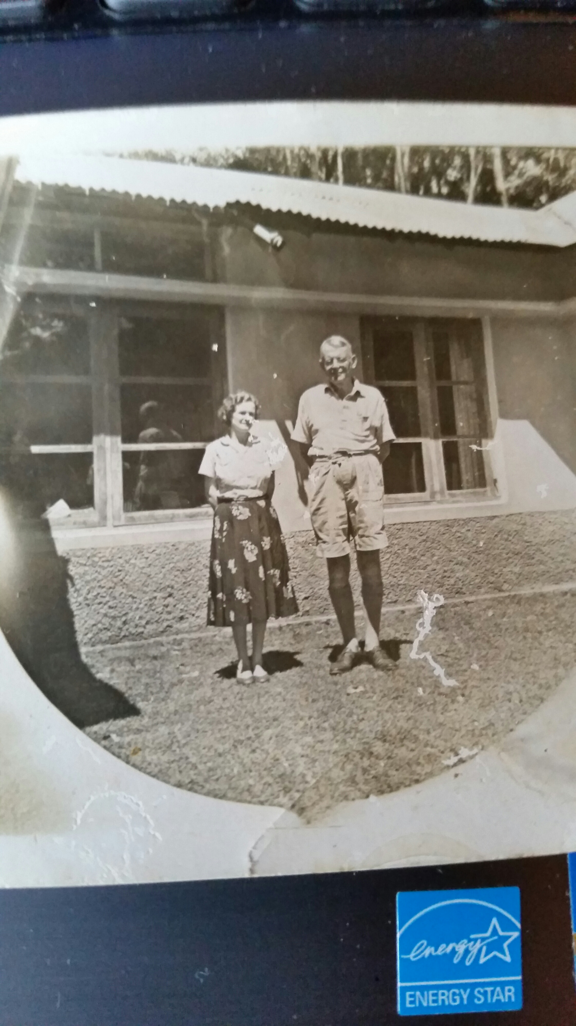

236. Ranji Casinader has sent us the following e mail on June 26, 2014

“Lakshman,

I was saddened to receive your email sending me Bradman’s eulogy to Duleep, but very thankful to you for letting me know of his passing away. Like Bradman, I had the privilege of being a close friend of Duleep for some ten years or so, first in Gurutalawa and then in Mount Lavinia when the school returned there after the end of the War. Although we had not seen much of each other after I left Sri Lanka in 1949, we did meet whenever I returned on my visits to Sri Lanka, most recently in 2003. We corresponded infrequently usually at Christmas time. I was very saddened to learn from his most recent Christmas card that he was so disillusioned with the political situation in Sri Lanka which may well have saddened him in his last years.

Thank you for letting me know of his passing away.

Ranji Casinader”

235. Charles Sarvan has sent us the following e mail on June 25, 2014

“Thank you for sending me this.

Duleep was my 'dorm' master; Bradman Weerakoon, we knew (respectfully, as became pupils, but also affectionately) as "Brady".
They were young men then, and were much admired by us: smart, energetic, given to witty repartee...
(Prof) Sarvan”

234. Ananda Amaranath has sent us the following e mail on May 19, 2014

“To The Prefects Group,

This is to bring to your notice that our classmate Arul ( STC Freshmen of '59 Group) along with his two brothers donated the New Commerce building to College. I believe this is the largest donation the college would have received.

We are extremely proud of our classmates kindness. The Warden In his speech thanked another of our classmates Milinda Hettiarchchi for arranging this gift to college.The Warden also mentioned about the work done by Karu Amerasinghe. He is a member of the Prefects Group.

Arul, Raja and Jey Gnanam, the trustees of Gnanam Foundation donated the Commerce block of St Thomas' College.

For the dedication of this building by The Lordship The Rt Reverend Dhiloraj Canagasabey, Lord Bishop of Colombo, in commemoration of their late father Deshamananya A Y S Gnanam was on the 5th of May 2014.

Kind regards,

Sriyan

on behalf of the STC Prefects Group.
*********************************************************************************

233. From: Milinda Hettiarachchi <rpmilinda@gmail.com>
Date: Tue, May 6, 2014 at 12:06 AM
Subject: Freshman 59

Dear Sriyan ,
The Freshman of 1959 has done great service to STC .
The new Commerce Block was funded by Arul with his brothers ( Gnamam Foundation ) on my initial request which clicked as mentioned by Warden in his speech at the opening .
It is worthy of circulation to the Freshman of 1959 .
Thank you

******************************************************************************

232. An opportunity to give back to our Alma Mater ( STC OBA Sydney Web)

Fellow Old Boys,

As you are aware the OBA has organised several events in order to celebrate our 125th year. As requested by the warden, all funds raised through these events will be used to build a state of the arts commerce and arts facility which is estimated between 75 -100 million.

One of the main fund raisers for this project is the Thomian fair scheduled for 1st-3rd September 2011 at College grounds.

To make this event a success the Warden & the Chairman of the Fair Committee Mr. B.R.L.Fernando (Chairman of CIC) have requested me to invite all Thomians to support the Thomian Fair 2011 and would appreciate if you could volunteer to be a member of the Fair committee. There will be over 40 sub committee's such as fund raising, gate, security, entertainments, trade stalls, sponsorship, ground arrangements, games stalls,amusement activity's, raffle draw, motor show, exhibition, secretarial, co-operate stalls ,souvenir, banner committee, publicity.

We would appreciate if you could let us know the area you would like to work in, so that we could include you in a sub committee where you could contribute positively. In conclusion, I appeal to all of you to please volunteer as we need to support our alma mater and ensure that the future generations of Thomians have the best, as the old boys of our time ensured that we had the best.

Would appreciate if you could fill in the following information and send it to the OBA email address which is stcmloba@sltnet.lk

Name / Period in college / OBA number / Areas you would like to assist / Mobile / E-mail

Esto Perpetua

Udaya Gunaratne
Honorary Secretary
STC ML - OBA

231. Boo Khan has sent us the following e mail on May 19, 2014

“Thank you so much

Pls pass down this message PHILIPS DULEEPKUMAR family pls

My heart goes out to you during this difficult time to your family

Let his soul rest in PEACE in the feet of ALMIGHTY

May god bless your family

Khan and family
STC – Guru

United Global Logistics, Inc.
Corporate office
147-39 175th Street Suite 103-C Jamaica, New York 11434.
Tel: 718 244 0906 (Ex:101) / 516 488 2766 (Ex:109), Cell : 516 - 650 - 4831,
Fax: 718 244 0907 / 516 488 2744
E-mail :- sales@unitedgloball.com
Web :- www. unitedgloball.com”

230. Michael Silva has sent us the following e mail on May 19, 2014

“This is very very sad news indeed and comes to me as a shock. Thought there were many more good years ahead of him! Have very pleasant recollections of him at Guru.
God bless him and may his soul rest in peace.
Thanks for letting me know.
Mike”

229.George Pillai has sent us the following e mail on May 19, 2014

“Dear Thomians,
All of us must grieve at the sad passing away of Duleepkumar. We know what Gurutalawa achieved. Duleepkumar and Gurutalawa were synonymous. When we celebrated "Old Boy's Day, he was there every year. We will miss you but will cherish everything you did for your school, in every sphere of activity. I clearly remember so many little quips you indulged in when we met, sometimes at the breakfast table and also in the playing field when watching the "Old Boy's Vs, Present Boys, Cricket Match. I salute you from afar.
George Pillai”

228. Muditha Dissanayake has sent us the following e mail on May 18, 2014
“Rest in peace. Learnt a lot from him (brief 3-6 months) about being a thomian than all the years at Guru”

227. Mithra Edirisinghe has sent us the following e mail on May 18, 2014

“Thanks Luxman for the information. I will be attending the funeral.”

226. J H Marikar has sent us the following e mail on May 18, 2014

“I just returned from Dulip Kumar's place. I was quite surprised to see the death notice in the Sunday Times this morning. I didn't know many people who were there. I was happy to meet Nalin Abeysekere, who was my prefect in Winchester at Guru. Funeral is at 4 30 pm. I am sure all the guys will be there at Kanatte.”

225. Ananda Amaranath has sent us the following e mail on May 18, 2014

“Regards
Ananda Amaranath

Sent from my iPad

Begin forwarded message:
From: Ralph Amerasinghe <ralphamerasinghe@hotmail.com>
Date: 18 May 2014 9:52:30 am AEST
To: Peter Weerakoon <peterweerakoon@optusnet.com.au>, Peter Amerasinghe <peter@ceyquartz.com>, Ananda & Pranetha Amaranath <aamaranath@optusnet.com.au>, Graham Masefield <gmasefield@hotmail.com>, Suraj Jayawickrama <suraj.j@gmx.at>, Randy & Mary Anne Morrell <themorrells@bigpond.com>, Nath Kannangara <nathkannangara@gmail.com>, Kishin Butani <kishin.butani@gmail.com>, Lakshman Jayatilaka <ashannjay@sltnet.lk>, Maxim Flamer -Caldera <maxim@maximcaldera.com>, "Milroy (CA-CIB) BERENGER" <milroy.berenger@gmail.com>, Nihal Dias Abeyasinghe <nihaldiasa@yahoo.com.au>, Nihal Wanniarachchi <nwanni@sltnet.lk>, Ronald Navamonie <r.navamanie@yahoo.com>, Shaan Ching <csching@hotmail.com>
Subject: Obituary PHILIPS DULEEPKUMAR - R I P

PHILIPS DULEEPKUMAR son of the late Sydney Philips and Gertrude Philips (nee Proctor) brother of late Arasakumar Philips and Shanthikumar Philips, partner of Accounting Systems & Services Ltd and an old boy of St. Thomas’ Gurutalawa and Mount Lavinia. Remains will lie at his residence 172/8A, Polhengoda Road, Colombo 5 from 10 a.m. today Sunday and be removed at 4.30 p.m. for Burial at the Anglican Section, Kanatte at 5 p.m. on Sunday 18th May. 088441”

224. Ralph Amerasinghe has sent us the following e mail on May 18, 2014

“PHILIPS DULEEPKUMAR son of the late Sydney Philips and Gertrude Philips (nee Proctor) brother of late Arasakumar Philips and Shanthikumar Philips, partner of Accounting Systems & Services Ltd and an old boy of St. Thomas’ Gurutalawa and Mount Lavinia. Remains will lie at his residence 172/8A, Polhengoda Road, Colombo 5 from 10 a.m. today Sunday and be removed at 4.30 p.m. for Burial at the Anglican Section, Kanatte at 5 p.m. on Sunday 18th May. 088441”

223. STC Mt. Lavinia OBA has sent us the following e mail on April 23, 2014
Old Boys’ Association
S. Thomas’ College, Mount Lavinia

E-mail: stcmloba@sltnet.lk Website: www.stcmloba.org
Telephone:-2727607/ 4955047
Hony.President Vice President Hony.Secretary Hony.Treasurer
Prof. Indra De Soysa Rev.M.Billimoria Dilshan Jayasuriya Shanil Jayasekera

“Dear Fellow Thomians,

It is with profound sadness that I announce the demise of Thomian Cricketing Legend Mr. Neil Chanmugam, a Former Group Director of the Maharaja Group of Companies. Cortege leaves the residence at No:10/6, Greenlands Lane, Colombo 05, on Thursday, 24th April at 3.00 pm for cremation at the General Cemetery Kanatte at 4.00 pm. On behalf of the STC OBA I wish to offer my sincere condolences to the members of the family of the late Mr. Chanmugam.

Thank you,
Yours sincerely,

Dilshan Jayasuriya
Hony. Secretary
STCML OBA”

222. Ananda Amaranath has sent us the following e mail on April 19, 2014

“From: Eksath Perera [mailto:eksath@bigpond.net.au]
Sent: Wednesday, 9 April 2014 7:35 AM
To: Richie De Silva; Ramesh Abayasekara; Abay, Ramesh; Rex Ratnam; Duke Ramachandran; Kumar Rasiah; Senaka Jayasuriya; Damika Wickremesinghe,; shaan ching; Bob Prabha Subramaniam; Shamilal Wijeyawardana; Eksath Perera; Gimantha Jayasinghe
Cc: Graham Marsefield; Milroy Berenger; Ananda Amaranath
Subject: FW: Squash Courts Photos (04)

Guru project

221. From: "Headmaster S. Thomas' College at Gurutalawa" <hmstcguru@gmail.com>
Date: Tuesday, 8 April 2014 11:00 am
To: Eksath Perera <eksath@bigpond.net.au>, Milinda Hettiarachchi <rpmilinda@gmail.com>, Senaka de Fonseka <senaka_fonseka@bat.com>, Ziard Sinnen <ziard@virgincmb.com>
Subject: Fwd: Squash Courts Photos (04)

Dear all,
I send herewith the photographs of the newly renovated squash courts at STC Gurutalawa for your information.This was achieved through the generosity of OBA OF NSW IN AUSTRALIA and OBA of STCG. As the headmaste,r I owe my gratitude to both camps.The total renovation cost was Rs 450,000.Rs 115,000 came from OBA NSW Australia and the balance from OBA STCG. My humble thanks to both organizations.
Esto Perpetua!

Fr.Nihal Fernando

---------- Forwarded message ----------
From: S. Kaviharan <kaviharans@gmail.com>
Date: 7 April 2014 18:44
Subject: Squash Courts Photos (04)
To: Ziard Sinnen <ziard@virgincmb.com>, Ziard Sinnen <zidosinna@gmail.com>
--
S.Kaviharan
IT Administrator Cum Instructor
S.Thomas' College,
Gurutalawa.
e-mail: kaviharans@gmail.com
Mobile: 0773 260439”
-----------------------------------------------------------------
Please Refer this Link to View Photos http://www.stcg62group.org/Newly_refurbished_squash_court_at_guru.htm

220. Ananda Amaranath has sent us the following e mail on April 19, 2014
“Hi Lucky,

The Warden appears to have lived in another world when he says this sort of thing wasn't tolerated in the past and never considered a 'tradition'.

Those of us who had to endure the 'Rag' in the Mount boarding in the 60s have stories that
will shock all Thomians to the core and make what happened in this instance a walk in the park.
The rag in the 60s brought out the sadistic traits of in some of the seniors and you would recall what happened to Rajpal Amarasuriya. A mild mannered kid who went off his head and consequently never recovered. I met him a number of times in adult life and found him to be a total wreck.

I clearly remember Ronald Ondaatje, who now lives in Melbourne, had his buttocks burnt by sparkler that was stuck in the crevice of his buttocks and lit by a senior.

In this day and age these actions would be subject to criminal sanctions, albeit in the Children's Court.

I am particularly concerned about the effeminate boys, those who are not up to the rough and tumble of a typical boy's school life.

I agree all attempts must be made to stamp it out.
Regards
Ananda Amaranath
------------------------------------------------------------------------------------------------------------

219. "LAKSHMAN JAYATILAKA" <mail@lakshmanj.com>
Date: 18 April 2014 1:04:54 am AEST
To: "LAKSHMAN JAYATILAKA" <mail@lakshmanj.com>
Subject: FW: Thomian Rugby “Blown away” in Kandy
Reply-To: <mail@.com>

Thomian Rugby “Blown away” in Kandy
Published : 12:05 am April 16, 2014 | No comments so far | | 650 reads |
By Marlon Dale Ferreira
The Thomian rugby calendar started off on the wrong footing when an unforgivable incident was “blown away in Kandy” leaving the College authorities in a dilemma. It resulted in one senior rugby player being sacked and another senior stripped of his Prefect’s title, reprimanded and eventually dropped from the team last week, for an incident that had the college authorities taking immediate stern disciplinary action. However, some circles claim it warrants criminal investigation to send a message to all schools that seniors have no business infringing on the rights and freedoms of juniors.
The incident took place when rugby players of all age groups travelled for their season opener against Darmarajah and stayed over from Friday to Sunday in Kandy. Over the years the trip to Kandy has been a nightmarish one for juniors with ragging and claimed “traditions” taking place between seniors and juniors without the consent of the younger boys. These appalling activities viewed by the authorities in the past as “boys will be boys -fun and games” borders inhumanity and have been rampant on outstation sport trips over the years. However, this reporter learned that the Warden was categoric in his address at a recent school assembly after the incident. He stated clearly ‘he was a student for over a decade, but harassment, ragging of juniors was never understood to be a tradition’, ‘It was not tolerated or acceptable then and it will not be tolerated now under the misguided veil of “tradition” ’.
Fortunately this year in Kandy the terrible practice that was being claimed as a “tradition” was “blown out” into the open when a junior player who was alleged to have been “victimized” the previous night spilled the beans the next morning to the touring school authorities saying that he wanted to go back home. The ensuing investigation revealed the entire disgusting episode and despicable act the junior had to perform and the fear of having to endure another “night of torture” in Kandy left the college touring authorities in absolute shock.
Warden Prof. Indra De Soysa was immediately contacted by telephone in Colombo by college officials who instructed that the alleged perpetrator be banished from the team’s accommodation with immediate effect assuring that it will be dealt with internally.
“With so many authoritative figures such as Warden, Coach, Junior Coaches, Master in Charge and the Rugby Advisory Committee Members in control, it is a shame that this episode took place. It appears that the best course of action the college took was to punish the perpetrators and deflect the entire blame on to them rather than the authorities taking full responsibility, hanging their heads and running away in shame whilst leaving matters for some other competent individuals to take over” lamented a junior player’s parent in absolute disgust.
Arguably the reason many talented rugby players have given up the sport could be due to the fear of ‘abuse’ in many forms with claims which could amount to sexual abuse. Another incident which occurred recently is where a brilliant player decided to quit rugby altogether after being assaulted by a senior player leaving him with a bleeding ear.
Prof.De Soysa in spite of the many achievements he has accomplished in his first tenure so far may have to spend some sleepless nights wondering what can be done to halt this insidious trend taking hold in the school under the misguided guise of tradition.
It is the ultimate expectation and wish of every parent that their children who are entrusted to the care of this college be it during school hours or on outstation trips are provided with the necessary safety and security precautions at all times. It will now be interesting to see if parents will send their young sons to Kandy later on in the season as two crucial encounters are scheduled against Trinity and Kingswood Colleges.
The College is further laden with controversy like with the cricket saga earlier on as rugby imports too have immigrated from C.W.W.Kannagara, Mahanama, Wesley and Nalanda depriving players who have done the hard work from junior days a chance to represent their Alma Mater at the senior level. At this rate the students can take consolation that they could be representing College only at junior level. Is it not incumbent up-on the school to have a programme in place to ensure that the juniors are trained properly and selected on merit to grow to represent their school one day? If the school is so bereft of talent this needs to be identified at the under-15 stage for talent infusion, not at the final stages.
It is also a known fact that junior coaches and some advisory committee members are in the thick of things with vested interest trying to secure spots for their kids who turn out for practices. This should be stopped immediately and any parents having their kids representing College should not get involved directly with coaching or in any College rugby administrative role.
This writer who hails from this college too, was deprived and prevented from writing an article on the sport, strategies, techniques, game plans and preparation of games after a lengthy interview with rugby coach Grant Dwyer by the college’s so-called “rugby advisory committee” who appear to be more powerful than the Warden himself and was also hounded by a fraction of old boys to prevent this episode been published.
It is unfortunate that the spotlight shines on one of the finest institutions for education in the land. This article is written in the hope that all schools will take heed from this unacceptable incident and include preventive measures and deterrents to safeguard their own children rather than point fingers at this college by the sea. It is of common knowledge that these sickening behaviours do take place in other schools which generally go unnoticed or swept asunder protecting the perpetrators of what is a crime.
The repercussions and damage caused by this incident due to a lacuna of supervision has had an ultimate effect on the college’s rugby team itself. The hammering they got from the Peterites last week is ample testimony of this. There was a highway open for the Peters’ line to run through, caused by the absence of two talented seniors who starred on the inside. The school, the parents and most of all the players themselves were let down by unacceptable behaviour that could have been averted by situationally aware college authorities.”

218. Ziard Sinnen has sent us the following e mail & some photos on April 09, 2014

“In supporting College by developing infrastructure and Sports, The squash Court was Fully refurbished and Handed over to the College in April 2014

Sponsored by the OBA of S.Thomas College Gurutalawa.

Please find attached the photographs of the newly refurbished Squash Court. “

Please click “here" to view the photos

217. Muditha Dissanayake has sent us the following e mail on March 13, 2014

“Dear Mr Jayatilaka,

Received some news about the prize giving which will be held on the Friday, 27th June and the Chief Guest will be Mr. Sunil Watawala. Kindly update your website when you get a chance.

Best regards,
Muditha”

216. Dilshan Jayasuriya Hony. Secretary of STC Mt. Lavinia OBA has sent us the following e mail on March 07, 2014
Old Boys’ Association
S. Thomas’ College, Mount Lavinia

E-mail: stcmloba@sltnet.lk Website: www.stcmloba.org
Telephone:-2727607/ 4955047
Hony.President Vice President Hony.Secretary Hony.Treasurer
Prof. Indra De Soysa Rev.M.Billimoria Dilshan Jayasuriya Shanil Jayasekera

“Dear Fellow Thomians,

It is with profound sadness that we announce the demise of a distinguished Thomian, Dr. Hemantha Wickramatillake who passed away quite unexpectedly in Malaysia upon suffering a heart-attack.
A brilliant product of S. Thomas’ College, Dr. Wickramatillake was a Medical graduate holding two postgraduate degrees in Occupational Medicine from the Adelaide University, Australia and the National University Singapore.
He also held the Fellowship and Membership of the Institute of Occupational Safety and Health, UK. Of his 35 years of professional career, he spent over 32 years in occupational medicine practicing as an occupational health physician in the Military (Sri Lanka Navy), Construction, Manufacturing and Aviation industry in Sri Lanka.
Overseas, he served the Adelaide University, Seafarers International Research Centre for Occupational Health at the Wales University and the prestigious Medical Research Council (MRC) of UK. He also served the World Health Organization, Europe Office as an Occupational Health Specialist.
Dr. Wickramatillake is the principal author of the WHO report, “Health and the Environment of WHO Europe Region; the situation at the beginning of the 21st Century.’ Since 2005, he also served the UN (UNICEF and UNOCHA) and the International Red Cross as a National Consultant in evaluating post Tsunami activities, on four occasions.
Dr. Wickramatillake was an Australian Government Research Scholar, University of Adelaide Scholar, National University of Singapore Postgraduate Medical Fellow and a WHO Scholar.
He actively served his Alma Mater in the OBA as well as in the Old Thomians’ Association of the United Kingdom (OTAUK) where he at one time held the position of Vice President. He is fondly remembered as a regular visitor and an active member of the OBA Facebook Group.
Dr. Wickramatillake is the father of Dr. Chandika Wickramatillake who is also a distinguished Old Boy of College and an active member and office bearer of the OBA and OTAUK.
The remains of the late Dr. Wickramatillake are due to lie at the Jayaratne Funeral Palour, Borella from 9 am till 5 pm. The Funeral (Cremation) will take place at the Borella General Cemetery on Saturday, 8th March 2014 at 6 pm.
All Old Boys and well wishers are requested to take part in the funeral proceedings and are requested to be present at the main entrance to the Borella General Cemetery (opposite Jayaratne Funeral Palour) dressed in the OBA tie by 5.15 pm.
Our sincere condolences go out to Dr. Chandika Wickramatillake and the family and friends of the late Dr. Wickramatillake.

Dilshan Jayasuriya
Hony. Secretary
STCML OBA”

215. Merril Aluwihare has sent us the following e mail on March 06, 2014
“Lucky just to inform you that Renganathan has replaced Mohan Abeynaike as staff rep mt lavinia from 1st april 2014. Cheers Merril”

214. Nihal Wnniarachchi has sent us the following e mail on March 06, 2014

“From: J H Marikar [mailto:jh.marikar@gmail.com]
Sent: Thursday, March 06, 2014 6:38 PM
To: undisclosed-recipients:
Subject: Fwd: Late Hemantha's funeral arrangements - Saturday

I am sure you remember Wickie - H D Wicremetilake in College. He became a doctor and Worked at CTC too. I think he later went to Brunei and worked in a University as a Prof ?
Sent from my iPad

Date: Thu, Mar 6, 2014 at 5:07 PM
Subject: Late Hemantha's funeral arrangements - Saturday
To:
Dear All,

We managed to speak to Dilrini a short while ago. She wanted me to convey the following to Hemantha's friends in Brunei:

The body will be taken from KL to Sri Lanka only on Friday night. The body will be kept at the Jayaratne Funeral Parlor, Borella from Saturday morning. The cremation will take place at Borella Kanatte - Saturday (8th) evening.

Kindly pass this message to Late Hemantha's friends.

Sincerely,
Kushan”

213.Muditha Dissanayake has sent us the following e mail on February 25, 2014
Dear Mr. Jayatilaka,

Lot of the usual participants at the AGM were not there possibly due to two long weekends either side of the OBA weekend and also with Mount AGM around the same dates.

But large numbers (around 150) were present for the weekend due to the high interest this time (due to the successful dinner, web and social media presence).

Anyway I have attached a photograph of the new EXCO. I declined due to my inability to serve this year so I will email you the official names if I get one. Ziard is the SVP, Kavi secretary and Krisantha W the treasure. Others I can't rememer.

Regards,

Muditha

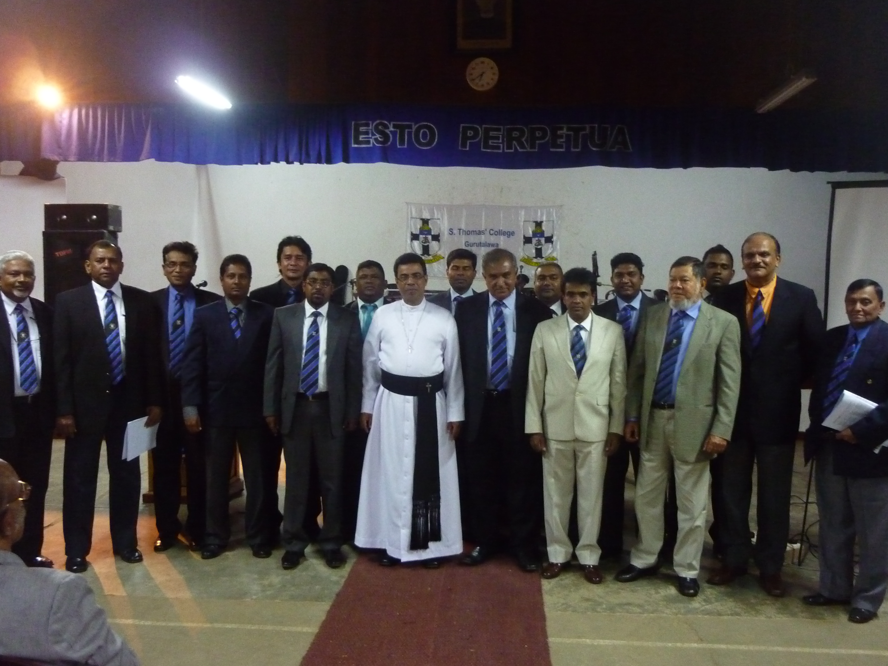

212. STC Mt. Lavinia OBA has sent us the following e mail on January 01, 2014

Old Boys’ Association
S. Thomas’ College, Mount Lavinia

E-mail: stcmloba@sltnet.lk Website: www.stcmloba.org
Telephone:-2727607/ 4955047
Hony.President Vice President Hony.Secretary Hony.Treasurer
Prof. Indra De Soysa Rev.M.Billimoria Dilshan Jayasuriya Shanil Jayasekera

“Dear Fellow Thomians,

On behalf of the President, Vice President and other Office Bearers of the STC OBA, I wish to extend to all our Members Warm and Sincere New Year Greetings for a fabulous 2014. Also, I wish to express my sincere gratitude to each and everyone of you for having supported all our projects and endeavours launched during the past year. The success of the said projects depended largely on the willing patronage extended to us by a large majority of our loyal Old Boys. As it is clearly evident College is doing extremely well in all spheres, under the able guidance and leadership of the Warden and the Sub Warden. The OBA made every efforts to extend its support, guidance and encouragement to College at all times, particularly by organizing events to keep the Thomian fraternity together and to raise funds in the process for the futuristic Commerce Building Project.

Considering the critical role played by the OBA in assisting College in the past, the Ex-Co has launched an important endeavour to revise and/or amend the OBA Constitution, in order to enable the OBA to face the challenges of the future and also to be more dynamic and meaningful in its continuing efforts of assisting College into the future. The proposed New Constitution, whilst retaining the salient features of the present Constitution, seeks to address all inadequacies, ambiguities and shortcoming found in the present Constitution. The support and guidance of all the Old Boys in revamping the Constitution is much needed and appreciated.

The 2014 AGM of the STC OBA would be held on Friday, 21st February 2014 at the College Hall, followed by the Traditional Old Boys Lunch on Saturday, 22nd February 2014. The Notices relating to the above events would be sent in due course.

Best wishes for a fantastic new year,

Warm regards

Dilshan Jayasuriya
Hony. Secretary
STCML OBA”

CORRESPONDENCE – 2013

211. Peter Weerakoon has sent us the following e mail on December 31, 2013

“-------Original Message-------

From: Webmaster - STC OBA (Australia)
Date: 31/12/2013 11:55:21 AM
To: undisclosed-recipients:,
Subject: BETTY CHAPMAN - FUNERAL SERVICE DETAiLS

Further to our recent notice to members of the death of Mrs Betty Chapman, we now provide details of the funeral service, which appeared in the Herald Sun Obituaries.
CHAPMAN. Family and friends are invited to attend the Funeral Service for Astrid Verna Elizabeth BETTY Chapman to be held at St James the Great Anglican Church, 68 Pender St, Thornbury on FRIDAY (Jan. 3, 2014) at 10.30 a. m. Following the Service, the Cortege will proceed to Warringal Cemetery, Cedars Lawn, entry via Darebin St, Heidelberg for burial. No flowers by request. In lieu, donations to the 80 Club would be appreciated. Envelopes will be available at the Church
--
STC OBA (Australia)
PO Box 2337
Mt Waverley, VIC 3149
Australia.
www.STCOBAaust.org.au”

210. Don Gazara has sent us the following e mail on December 31, 2013

“Stelanbosch, Cape Town, SA

H N year Lakshman,

Tks for all the mail for the past year. !!

Regds

Don Gazara”

209. Peter Weerakoon has sent us the following e mail on December 30, 2013

“This is to inform you that Betty' Chapmen's funeral service will be held on Friday the 3rd January 2014, at 10.30 Am, at St James the Great Anglican Church Corner of Pender and Newcastle Street. Thornbury .
Cemetery details into tomorrows Herald Sun

Peter Weerakoon”

208. Merril Aluwihare has sent us the following e mail on December 28, 2013

“We regret to advise members of the death on 26th December 2013 of Mrs. Betty Chapman, widow of the late Mr. A. Kilto Chapman, former Headmaster of S. Thomas' College Gurutalawa, and mother of Anthony. Betty is also the sister of Dermot Claasz, a member of STCOBA Australia Branch in Melbourne, and David who resides in Sri Lanka.
Betty was also the sister-in-law of Mrs Rowena Cook; and of Dr. Ben Chapman and Mr Ivor Chapman, both members of STCOBA Australia, Melbourne.
For many years Betty sang in the STCOBA choir at our annual carol service in Melbourne.
Our deepest condolences go out to all members of Betty's family.
Funeral details are not known and will be notified later.
--
STC OBA (Australia)
PO Box 2337
Mt Waverley, VIC 3149
Australia.
www.STCOBAaust.org.au

From: stcobaaust.webmaster@gmail.com [mailto:stcobaaust.webmaster@gmail.com] On Behalf Of Webmaster - STC OBA (Australia)
Sent: Friday, 27 December 2013 6:33 PM
To: undisclosed-recipients:
Subject: FUNERAL DETAILS - MR MAHES FERNANDO

We advise funeral details of STCOBA Australia's Treasurer, Mr. Mahes Fernando:
Viewing: 11.45am to 12.30pm at Boyd Chapel, Springvale Botanical Cemetery on Monday 30th December 2013 followed by a funeral service at the same venue from 12.30pm to 1.30pm and then the burial service.
After the funeral service and burial, there will be a wake at 3.00pm at St. John Vianney's church.
--
STC OBA (Australia)
PO Box 2337
Mt Waverley, VIC 3149
Australia.
www.STCOBAaust.org.au”

207. STC Gurutalawa OBA has sent us the following e mail on December 27, 2013

“OBITUARY
We regret to advise members of the death on 26th December 2013 of Mrs. Betty Chapman, widow of the late Mr. A. Kiltore Chapman, former Headmaster of S. Thomas' College Gurutalawa, and mother of Anthony.
Betty & her son Anthony established a Scholarship Fund for the award of two scholarships to the best 2 Science Students of the Upper School & Middle School of Gurutalawa and these are awarded annually in memory of the late Mr. A.K.Chapman.
Betty is also the sister of Dermot Claasz, a member of STCOBA Australia Branch in Melbourne, and of David Claasz, who resides in Sri Lanka and is a member of the OBA Gurutalawa.
Betty was also the sister-in-law of Mrs Rowena Cook; and of Dr. Ben Chapman and Mr Ivor Chapman, both members of STCOBA Australia, Melbourne.
Our deepest condolences go out to all members of Betty's family.
S.Thomas’ College Gurutalawa OBA.
27th December 2013”

206.Bandu Wanigasekara has sent us the following e mail on December 26, 2013

“Just received the sad news of the passing away of Mrs. Betty Chapman, a benefactor to our OBA, wife of late Mr. A.K.Chapman, Senior Master & Acting Headmaster STC Guru. ======= She was ailing for sometime.
From: peterweerakoon@optusnet.com.au
Date: 26/12/2013 5:47:29 PM
To: president@stcobaaust.org.au; Lawton Chris
Subject: Mrs Betty Chapman
This is to keep you informed that Mrs Betty Chapman, wife of late A Kiltore Chapman and mother of Anthony and sister in law to Dr Ben Chapman, Ivor Chapman and Rowena Cook and brother of David Claasz of our OBA, passed away today at 4. 30 pm at a private Nursing home. Funeral arrangements will be notified later.
Please advise membership via web site.
Thank you
Peter Weerakoon.”

205. Roger Aldons has sent us the following e mail on December 26, 2013

“Dear Lakshman/Eddie,
Forwarding email with the sad news of the passing of Mrs Betty Chapman (nee Claasz) for your information.
Best wishes & warm regards,
Roger

From:
Sent: Thursday, 26 December 2013 07:41 PM
To:
Subject: Fw: Mrs Betty Chapmen
-------Original Message-------

From:
Date: 26/12/2013 5:47:29 PM
To:
Subject: Mrs Betty Chapmen

This is to keep you informed that Mrs Betty Chapmen, wife of late A Kilto Chapmen and mother of Anthony and sister in law to Dr Ben Chapmen, Ivor Chapmen and Rowena Cook passed away today at 4. 30 pm at a private Nursing home. Funeral arrangements will be notified later.

Please advise membership via web site.
Thank you
Peter Weerakoon.”

204. Muditha Dissanayake has sent us the following e mail on November 26, 2013

Dear Mr. Jayatilaka,

The AGM and the Reunion weekend will be held on the weekend starting on 21st February 2014. Please add this date to the calendar on the 62 group home page when you get a chance. The full details will be available shortly.

Regards,

Muditha

203.Muditha Dissanayake has sent us the following e mail on December 20, 2013

Thank you,

I have updated accordingly,

Regards,

Muditha

202. Erasmon Saldin Has Sent Us The Following E Mail On December 19, 2013

“Dear Lakshman,
Thanks for the directory. It is great.
As for me you could add/amend the following:
I was at Guru from 1953 to 1956
At Mount Lavinia from 1956 to 1958
My occupation is : Chartered Accountant
Finally best wishes for a Very Happy 2014
Best regards
Erasmon Saldin”

201. Muditha Dissanayake has sent us the following e mail on December 16, 2013

“Dear Mr. Jayatilaka,

Please find the attached minutes of meeting of the meeting held at Gurutalawa in October. We had a meeting last Sunday but the minutes are not available yet.

Regards,

Muditha”

200. STC Gurutalawa OBA has sent us the following e mail on December 13, 2013

“Dear Old Thomians,

It is with much sadness we bring to your notice the demise of Mr.
Wickremasinghe Anura Shantha. (Old Boy of STC Gurutalawa)

The Old Boys' Association expresses our deepest condolences to the late Mr.
Wickremasinghe's family.

The remains lie at Siriniketha Kiriwattuduwa, Homagama. Funeral will take place tomorrow (14th Saturday) at 2 pm.

For more information please call Mr. Athula Thalagala on 0771053562

Old Boys' Association of S. Thomas' College at Gurutalawa”

199. Muditha Dissanayake has sent us the following e mail on December 02, 2013

“Dear Mr. Jayatilaka,

Thank you for the update. Your homepage says February 21,22,23 2013.

Please can you correct it when you get a chance. Although I'm sure everyone will understand its a typo.

Regards,

Muditha”

198. Muditha Dissanayake in an e-mail of November 26, 2013 writes:

“Dear Mr. Jayatilaka,

The AGM and the Reunion weekend will be held on the weekend starting on 21st February 2014. Please add this date to the calendar on the 62 group home page when you get a chance. The full details will be available shortly.

Regards,

Muditha”

197.Muditha Dissanayake in an e-mail of November 26, 2013 writes:

“Dear Mr. Jayatilaka,

Thanks for the photo. It is good enough for me (Quality).

I've noticed that you have uploaded all the photos. I am still waiting for a copy of the same to go on the OBA website.

Regards,

Muditha”

196. STC Gurutalawa OBA in an e-mail of November 25, 2013 writes:

“Obituary - Kurukulasooriya A M

Dear Old Thomians,

It is with much sadness we bring to your notice the demise Mr. Kurukulasooriya Asoka Malraj (1964-1967 Gurutalawa, 1968-Mt Lavinia, Staff Gurutalawa 1972-76)

The Old Boys' Association express deepest condolences to his family.

The remains lie at Jayaratne Funeral Parlour, Kalubowila. Funeral will take place today at 4 pm.

Old Boys' Association of S. Thomas' College at Gurutalawa
http://caughtbehind.us5.list- manage.com/track/click?u=925b1bbc9ec634eabec5c1b2c&id=3c08e4d8f6&e=ec7ba97dc5”

195. Roger Aldons in an e-mail of November 24, 2013 writes:

“Dear Lakshman,

Thanks for the email and links to photos, etc. The photos are great, but how about the photographer including the name(s) of the subjects as a ‘footer’ caption on each shot. It should be possible in this day of improving technology and will make the photos all the more meaningful to those of us abroad who may not identify old school mates after 50 or so years apart!

I hope you can please take up the suggestion with the photogparher.

Warm regards,

Roger “

194. Muditha Dissanayake in an e-mail of November 22, 2013 writes:

“Dear Mr. Jayatilake,

Thank you for this. And thanks for updating the website so quickly. By any chance do you have a high quality image of the attached ? If so can you email me please.

Ziard is meeting me tomorrow with some more photographs and I will make them available to you via a downloadable link. Hope you enjoyed the night. What's the feedback like from your guests? I had to leave early but I'm told the party went on till the early hours.

Regards,

Muditha”

193. Brian Wickremasinghe in an e-mail of November 20, 2013 writes:

“1958 to 1962. Then I should remember him, unless he left in 1961, which was the year I joined. Dimbulane does not ring a bell. Probably he should be in his mid sixties.”

192. Don Gazara in an e-mail of November 13, 2013 writes:

“Dear Prabhu,

I join Lakshman in thanking you for this great birthday celebrations you organised so well for your
Father.

I am, with the rest if humbled by this evening.The family is the pivot of us all.please ask your Appa to try and come for this week ends old boys dinner .

Lakshman,

As always, a pleasure to see you and I thank you for the mail and photos

Don”
191.Thomian Society of Colombo in an e-mail of November 12, 2013 writes:

“Thomian Society of Colombo
invites you to
‘Christmas in the Air-2013’
On 29th November 2013 from 7.30pm onwards
@ Grand Oriental Hotel

Tickets available @ GOH reception.

++++++++++++++++++++++++++++++++++++++++++++++++++++++++++++++++++++++++++++++++++++
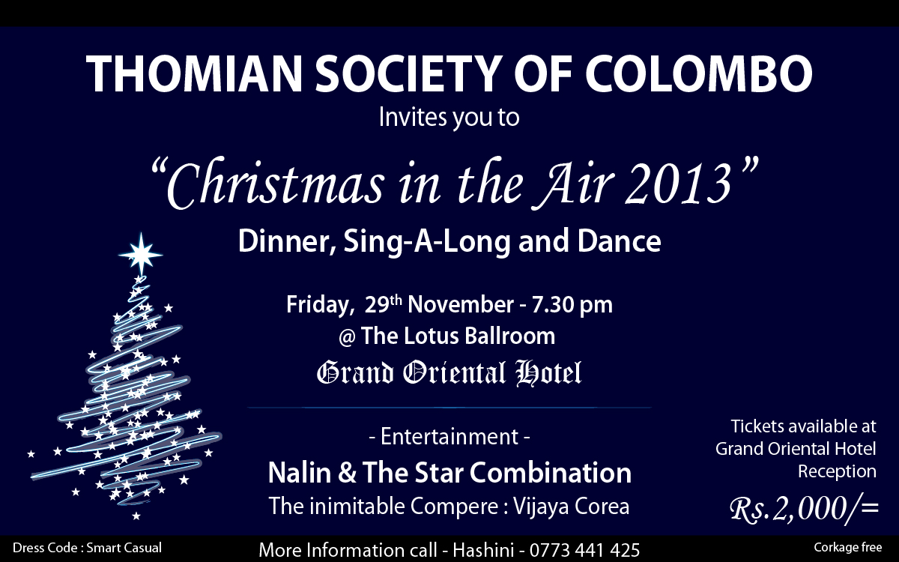

190. Roger Aldons in an e-mail of November 04, 2013 writes:
“Hi Lakshman!

Just a small correction on the site:
a) STC Mt. Lavinia Choral Even Song -August 05, 2013 – Evensong is the correct spelling – i.e. one word.
Kind regards,

Roger”

189. S. Prabhu Son, of T. Sunderaraj (STC Guru 1955 -1961) in an e-mail of November 04, 2013 writes:

“Dear Uncle ,

I am Prabhu Sundararaja ( Junior Kalle) , Sundaraja,s Son or known to you all as Kalle at Bandarawela and Guru. As almost all of you are my Appa,s age i think i need to explain little bit more to place him well.
He was at Reeds Dorm at Guru , Hockey , Cricket Player , caught eating Punnakku which was kept for Pigs Dr Mrs Hyman gave him opening dose and then treated him at cargills , and yet to taste Alcohol , etc ....

My father after his planting at Black wood estate , Haputale , moved to Colombo. My sisters and i have settled in Colombo.
We live in Kalubowila now. Next to the Vishnu Temple.

Appa was not well , and had to admit him to the Hospital for Endoscopy and Colonoscopy as his haemoglobin has drastically dropped.
Now he is back at home , fit as we transfused two paints of Blood. Back to normal kalle .......

Appa is turning 71 on Nov 11 th and we children thought that we will organise a surprise Birth day party.
Or shall we call it a re union of the Batch mates.

Over the past 30 years or more from the time we can remember well , your names have been spoken regularly and the bad or the naughty things you all together have committed. We in the Family also want to see your faces.
I must say truly that he has never spoken any good things that you all have done together. ha

We will meet at my sister,s residence Nov 10 , 2013 Sunday at 61 /3 , 4 th lane Woodlands mawatha Kalubowila.

This is a surprise party and we don't want appa to know about this and request you all not to call home and tell him anything .

Also want to make this more of a re union of your Guru and B wela friends of the Batch.
I will be mailing and calling each one of you personally and hope you will be able to come on Nov 10 th at 7 Pm . I am sorry this informed to you in short notice as we were waiting till Appa came home from the Hospital ( Nov 3 rd ) . I am also mailing the friends who are in out station and in case you are planning to be in Colombo on Nov 10 th will be glad to have you in the re -union.

Please come with your Wife or even with your partner. ( male or female is accepted as we all are Thomians)

The friends and Batch mates we have got names are as follows.
Sydney Abeykoon , Nalin Abeysekera , Lakshman Amunugama , Anver Chatoor , W,S,Atygalle , T.R. Brigdge , Prakash Butani, Zubair Gaffoor , Chandramohan , Radhakrishnan, Shantha Dimbulana , N.L.Fernando , Ananda Gallearachi , Walter Gammampillai , Don Gazara , A.M. Gunaratne , Harath Chandrasiri , Seneka Horadagoda, Illapperuma , Lakshman Jayatileka , Uplai Jayawardena , Gamini jayawardena , Jabir Junaid , R.Mahawaduga , B.A Mahipala , Junair Marikkar , Ana madonza , Asgar mihilar , B Munasinghe , Anura Nilaweera , Nihal Nilaweera K.K. Perera , N.G.T. rajapakse , S.N.Rodrigo , Siva Selvaratnam , Sarath Suraweera , N.D. Kurutumpala , Sanath Jayathileka , Dr Ranjith Weerakoon , Sumith Samayadasa , Ranjith De silva.

As we see quite a lot of Muslim friends we will definitely see that Chicken is Halal.
We are planning a cock tail and Indian Food for Dinner . Any preferences , pls do let us know and we will try to accommodate your request if possible.

Please be kind enough to confirm with us so that we can organise the catering and other preparations.

best regards

Junior kalle.
0773215333

*S.Prabhu*

23 Anderson Road
Kalubowila
Sri Lanka
Mobile No : 0094 773 215333
Skype : prabhu.emar”

188. Ananda Amaranath in an e-mail of November 04, 2013 writes:

“Dear Lakshman , Many thanks for the photos.They have come out great!
I was a nice party and get togeather.
Regards, Ana.”

187.Sriyan jayasekera in an e – mail of August 12, 2013 writes:

“To The DSA Era Group.
This is to inform you the following sad news.
1. Death of Jayampathi Bandaranayaks' both parents.
Private funerals were held. His E-mail-jdb134@gmail.com
For more details http://www.tyretracks.com/showthread.php?t=1089
2. Death of Lanka Nesiah.
Passed away in London.
E-mail- Nagulan Nesiah <whoopinag@yahoo.com>
For more details http://www.tyretracks.com/showthread.php?t=1086
3. Death of Gamini Jayasuriyas' father at Padukka.
His E-mail - gamini@lalanrubber.com
For more details http://www.tyretracks.com/showthread.php?t=1088

4. Death of N.T.Perera
Brother of the late N.T & J.K.Perera, P N Perera passed away yesterday. His funeral will be tomorrow(13th August 2013) at Mt Lavinia Cemetery. The remains will be at Mahinda funeral parlour from today onwards.
E-mail of J K Perera - jkperera@sltnet.lk
For more details http://www.tyretracks.com/showthread.php?t=1090
May they attain the Bliss of Nibbana!
kind regards
Sriyan
on behalf of The Prefects Group & The DSA Era Group”

186.Dulip de Alwis in an e – mail of August 12, 2013 writes:

“To all Thomian Society members

Dear Members ,

T S O C FAMILY OUTING – 15th September 2013

The Thomian Society Ex Co has arranged a family outing for all members, we would like to have many members with your families to join and if you have any Thomian friends who are not members could also join.
Attached please find the family outing flyer to LAYA BEACH WADDUWA.
We look forward for your participation.

Best Regards

Dulip de Alwis
Hony Secretary
T S O C”

185. Dulip de Alwis in an e – mail of August 14, 2013 writes:

“Hi Lakshman!

I am sure you must be aware of this information, but am forwarding the emails copied below just in case you and others from Guru were not informed.

Thanks and kind regards,

Roger

Roger Aldons
ACCESS DOWNUNDER
10 Buldah Street
Dandenong North Vic 3175
Australia
Phone: (61-3) 9701 1862; Fax: (61-3) 9701 1863

184. From: nagulan nesiah [mailto:nesiah@gmail.com]
Sent: Wednesday, 14 August 2013 09:18 AM
To: sangeetha nesiah; nagulan nesiah
Subject: Lanka Nesiah service information

Dear Friends,
Further to our email yesterday, the body of Lanka Nesiah is laying in state at W.Sherry Funeral Home, 87 Greenford Avenue, Hanwell, W7 1HA. A public viewing has been arranged from 4-5pm on Thursday, 15 August 2013. A private service of cremation for immediate family will be held the next day.
The funeral service will be at 6pm on 24 August 2013 at the Chapel of Transfiguration, S. Thomas’ College, Mount Lavinia, Sri Lanka. A private service of the burial of ashes will be held in Jaffna later in the month.
In lieu of flower or gifts, donations, if desired, can be made to the Lanka Nesiah Memorial Fund c/o the Diocese of Colombo, 368 Bauddhaloka Mawatha, Colombo 00700, Sri Lanka. The fund will be designated towards need-based scholarships for students at S. Thomas’ College, Gurutalawa, Sri Lanka. Lanka Nesiah’s first job, 54 years ago, was as a teacher at S. Thomas’ Gurutalawa.
Thank you,
Sangeetha & Nagulan

---------- -------------------------------------------------------------------------------------------------

183.
From: Lanka Nesiah <lmnesiah@gmail.com>
Date: 11 August 2013 15:11
Subject: Lanka Nesiah - Resting in Peace
To: Nagulan Nesiah <whoopinag@yahoo.com>
Dear Friends,
A few hours ago, at 3pm local time, Appa passed away in the Oncology ward at Charring Cross Hospital in London. He was admitted 5 days ago, when he suddenly needed more intensive nursing care. Until that time, Appa (and Amma) were living with, and under the care of Sangeetha and family in Ealing.
We regret that you are receiving this mass email but we do not have the strength to communicate this sad news to you individually and privately, as we would ideally have liked to do. We also are not able to offer the courtesy, in this short term, of responding to your emails and returning your phone calls. We rest assured of your generous thoughts and prayers since Appa was diagnosed with lung cancer in October, but particularly during the last few weeks when Appa’s condition rapidly deteriorated, and during the next few difficult weeks as we figure out life without him.
As you all know, Appa fought hard over the past 10 months and continued to live his life with vigor and joy. He was our source of strength until this last day. But in the end, since we learned of the metastases to the brain in mid-July, the fuel to fight began to run out. We like to think that Appa didn’t give up, but that, in his signature style of thinking of the rest of us, decided to leave us with the happier memories.
As per his wishes, Appa will be cremated here in London, and we anticipate having his funeral at the S. Thomas’ Chapel in Mount Lavinia sometime before the end of August. We shall keep you updated.
We thank you for your support.
Love,
Sangeetha & Nagulan (on behalf of Amma as well)

p.s. Please feel free to forward this email.”

182. Dilshan Jayasuriya, Secretary of STC Mt. Lavinia OBA in an e – mail of August 13, 2013 writes:

“

Old Boys’ Association
S. Thomas’ College, Mount Lavinia

E-mail: stcmloba@sltnet.lk Website: www.stcmloba.org
Telephone:-2727607/ 4955047
Hony.President Vice President Hony.Secretary Hony.Treasurer
Prof. Indra De Soysa Rev.M.Billimoria Dilshan Jayasuriya Shanil Jayasekera

Dear Fellow Thomians,

I take pleasure in announcing that the "Thomian Nite" Dinner Dance would be held on Saturday, 21st September 2013 at the Hilton. Tickets are selling fast and any Member desiring to purchase tickets may contact the OBA Secretariat (Tele:0114955047) for further information before 24th August2013.

Thank you,
Yours sincerely,

Dilshan Jayasuriya
Hony. Secretary
STCML OBA”
181. Ziard Sinnen in an e-mail of June 12, 2013 writes:

“Dear Lakshman,
Many thanks for this,family outing photos have been uploaded on the fb group.
Shall send the originals through somebody to be uploaded on 62group.

Kind regards

Ziard

Ziard Sinnen- Senior Manager
International Airline Services (Pvt) Ltd
G.S.A for Virgin Atlantic Cargo-Colombo
Email: ziard@virgincmb.com
Mobile: +94 777 420 191
Tel: +94 11 2573881
Website: http://www.virgin.com/cargo”

180. P. S. Duleep Kumar in an e-mail of May 31, 2013 writes:

“As a thomian who went through the Gurutalawa hibernation during the war I likethis story.At that time with Dr.hayman and Canon foster in charge we were the beat school in Ceylon if not the World.? so I think!!”

179. Ziard Sinnen with an e-mail of May 30, 2013 sent us the following:
“How does one convert a ordinary fast bowler to a 'World's Best Spinner'.
Answer: You get him to play against S. Thomas' College at Gurutalawa
Read the story below
https://groups.google.com/forum/?fromgroups#!topic/rec.sport.cricket/NUskx2RilYs
[Article] A Quality Fast Bowler - Google Groups
groups.google.com

178. Peter Weerakoon in an e-mail of May 27, 2013 sent the following:

“-------Original Message-------

From: Webmaster - STC OBA (Australia)
Date: 05/27/13 17:59:13
To: undisclosed-recipients:,
Subject: THOMIANA VOLUME 17 ISSUE 1, MAY 2013

We have pleasure in attaching the latest copy of Thomiana. We regret the long delay in sending you this edition.
In view of the lateness of this issue, the next three editions will be published on or around 31st July 2013, 31st October 2013, and 15th January 2014, and not at the end of each calendar quarter.

--
STC OBA (Australia)
PO Box 2337
Mt Waverley, VIC 3149
Australia.
www.STCOBAaust.org.au”

177. Muditha Dissanayake in an e-mail of May 13, 2013 writes:

“Dear Mr. Jayatilaka,

Please find the minutes of the meeting no 02 of the STCG ex co.

Regards,

Muditha”

176. Vidiya B Ratnayake in an e-mail of May 13, 2013 writes:

“Thank you for the invitation however living in Spain makes it difficult to attend.
Have wonderful day!
Very best wishes
Vidiya B Ratnayake”

175. R.Sandanakrishnan in an e-mail of May 11, 2013 writes:

“Dear Rev.Sir,

Thanks a lot for your mail. We will circulate among our old boys.

With Best wishes

R.Sandanakrishnan”

174. Rev. Marc Billimoria the Sub Warden of STC Mt. Lavinia in an e-mail of , May 10, 2013 writes:

“Gentlemen,

I wish clarify that while this event is primarily organised in order to celebrate the historic links between what was once the two campuses of the one School - Gurutalawa and Mount Lavinia - so that the present boys of Mount Lavinia will never be allowed to forget that Gurutalawa sheltered STC during the War and the legacy of Dr Hayman and Fr Foster, ALL members of the wider Thomian family, that of course includes our schools at Kollupitiya and Bandarawela, [that were Mr Keble's gifts to us] are welcome to join the celebration - after all we do belong to each other. Thus our brother old boys of Kollupitiya and Bandarawela who would like to attend are more than welcome.

The finalised programme is

7.40 a.m. Thanksgiving Service - Preacher: the Revd Dushantha Rodrigo, former Chaplain of Guru and Actg Warden of Mount
8.40 a.m. Special Assembly - Chief Guest and keynote speaker: Mr S K Wickremesinghe, a pioneer Guru Thomian
9.30 a.m. onwards the inaugural U17 cricket encounter between STC Guru and STC Mount for the Hayman-De Saram Trophy presented by Mr Krishantha Weerawardene. Guru and Mount old boy Mr R Renganathan will be chief guest at the award ceremony.

See you on the 17th.

Best regards

Marc Billimoria”

173. Peter Weerakoon from Australia has sent us the following e mail on May 01, 2013

“Lucky, this might be of interest to you. I was seven years old and in Kalutara at that time where my Dad was ASP. I saw the planes in the distances like birds,ad as ,my younger sister was crying I was Showing her birds flying in the distance. until my dad,s return without, Mum from Easter Service, at St John's and ordered the servants and both me and my little sister into the Trench in the Garden, the birds were in fact Jap planes flying near the horizon ,He donned his uniform and left with a Kiss to me and my younger sister. Mum And my other three siblings,namely Yvonne (Akki), Ronnie and Brad arrived from church after the all clear was sounded. No bombs fell anywhere near us. We were of course sent off from near Kalutara town to a Small Rubber Plantation owned by one of my Dads friends, in a place called Megaha tenne.

Gututalawa Branch was then opened as Mount became a military Hospital and both my Brothers Ronnie and Brad were the pioneers of Guru, sometime after this my Dad was promoted and transferred as SP UVA province.

Enjoy.
Peter”

172. R.Sandanakrishnan of STCBW has sent us the following e mail on April 30, 2013

“Dear Lakshman

Thank you for your assistance.

We are undertaking another Major Project “ Laying Wooden Badminton Courts for the SLA Ratnayake Memorial Indoor Stadium” – Project cost is estimated Rs 3.00 million including repairs to the roof.

Our next events are
1- Inter Batch Cricket Sixes in June 2013 in Colombo.
2- Career Planning & Guidance for GCE(A/L) Students in July 2013 in Bandarawela

The AGM will be in a different note from this year. We will have a system of “calling for nomination”. We will be able to build a strong team to lead us in future.
Annual STC Bandarawela OBA Week end is from 16th August to 18th August in Bandarawela “ Back to College- No tears this time”
AGM will be held on 17th August – Saturday at 10.00 am in W.T.Keble Memorial Hall

We wish to see you in our events. Please plan to be there for the AGM this year.

Thanks a lot once again

Warm Regards

R.Sandanakrishnan
STCBWOBA”

171. Muditha Dissanayake in an e-mail of April 02, 2013 writes:

“Dear Mr. Jayatilaka,
Thank you for the email and web update. The next ex co meeting will be held on the 21st (not confirmed yet). I will be out of the country briefly so will have some updates later this month. Also I will have more news re the family outing.
Wish you and the family a very happy sinhala new year.

Regards,
Muditha”

170. Brian Wickremasinghe in an e-mail of April 01, 2013 writes:

“Hi Lucky,
We met last Saturday to celebrate the 86th birthday of Mr. Pillai. This is a picture of the Guru old boys from left to right,
Mahendra. U. Liyanage, Dr. Milroy Fernando, Dr. Bharath Kumar, Mr. George Pillai, Dr Shankar Sundaram, Brian Wickramasinghe and Ajith Munasinghe. They were all of Dr. Haymen/ Fr.Foster era. We are what we are thanks to the great institution and the staff that molded us.
Hope all is well with you and the family.
Regards, Brian.”

169. Muditha Dissanayake in an e-mail of March 29, 2013 writes:

“Dear Mr. Jayatilaka,

I am forwarding the below email from Fr Nihal. Please update the 62group website with the news and events mentioned.

Regards,

Muditha”

---------- ----------------------------------------------------------------------------------------------

168. From: Headmaster S. Thomas' College at Gurutalawa <hmstcguru@gmail.com>
Date: Thu, Mar 28, 2013 at 4:55 PM
Subject: Re: School Calendar
To: Muditha Dissanayake <mudithaa@gmail.com>
Dear Muditha
The annual swimming meet and Avrudhu Ulela (New year celebrations ) will be held on 05th of April 2013.The school closes on the 06th of April and reopens on the 05th of May 2013.
Etisalat company conducted "web Patashala programme",an awareness programme for the students as how to make use of the web to educate themselves.This was conducted for the parents as well.It was held on the 18th of March 2013.
Our students took part in the zonal athletic meet and secured third place.
Our school is organizing an art competion with the collaboration of Seylan Bank,welimada and invited all the schools in the Uva province to take part in the competion.The final exhibition and award ceremony will be held at STC Guru in May 2013.

I could not trace the information provided by Vinod regarding the web site.
Esto perpetua!
Fr.Nihal Fernando
On 28 March 2013 14:09, Muditha Dissanayake <mudithaa@gmail.com> wrote:
Dear Fr Nihal,
Hope you are well. I remember you said the swimming meet will be held at the end of the term. Can you please send me details so I can update Mr Jayatilaka (for stcg62group site) and other social media. also if there are any other events please do send them so I can do the same. When does the College close for April vacation and when will it re-open?
Did you manage to find the document which Vinod emailed with the login details to the website?
Regards,
Muditha

167. Merril Aluwihare in an e-mail of March 28, 2013 writes:

“Hi ! I am sure you all remember Bala .He was an outstanding athlete and was also head prefect at STC. He was chief guest at the match on 24/3/13.”

166. Bandu Wanigasekara in an e-mail of March 28, 2013 writes:

“The resolution on the Hayman/Foster/Chapman Schol Funds is not relevant to the OBA Rules but only needs full implementation by the new Ex-Co as outlined in the resolution.
Hope it will be done by requesting the Hayman Trust Committee to invest the Money in the Commercial Bank account. (The Hayman Trust has two Accounts).
Kind regards
Bandu”

165. Bandu Wanigasekara in an e-mail of March 17, 2013 writes:

“Dear Lucky,
Since I was not present at the AGM, I think you will have to get fuller details from the Secretary, instead of indirect confirmation. I know the Secretary is slow to re-act, but he must confirm for authenticity.
The first one is a replacement & the second is an addition to the Rules - so no problems there.
But the third is amendment in part and the clause should be amended as:
......................... and which fee is Rs.1500/= effective 16th February 2013. (The last lines only).
Kind regards
Bandu”

164. Muditha Dissanayake in an e-mail of March 15, 2013 writes:

“Dear All,

Mr Zulfiquar Junaideen of 1996 (O/L) batch sent me the following details to be updated on the directory.

Mohamed Zulfiquar Junaideen,
Zulfiquar Manzil
16, Uva Ben Head Road,
Welimada.
Mob: +94-775-580580 (Sri Lanka)
Mob: + 973-39471590 (Bahrain)
E-mail: zulfiq4@yahoo.co.uk

Regards,

Muditha”

163. Muditha Dissanayake in an e-mail of March 15, 2013 writes:

“Dear Mr. Jayatilaka,
Thank you for responding so quickly. I shall wait for confirmation from Mr. Bandu Wanigasekara.
Regards,
Muditha”

162. Don Gazara in an e-mail of March 15, 2013 writes:

“Lakshman

at the end of a v heavy day- though intertesting- yur mail re Duleepkumar's speech is very 'reminding'.

Lone was here- feel v sad with the current values etc

don”

161. Bandu Wanigasekara in an e-mail of March 15, 2013 writes:

“Dear Lucky,
Relevance of this to Guru ??
This is an achievement Guru can be Proud of New Secretary of JSC assumes duties .
Is he a Guru Old Boy - what years ?
Though sometimes in the current context of appointments by Fiat not merit - I wonder if it is indeed something to be proud about. May be I am Old School !!
Kind regards
Bandu”

160. Ranjit Jayesingha in an e-mail of March 15, 2013 writes:
“Dear Lakshman,
Thank You very much for this useful information. Trust you and your family are keeping well.
With warm regards,
Ranjit Jayesingha (ERV in Cambodia)”

159. R.Sandanakrishnan in an e-mail of March 14, 2013 writes
“Dear Lakshman,

Well done, very informative.

Please continue your good work. We highly appreciate your contribution towards the Thomian Family.

Warm Regards

R.Sandanakrishnan
STCBWOBA”

158. Athula Talagala in an e-mail of March 13, 2013 writes

“My dear Laxman
We really appreciate your duly updates about college & us, pray for more strength to you for future.
Would like to add another STCG past pupil achievement - who was appointed as Secretary of the Judicial Service Commission with effect from 1st February 2013.He was in our batch (1973) & was from Idalgashinna Haputale.
If there is a possibility please include is appointment in your next circular.
Warmest regards
Athula Talagala”
157. Muditha Dissanayake in an e-mail of March 13, 2013 writes

“Dear Mr. Jayatilake
Please find below the OBA sub committees and the members assigned to those sub committees. Please note the dates mentioned are not confirmed as yet
Fund raising - two events
Familty Outing in May or early June
Athula K - Chairman
Upul Jayawardana
Ajith Jayatilaka
Dayabaran
Chandimal Ranathunga

Dinner Dance - September
Ziard Sinnen - Chairman
All ex-co members to be involved as this is the main fund raising event

College Infrastructure Development
Jagath Ravisinghe - Chairman
Ajith Jayatilaka
Muditha Dissanayake

Education/Sports Development
Muditha Dissanayake- Chairman
Dimuthu Tennakoon
Upul Jayawardana

Membership
Muditha Dissanayake - Chairman
Srinath Dodanwela
Chandimal Ranathunga
FYI, below are the coopted members, but I am told that some of them haven't given their consent yet so the below may change in the next meeting.
MDH Perera
Milinda Hettiarachchi
Bandu Wanigasekara
Nihal Wanniarachchi
Dayabaran
On another note, Ziard asked me to liase with you and ask your help for updating the OBA rules as there were resolutions which were carried forward at the last AGM. I will forward you the AGM notice email which had the resolutions. Is that all you require to update the OBA rules. Can you please advice.
Regards,
Muditha”

156. Muditha Dissanayake in an e-mail of March 13, 2013 writes

“Dear Mr. Jayatilaka,
I am sending you the new membership application (as the membership fees are now increased to 1,500).
Please replace the application form on your website with the attached.
Regards,
Muditha”

155. Quintus de Silva in an e-mail of March 12, 2013 writes:
“Thankyou for the news letter. I am QUINTUS DE SILVA who was in Gurutalawa from 1950-54. Bandu Wanigasekera, amongst others , was in my group. I plaed 1st 11 football for College, along with Bandu. Bandu contacts me whenever there is OBA of STCG, but unfortunately I have not been able to attend many of the functions, mainly because it is held out of Colombo. We who do not have vehicles of our own find it difficult to get cabs late at night. Even those who have vehicles have to be careful about driving at night, especially after a party, as the Police arrest those under the influence of liquor and the attendant problems. Why not have the STCG OBA in a hotel in Colombo. Recently there were 2 OBA’s at the Taj Samudra and was well attended. I hope you will please consider my suggestion as it would be great to meet all the guys from the past and it is always nice to have as many buddies as possible.
Best regards
Quintus de Silva
Email: qntsdesilva@gmail.com”

154. AHM Razeek in an e-mail of March 12, 2013 writes:

“Hi Lakshman,

YOUR MAILS ARE SENT TO MY CORRECT E MAIL ADDRESS. But, last one on circular 103, STCG was sent to my wife's e mail address. Ofcourse, she forwarded it to me.

Can you please delete my previous e mail address which is now used by my wife and have only my present e mail add in your list: ahmrazeek@hotmail.com

I think you still carry my old e mail address in your list where you send STCG 62 group circulars. All what I am requesting is to insert my present e mail address in your contact list which is : ahmrazeek@hotmail.com

Regards
Razeek”

153. PK William in an e-mail of March 12, 2013 writes:

“Please note that I no longer will be using this e-mail account. I have switched to Gmail. Please e-mail me at djpkwilliam@gmail.com
Thanks,
PK William, PMP, CSM
Sri Lanka # - +94 778 499 007
USA # - (571) 399 0126
View PK William, PMP, CSM's profile on LinkedIn”

152. Senaratne Wilmot in an e-mail of March 11, 2013 writes:

“Hi Lakshman,

Could you also include my contact details in this group (62 group) please. Details are as follows.

Thanks
Regards
KD
K.A.D. W. Senaratne
Quarantine Manager (Weed QC3) & Senior Experimentalist
Biosecurity Queensland
Department of Agriculture, Fisheries and Forestry
Level 3C West
Ecosciences Precinct
GPO Box 267, Brisbane, Qld 4001
AUSTRALIA
t: (07) 3255 4452
f: (07) 3846 6371
m: 0429470905
e: wilmot.senaratne@daff.qld.gov.au”

151. Bandu Wanigasekara in an e-mail of March 08, 2013 writes:

“Dear Lucky,
President should read Senior Vice President
Rgds
Bandu below”

150. Padma Salgado in an e-mail of March 08, 2013 writes:

“Hi Lakshman,

My gratitude for your posting and it’ll definitely help us to keep touch with our Guys….
Also, where’re those Pics. of OBA held recently…..? Pls. make arrangements to post them, too…
Thank you..!
Padma Salgado

Ps: Pls. pick my latest picture clicked during 2013 winter in Toronto, Canada”

149. Muditha Dissanayake and Ziard Sinnen have in e-mails of March 07, 2013 Written:

“Came across this article by Milinda Hettiarachchi on the etisalat RoyTho website. Thank you Milinda
http://roytho.etisalat.lk/royal-thomian-nexus-in-retrospect/
Regards,”

148. Ralph Amerasinghe and Ananda Amaranath both of Sydney in e-mails of March 02, 2013 have sent us the following clipping with regard to The Uva Thomian encounter:
“Uva Thomian’s encounter starts today

The annual Uva Thomian Cricket Encounter 2013 will be held today and tomorrow at Bandarawela Municipal Ground, starting at 9.00 a.m.
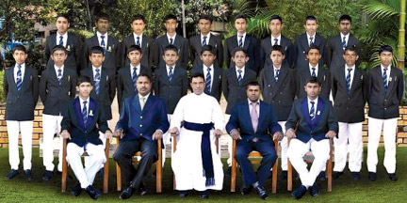
S. Thomas' College Gurutalawa team
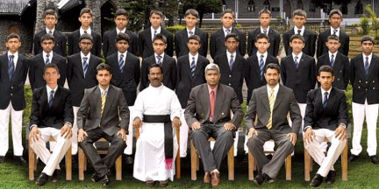
S. Thomas' College, Bandarawela team
S. Thomas' College, Bandarawela is captained by 4th year coloursman Nihanga Divantha Liyanage while S. Thomas' College Gurutalawa will be captained by 3rd year coloursman M.H.B. Dickkumbura.
The Uva Big Match fever was introduced to the up-country and thus began the annual fixture in 1984. Although many other schools in the region were involved in cricket matches, none of them were annual fixtures and they were never able to generate the kind of enthusiasm and excitement that is usually accustomed in Big matches. Although during this period leading schools in Colombo had already begun their "Big Matches" with the "Royal Thomian Encounter" taking centre stage, people from the up-country didn't have the privilege to witness such events and as a result the fixture between the two Thomian Colleges was most welcome.
As mentioned previously the "Battle" of the Blues as it was called in the 80's began on the March 24 in 1984 under the guidance of the late Headmasters Messrs S.L.A. Rathanayake from S.Thomas' College, Bandarawela and Patrick Gunawardena of S.Thomas' College, Gurutalawa .
The big match is played for the A.G. Gunasekera and Ratnayake challenge cup. Gurutalawa Thomian's won the big match in 2011 but narrowly lost by 24 runs in 2012.”

147. Muditha Dissanayake in an e-mail of March 01, 2013 writes :
“Dear All,
Ziard, Dimuthu, Dayabaran and Badurdeen are on their way to Gurutalawa tonight to represent Guru OBA at the UTCE tomorrow.
The toilet complex of Ilangakoon dormitory which underwent refurbishment will be opened tomorrow. This was funded by the OBA with the money raised from the Rhythm of the Blues Dinner Dance.
The ex-co also managed to acquire a sofa from Mr J A M Naleem of 1979 batch for the parents' room which underwent refurbishment recently with the generous donations from Mr. Razeek and his family.
Mr. Rameshan (Head Prefect of 1994) and his friends have donated a new cricket matting.
Finally, I'd like to remind you of the first ex-co meeting which will be held on sunday the 10th Match at Mr. AthulaKumaranayake's residence (174/8A, Nawala Road, Nugegoda - Start at 5pm).
Regards,
Muditha”
146. Mahendra Kalupahana in an e-mail of March 01, 2013 writes:

“Thank you Dimuthu,

Please kindly get drunk much as possible at the macth tomorrow.

regards,
mahen
On Fri, Mar 1, 2013 at 8:49 PM, Muditha Dissanayake <mudithaa@gmail.com> wrote:
Dear All,

Ziard, Dimuthu, Dayabaran and Badurdeen are on their way to Gurutalawa tonight to represent Guru OBA at the UTCE tomorrow.

The toilet complex of Ilangakoon dormitory which underwent refurbishment will be opened tomorrow. This was funded by the OBA with the money raised from the Rhythm of the Blues Dinner Dance.

The ex-co also managed to acquire a sofa from Mr J A M Naleem of 1979 batch for the parents' room which underwent refurbishment recently with the generous donations from Mr. Razeek and his family.

Mr. Rameshan (Head Prefect of 1994) and his friends have donated a new cricket matting.

Finally, I'd like to remind you of the first ex-co meeting which will be held on sunday the 10th Match at Mr. Athula Kumaranayake's residence (174/8A, Nawala Road, Nugegoda - Start at 5pm).

Regards,

Muditha”

145. Boo Khan, STC Guru in an e-mail of February 26, 2013 writes with regard to FazalCader:

“Very nice and we all are proud about him Lakshman

Khan
STC – GURU

United Global Logistics, Inc.
Corporate office
147-39 175th Street Suite 103-C Jamaica, New York 11434.
Tel: 718 244 0906 (Ex:101) / 516 488 2766(Ex:109),Cell : 516 - 650 - 4831,
Fax: 718 244 0907 / 516 488 2744
E-mail :- sales@unitedgloball.com
Web :-www.unitedgloball.com”

144. Roger Aldons in an e-mail of February 26, 2013 writes:

“Hi Friends!

Congratulations to Old ThomianFazalCader who was successful in pre-selection and is now the endorsed Liberal candidate for Hotham at the 2013 election set for 14/09/2013. I thought you might be interested in his website details below for circulation to friends and family who live in his electorate of Hotham. I am sure that any offers of help and support – both personal and/or donations – to assist his campaign would be gratefully appreciated by Fazal in his effort to be elected to Federal Parliament. If successful, he will enjoy the distinction of being the first Thomian to ever be elected to the Australian Parliament in Canberra. He has a formidable but not impossible task to knock the sitting ALP member Simon Crean off his very cosy and comfortable perch. Hopefully, fellow Thomians will rally round the College flag and get behind him with their personal support. You will note the famous College colours used on his web page!

Fazal’s website: www.hothamliberals.org.au web site.

You are welcome to forward a copy of this email to your family, fellow Thomians and your other friends of all nationalities.

Thanks, regards and best wishes ,

Roger

Roger Aldons
ACCESS DOWNUNDER
10 Buldah Street
Dandenong North Vic 3175
Australia
Phone: (61-3) 9701 1862; Fax: (61-3) 9701 1863”

143. MudithaDissanayakein an e-mail of February 23, 2013 writes:

“---------- Forwarded message ----------
From: "Kaviharan.Selvarajah" <kaviharans@yahoo.com>
Date: Feb 22, 2013 12:03 PM
Subject: NOTICE OF MEETING NO.01 _ 2013/2014
Dear Fellow Thomians,

Please find the attached Notice and the contact details of the EX-CO members for year 2013/2014.

Esto Perpetua.

S.Kaviharan
Hony.Secretary
STC Gurutalawa OBA"

142. JaikishanPeiris, an Old Boy of STC Mt. Laviniain an e-mail of February 23, 2013 writes:

“
HEARTBEAT

Heartbeat is a charity initiative in aid of 19 year-old HarshulaWimalshantha, the only child of his parents, and a past pupil and college prefect of S. Thomas’ College, Mt. Lavinia.
This event focuses on providing financial support and raising awareness about his battle against cancer. It will be conducted as a 5 km charity run where all proceeds collected would be donated to his family in order to support his struggle with brain cancer.

HEARTBEAT will take place on the 2nd of March 2013 at the Sports Ministry Grounds (Next to Independance Square) commencing at 7.00 am.

Registrations will be Rs. 500 each, Registration forms could be handed at the S. Thomas' College Mt. Lavinia Gym.
Last date for registration will be the 28th of February 2013, at 8.00 pm.
Further information about Heartbeat can be obtained from the facebook event page.

http://www.facebook.com/events/480568922007612/

Participation of each and every one of you is essential in the success of the event.
We can choose to make a difference in this young boys life, all you need to do right now is register.

Looking forward to seeing you there,

ORGANIZING COMMITTEE

Anyone who is interested in making voluntary contributions could do so at the following account,

Account No : 0029 6000 0423
Bank : Sampath Bank
Branch : Head Quarters”

141. MudithaDissanayakein an e-mail of February 20, 2013 writes:
“Dear All, Please see the message from AthulaThalagala below.
PEIRIS - K.H. OLIVER NIHAL (Former Tutorial Staff Member of St. Thomas’ College, Gurutalawa and former Vice Principal of St. Thomas’ Prep, Kollupitiya), beloved husband of Ayomi, loving father of Nayomi (Staff, Bishop’s College, Col-03), father-in-law of Kusal (Involve 360 Ltd), grand father of baby Thishaine. Cortege leaves residence at 3.30 p.m. on Wednesday the 20th February 2013, for Methodist Church, Rawatawatte. After the Service, burial at Methodist Church Cemetery, Moratumulla, Moratuwa. 042590”

140. Samantha Pererain an e-mail of February 20, 2013 writes:

“Dear Lakshman:
I have some sad news. Mr. O.N. Peiris( former staff member of STCG and STC Prep-Colpetty) passed away Monday evening. The Funeral is on Wednesday Evening.

I am in Africa at the moment. If you don't mind, kindly contact Mrs. Peiris at 2655668 for more details about the funeral arrangements.

Kindly inform the old boys of Guru.

Thank you very much.

Samantha Perera”

139. Roger Aldonsin an e-mail of February 20, 2013 writes:

“Dear Lakshman,

Many thanks for your eleven e-mails – all received safely! I have downloaded and saved several of the shots and appreciate you going to all the trouble of organising and sending these photos to me.

I hope you can obtain some good photos of Dr. Hayman and Father Foster sometime, please, if possible, from the archives or around the traps.

Thanks and kind regards,

Roger Aldons
10 Buldah Street
Dandenong North Vic 3175
Australia
Phone: (61-3) 9701 1862; Fax: (61-3) 9701 1863”

138. MudithaDissanayakein an e-mail of February 20, 2013 writes:

“Dear MrJayatilake,
Here's a link to a video presentation made by two school boys. (I was very impressed by the work and the way they handled the equipment) I managed to copy the file but due to the size limit on my memory card, the lads kindly reduced the file size of the video. (but that reduced the video quality)
http://www.youtube.com/watch?v=WX7nFzwWlTU
use the code below if you want to embed the above video on the website.
<iframe width="420" height="315" src="http://www.youtube.com/embed/WX7nFzwWlTU" frameborder="0" allowfullscreen></iframe>

I will bring the video file along with the photos. Is Saturday morning ok with you? as I will be taking the kids to a birthday party at Nugegoda. If not I will try to bring them tommorow.
Regards,
Muditha”

137. Mahendra Liyanage (USA) in an e-mail of February 14,2013 writes:
“Hello Lakshman,
I am sorry for the delay in my reply. I like the web site and as I said before you do so much for all of us and I wish I can be of some help. Let me know.
I was hoping to come for the Royal/Thomian, but since Chitra (my wife) cannot come in March I am postponing to a later date. Will keep you informed and we shall meet. I am hoping to host George pillai and his family and others during his birth day month in April. Will send you more details hopefully with pictures.
I like to share the following with you. Reason for the delay to communicate. Attached file shows us in Machu Picchu.
We were in Peru checking the Inca civilization from Jan 2 to 9 . We were amazed to see how these ancient folks had so much logic and intelligence to build these structures over 1000 years ago. There are no documents to support their intelligence and logic, however when you see the place you can just accept their advances for that time. Like all the conquerors in our history books the Spaniards destroyed them and their culture.
Attached pictures show our visit, you can see better pictures on the web.
Regards.
Mahendra
Check link below
http://famouswonders.com/machu-picchu/
Below explanation is from this link;
http://en.wikipedia.org/wiki/Machu_Picchu
Machu Picchu (Spanish pronunciation: [ˈmatʃu ˈpiktʃu], Quechua: Machu Picchu [ˈmɑtʃu ˈpixtʃu], "Old Peak") is a pre-Columbian 15th-century Inca site located 2,430 metres (7,970 ft) above sea level.[1][2] Machu Picchu is located in the Cusco Region of Peru, South America. It is situated on a mountain ridge above the Urubamba Valley in Peru, which is 80 kilometres (50 mi) northwest of Cusco and through which the Urubamba River flows. Most archaeologists believe that Machu Picchu was built as an estate for the Inca emperor Pachacuti (1438–1472). Often referred to as the "City of the Incas", it is perhaps the most familiar icon of Inca civilization.
The Incas built the estate around 1450, but abandoned it as an official site for the Inca rulers a century later at the time of the Spanish Conquest. Although known locally, it was unknown to the outside world before being brought to international attention in 1911 by the American historian Hiram Bingham. Since then, Machu Picchu has become an important tourist attraction. Most of the outlying buildings have been reconstructed in order to give tourists a better idea of what the structures originally looked like.[3] By 1976, thirty percent of Machu Picchu had been restored.[3] The restoration work continues to this day.[4]
Since the site was never known to the Spanish during their conquest, it is highly significant as a relatively intact cultural site. Machu Picchu was declared a Peruvian Historical Sanctuary in 1981 and a UNESCO World Heritage Site in 1983.[2] In 2007, Machu Picchu was voted one of the New Seven Wonders of the World in a worldwide Internet poll.”
Click “here” to view picture

136. R.Sandanakrishnan Vice President – STCBW OBA in an e-mail of February 11,2013 writes:
“Dear Lakshman

Thanks a lot for your mail. We appreciate your assistance.

Warm Regards

R.Sandanakrishnan
Vice President - STCBWOBA
Mobile : 0094 774 781828”

135. Roger Aldons in an e-mail of February 05, 2013 writes:
"Hi Friends!
I thought you might be interested in news of the progress of David Ratnanayagam, another product of S. Thomas’ College, Mount Lavinia, Sri Lanka who studied at Melbourne University and is now a successful organist in the UK. He studied organ with June Nixon (just retired as of last Sunday) at St. Paul’s Cathedral in Melbourne and gave many organ recitals in Melbourne, his last (I think) at St. Mark’s Church in Camberwell.
Copied below (downloaded off the internet) are a few old news items of some of David’s successes, recitals and appointments since he left Melbourne and returned to Sri Lanka and then went to the UK.
In view of his excellent ability, knowledge, success, qualifications and experience, It would be fantastic if he would return to Sri Lanka to serve his alma mater (STC) one day, when a vacancy occurs, as Choirmaster and Organist, to further enhance the College choral music tradition and the high standard of choral music in the Chapel of the Transfiguration and to teach the boys music and the organ, in particular. Hopefully some of them might be motivated and talented enough to follow in his footsteps and those of his successful, illustrious predecessors, such as Revd Roy H.B. Yin, Lucian Nethsingha, Revd. L.G.B. Fernando, Russell Bartholomeusz, etc, as organ scholars, with scholarships awarded to them under the Revd Canon Roy Henry Bowyer Yin Scholarship Fund that has been established for this purpose, and which many of you have generously supported with donations and in purchasing the CD, ‘We’ll always remember’.
I don’t think it is David in the photo below (taken from the RCO website). I understand that Freddie James (mentioned in the RCO list below) was very recently Organ Scholar at St. John’s College, Cambridge, where Andrew Nethsingha (the very talented son of Old Thomian, Lucian Nethsingha) is currently Director of Music and Organist.
Thanks, regards and best wishes,
Roger
Roger Aldons
10 Buldah Street
Dandenong North Vic 3175
Australia
Phone: (61-3) 9701 1862; Fax: (61-3) 9701 1863

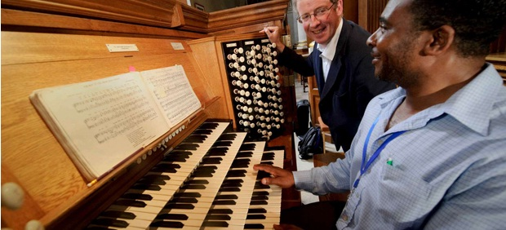
RCO announces summer 2011 examination results

RCO announces summer 2011 examination results
The Royal College of Organists has announced the results of its 2011 summer examinations.
A total of 23 members were successful in the examinations for the Fellowship of the College (FRCO), Associateship of the College (ARCO) and the Certificate (CertRCO).
Successful candidates will receive their awards at the College’s annual conferment at Southwark Cathedral on 10th March 2012.
The successful candidates were:
THE DIPLOMA OF FELLOWSHIP (FRCO)
Jonathan Ayerst (Porto, Portugal)
Matthew Dunn (Manchester)
Freddie James (Cambridge)
Dr Stephen Payne (Oxford)
David Ratnanayagam (Llandenny, nr Usk)
Sebastian Thomson (Oxford)
Limpus Prize, Frederick Shinn Prize, and Durrant Prize
Freddie James
Turpin Prize and Durrant Prize
David Ratnanayagam
Harding Prize and Durrant Prize
Freddie James
Samuel Baker Prize
Freddie James
Durham Cathedral’s Master of Choristers & Organists
Organists

Durham Cathedral benefits from having three exceptional organists in James Lancelot (Master of the Choristers & Organist), Francesca Massey (Sub Organist) and David Ratnanayagam. (Assistant Organist)

James Lancelot, Master of Choristers & Organist
James Lancelot is Master of the Choristers and Organist of Durham Cathedral, a position he has held since 1985. Prior to this he was successively a Chorister of St Paul’s Cathedral, Organ Scholar of King’s College, Cambridge and Sub-Organist of Winchester Cathedral. He studied with Ralph Downes, Gillian Weir and Nicholas Danby. At Durham he takes responsibility for the cathedral’s musical ministry, at whose heart are the services sung daily by the Cathedral Choir.
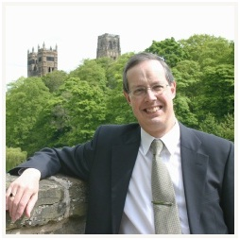
During his tenure the choir has maintained its reputation as one of Britain’s leading cathedral choirs. He has taken them on tour to Holland, Scandinavia, Germany, Brazil , Versailles and the USA, and with them he has worked with the Northern Sinfonia, the BBC Philharmonic, the London Festival Orchestra, the Yorkshire Baroque Soloists, BT Scottish Ensemble and Stan Tracey and his orchestra and STING.. The choir has recorded on many occasions both for Priory and privately for Durham Cathedral Choir Association, and has made numerous broadcasts; in July 2005 it appeared in concert at the International Organ Festival at St Alban’s Cathedral. James also takes overall responsibility for the cathedral’s second choir, Durham Cathedral Consort of Singers, which he was instrumental in working with the Cathedral Chapter to found in 1997; this choir sings regularly in the Cathedral on its own but also on occasion combines with the Cathedral Choir.
James is also Organist to the University of Durham, Conductor of Durham University Choral Society and immediate Past President of the Cathedral Organists Association; in 2002 he became a Lay Canon of Durham Cathedral and received Honorary Fellowship of the Guild of Church Musicians, and in 2006 he was appointed a Fellow of St Chad’s College, Durham.
In addition to his work at the cathedral, James Lancelot pursues an active recital career both in Britain and abroad. Recent years have seen visits to Holland, Belgium, Poland, Germany, Denmark, the USA, France, Russia, Norway and Sweden as well as recitals in many British cathedrals and town halls.
David Ratnanayagam, Assistant Organist
David Ratnanayagam was appointed Assistant Organist at Durham Cathedral in June 2012. Previous to this, he was Organ Scholar for two years and then Interim Assistant Organist; this new appointment also includes his role as Assistant Director of Music at The Chorister School. In addition, David is Director of Music and Organist at St Cuthbert’s Church, Darlington.
David received his education at St Thomas’ College, Mount Lavinia in Sri Lanka before reading Music and English at the University of Melbourne on an Australia Ceylon Music Scholarship. He was awarded first class honours in Organ Performance and twice during his university career was presented with the Harold Charles Chatfield Medal for gaining top marks in the Faculty of Music. Whilst at university, the Victorian Society of Organists conferred on him the Herbert Davies Organ Prize on winning an Australia-wide organ competition. In 2002, David was selected to participate in the Asia Pacific round of the Calgary International Organ Festival in Hong Kong.
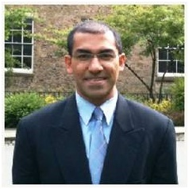
David was Assistant Organist at St Paul’s Cathedral, Melbourne for four years before returning to Sri Lanka in 2003 to pursue a career in teaching. For the next six years he led the Music Departments of two international schools in Sri Lanka and Zambia. In 2009, he moved to the UK to undertake postgraduate study at Durham University from which he graduated with Distinction in Music Performance.
David is a Fellow of the Royal College of Organists. His teachers in organ have included Dr June Nixon, Keith Wright, James Lancelot and Dame Gillian Weir. Based in Durham, he is in demand as a soloist, accompanist and teacher.

Francesca Massey, Sub-Organist
Francesca Massey took up the post of Sub-Organist of Durham Cathedral in September 2011. Prior to this, she was for four years Assistant Director of Music at Peterborough Cathedral, where in addition to the daily provision of music for services, she regularly accompanied the cathedral choir in concerts, tours, broadcasts and recordings, including the live televised-broadcasts of Midnight Mass and Christmas Day Eucharist in 2008. Concert venues with the choir included the cathedrals of Amiens, Bourges, Blois and Orléans. Born in Birmingham, Francesca was educated at Cambridge University and the Royal Northern College of Music (as an ABRSM Scholar) and has held Organ Scholarships at St. George's Chapel, Windsor Castle, Gonville and Caius College, Cambridge (also Acting Precentor for a term) and Manchester Cathedral as well as being Assistant Organist at Great St. Mary's Church, Cambridge.

At the age of 19, Francesca gained all of the top prizes in the FRCO diploma and has since been awarded the WT Best Memorial Scholarship and Silver Medal of the Worshipful Company of Musicians, and the Musicians Benevolent Fund’s Ian Fleming Award. She has studied with Jeremy Filsell, Kevin Bowyer, David Goode and Andrew Fletcher.
Francesca’s recital venues have included many major concert halls, cathedrals and churches in the UK, and she has also performed throughout South Africa, Sardinia, Sweden and Denmark with Caius College Choir, with whom she recorded a number of acclaimed CDs. Francesca has worked as a tutor for Cambridge University Faculty of Music, and on various courses hosted by Oundle for Organists and the RSCM, as well as performing extensively as an organ accompanist, continuo player, pianist, violinist and singer. She is currently the rehearsal accompanist for The Durham Singers.

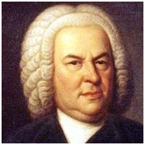

BACH @ Hatfield (David Ratnanayagam)
2nd March 2012, 13:10 to 13:50, Hatfield College Chapel
Lunchtime Recital no. 7 of 8 in Hatfield's Epiphany series featuring the organ music of Johann Sebastian Bach.Hatfield College is hosting this series of eight organ recitals by professional organists featuring the finest organ works by J. S. Bach on their 1883 Harrison & Harrison Organ. They are free to the public and will last around 35 minutes.
Further details may be obtained from Jonathan Clinch (j.d.clinch@durham.ac.uk).
Contact j.d.clinch@durham.ac.uk for more information about this event.

David Ratnanayagam
Wrong David Ratnanayagam?
Phone: +44 *** *** **** HQ Phone
Durham Cathedral
Chapter Office
County Durham DH1 3EH
United Kingdom

Web References
Durham Cathedral - News
www.durhamcathedral.co.uk, 5 April 2011
Wednesday 20th July: David Ratnanayagam (Durham Cathedral)
DURHAM CATHEDRAL Organ Recitals
www.duresme.org.uk, 7 July 2010
11 August: David Ratnanayagam [Durham Cathedral]
...
Tues. 24 Aug: 6.30pm: David Ratnanayagam [Durham Cathedral] - Free Admission
RCO Academy: Member Recitals
www.rco.org.uk, 17 Sept 2006
David Ratnanayagam Durham Cathedral

134. Muditha Dissanayake in an e-mail of February 02, 2013 writes:
“just had confirmation of the motor rally date. Please see the HeadMaster's reply below.
Thanks
Muditha”
133. Milinda Hettiarachchi in an e-mail of January 31, 2013 writes:

“Dear Lakshman,
I am deeply touched by your appreciation ~ thank you very much .
To help Guru, one need not be in the EXCO or hold high office , as you correctly say .
I am sorry to hear about your experience in 2001 / 2002 .
Let us all rally round again for Guru .
In appreciation Dr Hayman , I will be committed to uplift Guru for a life time .
I am on the ball collecting more funds , without publicity on my part .
I am repaying my nurture fee to STC of which Guru is a vital link .
Esto Perpetua & Best Wishes .
Milinda”

132. “Roger Aldons in an e-mail of January 31, 2013 writes:

Dear Lakshman,

Thanks for your email and kind words, and thanks too for the latest STCG 62 Group newsletter and website links. I am very pleased to see that the recordings of ‘The School by the Sea’ and ‘The College Song – Esto Perpetua’ from my CD, “We’ll always remember” are now up on the website. I have, however, noticed a few typographical errors in the credits as detailed below, which you may care to correct, please, and also in the list of articles (see item 3).

- The letter ‘r’ has been omitted from the incorrect spelling of the surname of Mrs Irene van der Wall, who arranged ‘The College Song – Esto Perpetua’.
- The letter ‘m’ has been omitted from the incorrect spelling of the word ‘Remember’ from the CD title.
- Misspelt word “Rugby” in title.

Words: Edmund de Livera.
Melody ascribed to Warden Stone; Arranged by Mrs. Irene van de Wall (1913-2010), for Roger Aldons; Edited and organ part by David K. Patrick
The above two tracks taken from
the CD titled 'We'll Always Remeber'
are reproduced with permission from Roger Aldons

Thomian Rubgy - By Shanaka Amarasinghe

I hope you don’t mind me bringing these items to your attention!

Finally, I note you have two photos of Dr. Hayman and father Foster on your website home page. Would it be possible to please send me a high-resolution copy of each of these, and if possible, one of Warden de Saram? I am writing a biography of Revd Cannon Roy Henry Bowyer Yin, incorporating his own memoris which I have, and I would like permission to use the photos requested above, please, in the book, because father Yin spoke very highly of these three great men in his memoirs. I would also be grateful for a high resolution copy of the photo of the Guru Chapel with the swimming pool in the foreground, please, for inclusion in my tome. The reason for high resolution copies is for clear reproduction on printed pages of hard copy. There may be other items such as articles by and about Dr Hayman and Father Foster which I may seek permission to use later, once I have been through and read them, as they are useful sources of information about these higly respected friends of Father Yin. I hope you can please oblige.

Thanks, kind regards and best wishes,

Sincerely,

Roger

Roger Aldons
ACCESS DOWNUNDER
10 Buldah Street
Dandenong North Vic 3175
Australia
Phone: (61-3) 9701 1862; Fax: (61-3) 9701 1863”

131. Milinda Hettiarachchi in an e-mail of January 29, 2013 writes:
“Dear Lakshman ,

Thank you very much for your kind sentiments expressed .
I am committed to Guru as we will never ever find another Dr Hayman .
I am very happy that I was able unite STC at Guru and Mount after 02 hard years .
Shall continue to assist Guru till I live .
Be rest assured & Esto Perpetua !
Milinda”

130. Ananda Amaranath in an e-mail of January 25, 2013 writes:

“Dear Lucky,

It is always a pleasure to keep in touch and help you in any way with the wonderful work
you are doing in maintaining the website. It does provides a platform for the Guru fraternity to keep in touch and be kept well informed about the recent developments in the school.
I shall continue to send you any news which may add value to the site…………………………………….”

129. Brian Wickremasinghe in an e-mail of January 24, 2013 writes:
“Hi Lakshman,
I have been delinquent in this area. I should take a keener interest – probably my wish list for 2013. Recently I touched base with Moggie ( Mohan Guneratne), who as an instructor at Korean Airlines is shuttling between LA and Korea. Plan to meet on his next two week spell in LA. We are also planning to meet with Mr. Pillai, Lal Yapa , Mohan, MS Siriwardena and a few others at Bakka’s place. Quoting Bakka, we don’t know how long we will live !! At this time I am not planning a trip to SL. I feel depressed at what is happening, but don’t want to get into this whole thing about governance accountability and democracy. Last September I did a trip to Amsterdam, Germany. Austria, Italy and France. But don’t count me out. Might make a flying visit – even a short one, without notice.
I hope this finds you and the family in good health and I wish you all the best for 2013.
Regards,
Brian.”

128. Merril Aluwihare in an e-mail of January 24, 2013 writes:
Thankyou for your kind words. Senaka de Fonseka has been appointed Manager Gurutalawa and he has visited school in this capacity, but this has not yet been announced to the Board by the Bishop.Senaka is truly a first class Thomian, his brother sacrified his life in the battle front in Army he has colours in many sports, has been secretary to two Thomian fairs, is a senior manager at Ceylon Tobacco and an excellent gentleman whom all Thomians can be proud of.
rgds merril”

127. Asgi Fazleabas in an e-mail of January 24, 2013 writes:

“Thanks Laksman
No worries about the Guru information. Really appreciate all the hard work you do and congratulations on your son's marriage. My best, Asgi”

126. Rev. Marc Billimoria in an e-mail of January 24, 2013 writes:

“Dear Lakshman,
Many thanks for your email. It has been some time since we met. I must pop round and see you sometime for a chat. Would any evening be ok? Or is there any particular evening that would suit you?
Best regards,
Marc”

125. Muditha Dissanayake in an e-mail of January 24, 2013 writes:

“Dear Mr Jayatilake,
Thank you for the email and updating your website. And again I apologise for the delay with the dinner photos. I dropped a DVD this morning at your office. I may have copied all from the two directories on my PC including the short videos. ………………………………………………………………
Did you also receive my short email with the dates from the headmaster's report which had the dates of guru sports meet and the Uva Thomian encounter ?
Regards,
Muditha”

124. Asgi T. Fazleabas in an e-mail of January 4th writes:

“Hi Laksman,

I enjoy receiving e-mails from you and hearing all about our friends and colleagues from the old days. I was at Guru from 1963-1966 and then went to Mount to complete my “A” levels. I came to the US in 1972 to pursue my graduate degrees and have been here ever since. Several years ago I had sent all my information so that it could be included in the directory at the urging of Kamal Nilaweera but for some reason it must not have got included. Could you please update the directory with my information which is given below. Thanks and please keep these wonderful e-mails coming. My best for the New Year. Asgi

Asgi T. Fazleabas PhD
Professor and Associate Chair
Department of Ob/Gyn & Reprod Biol
Director, Center for Women's Health Research
Co-Director, Reproductive and Developmental Sciences Program
Michigan State University
College of Human Medicine
333 Bostwick Avenue NE
Room 4027 - Van Andel Institute
Grand Rapids, MI 49503
Phone: 616-234-0981
Fax: 616-234-0990
E-mail: asgi@hc.msu.edu”
2012

123. Roger Aldons in an email of December 20 2012 writes:
“Hi Friends and Family!
I thought some of you (especially those overseas) might be interested in this interesting and informative description by one of our Senators of how the Festive Season leading up to Christmas is experienced and celebrated in his hometown (St. George) area in Western Queensland (and many other places in Australia). Temperatures mentioned are in Celsius. Please feel free to share this article with your (and my old) friends and family.
Compliments and Greetings of the Season with our best wishes to you and your family for a joyous Christmas and a happy, healthy, successful and peaceful New Year filled with beautiful music!
Thanks and cheers,
Roger & Julia
Roger & Julia Aldons
10 Buldah Street
Dandenong North Vic 3175
Australia
Phone: (61-3) 9701 1862; Fax: (61-3) 9701 1863”

122. Roger Aldons in an email of December 4 2012 writes:

“Greetings Friends!

The Choir of St John’s College, Cambridge, directed by Andrew Nethsingha, (son of Old Thomian and former fellow Revd Roy Yin–trained STC chorister & organist, Lucian Nethsingha, former Director of Music at Exeter Cathedral) sang their Advent Carols Service last night our time (4pm GMT) and it was broadcast live yesterday on BBC 3 and on BBC i-Player over the internet.

If you are interested, you can hear their service, lasting some 90 minutes, on your computer over the internet. The organ is ‘driven’ by the Senior Organ Scholar, Freddie James. The programme, copied below FYI, covers a wide range from modern special commissions to traditional favourites, and ends with some Bach - (Wachet auf....).

If you Google www.bbc.co.uk/iplayer , then select RADIO from the display, click on Radio 3, the day's programmes will be displayed (or you can find it in the search section), from which you select the service which was broadcast. There is some music and chatter before the broadcast programme gets underway. They usually retain everything they broadcast for a week, a bit longer if the programme is an interesting one. It is available for listening for just seven days.

Enjoy!

Best wishes & cheers,

Roger “

121. George Pillai in an email of Nov., 24,2012 writes:

“Hi Lakshman!
I understand that STCG is celebrating the 70th Anniversary of its founding.
Could you kindly let me know the dates. I will be in Sri Lanka on the 10th of December and would be delighted to attend the celebrations.

George Pillai”

120. Bandu Wanigasekera in an email of October 31,2012 writes:

“Dear All,
Charlie was with me or a year junior & I recall him well with spectacles & all !!.
While he is accurate in many details, he was wrong to say that in 1950 there were 200 students.
I quote from Dr. Hayman's Prize Day speech on 30th November 1949 :
The number of boys is 24 more than last year. This term we have 149 boarders and 9 dayboys making a total of 158. Without fresh accommodation no further increase in numbers seems possible, though it is our aim to bring the total to about 200 when conditions permit.
It was in 1952 that Guru reached 201 students - 191 boarders & 10 dayboys.
Regarding ethnicity, the Guru Magazine - published in a single volume with Mt. Lavinia, September 1953, states :
The composition of the School has been unusually international and apart from Kandyan & Low Country Sinhalese, were Ceylon Tamils & Ceylon Moors.We have had boys whose parents were Indian Tamil, Telugu, Malayalam, Malayan, Australian, Austrian, Swiss, English, Scottish, Dutch and American.
What a mix. !!
Regards
Bandu Wanigasekera”

119. Dilshan Jayasuriya in an email of October 15,2012 writes:

“Dear Fellow Thomians;
The OBA has launched another Scholarship Fund to help our boys. This would be in memory of Mr. Wilson I. Muthiah and will be awarded to a scout as identified and selected by the Warden.
More details are in the attached letter of appeal and please feel free share with other fellow Thomians so we can raise sufficient funds to enable us make the award available from January 2013
Thank you,
Yours sincerely,
Dilshan Jayasuriya
Hony. Secretary”

118. Ziard Sinnen in an e-mail of October 7th, writes:

Dear Lakshman

A celebratory dinner is being organized to celebrate 70 years of S Thomas’ College at Gurutalawa which would take place on Friday, 30 November’12 at the Berjaya Mount Lavinia Hotel Mount Lavinia commencing at 7.30pm. The theme of the night has been aptly named “Rhythm of Blues”

We have observed the brilliance with which the Group of’62 website has been designed. Also seeing that your website caters to a cross section of diverse communities we would appreciate if you would give our function due prominence in your website by publishing our flyer which we attach herewith.
We also attach request letters for banners and souvenir advertisements which we would be glad if they too could be published.

We further solicited your good self in promoting our function and encourage you and your friends and colleagues to bring their spouses along to this event which is bound to be an enjoyable one.

On behalf of the Executive Committee of this event may I take this opportunity to thank you.

With best regards

Ziard Sinnen
Chairman, Organizing Committee

117. Ranjith Jayasinghe in an email of August 21,2012 writes:

Dear Lakshman,
I already received this sad info from Wanni. I am so sorry to hear about the passing away of our good friend, JoJo. I kept in touch with him even after leaving school because we were members of the same LIONS Club in Colombo, the Lions Club of Cinnamon Gardens. We used to meet at least once a month at regular club meetings and events. But this was a long time ago. Time flies so fast.
I will not be able to attend the funeral because now I live in Cambodia. It would be appreciated if you could kindly convey my deepest sympathies and sincere condolences to his wife and family.
Sincerely,Ranjit Jayesingha (ERV)”

116. Nihal Wanniarachchi in an e-mail of August 20, 2012 writes:
“It is with much sadness that I inform you of the demise of a very sincere supporter of the Guru O B A , Mr. J J Rajakaruna, popularly known amongst his many friends as Jo Jo. He died this evening after a brief illness. On behalf of the Guru O B A let me condole with the bereaved family members, our deepest sympathies.”
115. Muditha Dissanayake in an email of July 18, 2012 writes:
“Dear Mr LJ,
Hope you are well. The college annual prize giving will be held on the 4th August at the Foster Memorial Hall. (10.00 am). Warden Indra De Soysa is the chief guest.
Please update the stcg62group when you can as I dont think the college website will get updated before the event. There is discussion about a OBA family day and a dinner but nothing confirmed as yet. I will keep you posted when I hear the confirmed dates and venues. In other news Mrs Seetha Jayasekara completes 30 years service this year.
Regards,
Muditha”

114. Roger Aldons in an email of July 8, 2012 writes:
“Dear Friends,

Forwarded is a most timely and useful pleasing news update about Rev Baldwin Daniel, kind courtesy of Corrine King, for your information and interest. Please feel welcome and free to forward it to friends of Father Baldwin within the Thomian Community and beyond who may wish to communicate with him.
Sorry if this news has already been received from another source.
Esto Perpetua!

Kind regards,
Roger”
113. LAM Chandrasekera,Headmaster of STC Bandarawela in an email of June 25, 2012 writes”

“Dear Mr. Jayatilaka,
Please be informed that the prize covering the criteria “FOR OVERALL EXCELLENCE IN CONDUCT, LEADERSHIP, SCHOLARSHIP AND ALL ROUND PERFORMANCE AS A THOMIAN” is covered under the S.L.A. Ratnayake Memorial Prize for the Best all rounder and if you wish you could contribute for the Most Promising Chorister in the Senior Category or the prize for the Sinhala Essay Competition (Grade 12 & 13) these are the only two that nobody is contributing at the moment.

Thank you,
L.A.M. Chandrasekera
Headmaster
S. Thomas’ College
Bandarawela”
112. Roger Aldons in an email of June 8, 2012 writes:
“Dear Friends,

I visited Father Baldwin Daniel at the Kingston Centre around 2:00pm this afternoon. He was not in his room and his bed had been stripped bare and the cleaner was cleaning the room. As I was heading towards the nursing station I noticed Father Baldwin seated on a couch in one of the patient lounges dozing, surrounded by all his ‘bags and baggage’! I tapped him on the shoulder and he woke up and greeted me. He explained that he had been “disturbed” at 11:00am this morning and told to hurry up and get dressed as he was due to be moved to a ‘halfway house’ – a respite facility – until a permanent aged care place could be found for him by his family. He was very frustrated and agitated at the long wait he had endured in limbo, especially as his bed had already been reallocated to a new patient today and it was the first he had heard of his pending move. I enquired at the nursing station where he was due to be moved to (as Baldwin had no idea) and I was told he was being moved to Homewood (or Holmwood) Aged Care at 8 Young Street in Hallam. Apparently his niece Linda had been informed about the move but nobody had told him! He asked me to call Linda when I got home, which I have done, and ask her to find out when he was going to be moved. Unfortunately, he just has to wait until the patient transport ambulance is available. He was glad that they had given him lunch and he also had some afternoon tea brought to him just before I left.

He looks remarkably well considering what he has been through. He still has memory gaps and cannot remember anything about his car accident or his subsequent collapse and admission to hospital. However, he looks to be progressing well and hopefully his improvement will continue. He will be much happier when he eventually settles down in his new “home” when a permanent aged care facility place is found for him. Linda is trying to find somewhere within easy reach of the family for convenience so that they can visit him regularly.

Father Baldwin asked me to please convey his best wishes and warm greetings to all his friends in the Thomian Community. He is very appreciative and grateful to everyone for thinking of him, for their good wishes and especially for remembering him in prayers. He didn’t want me to leave and would have preferred that we continue chatting until his transport arrived. However I assured him that I would call to see him again at Hallam (which is closer to me). He very much appreciates the visits by friends and relatives and is grateful to everyone who visits him as he loves chatting, especially about the old days at STC and is very interested in news about College, the Chapel, Choir, etc. I am sure that visitors help his memory problems through their conversations which serve to stir up lost names and events. Prompting his memory with reminders of events past, names, etc must surely assist his recovery and return to normal.

Thanks and regards

Roger”

111. Roger Aldons in an e mail of June 7, 2012 writes:
“Dear Lakshman,

Thanks for the link to the website with the very beautiful photos of “Guru Day at Mount”. It looks to have been a resounding success judging by the large number of attendees, the smiles and happy faces and I am sure the event would have been much enjoyed by all. Congratulations to everyone who organised the event and most importantly all those who supported it by participating. I have circulated your email within the STCOBA (Australia Branch) membership.

I would like to take this opportunity to respectfully suggest that you might like to consider updating the recording of College Song on your website (and also on the main STCML website) from the instrumental version to the version recorded (arranged by the Late Mrs Irene van der Wall, with all the verses sung to a rousing pipe organ accompaniment) on the CD titled, “We’ll Always Remember”, which I produced in memory of Revd Father Roy H. B. Yin and released in 2010. The words of all verses (as in the CD booklet) could be printed on the page below the buttons. It may also be appropriate to include the recording, also from the same CD, of Father Yin’s famous song (also with the words printed from the CD booklet), “The School by the sea”. Alternatively, you could include buttons on each website for both the present instrumental version AND the sung version, which I believe is more appropriate, inspiring and stirring, with the strength of the beautiful words. On behalf of my company, you certainly have my permission to use these two recordings on the websites concerned with due acknowledgement, if you and the Warden, Sub-Warden/Chaplain, Headmaster of Guru, etc are happy about it and wish to do so.

Eddie Appathurai will, I am sure, gladly make available a copy of the CD so the two tracks may be copied and transferred (preferably at CD quality for the best reproduction) as needed.
Best wishes to all!

Thanks and kind regards,

Roger

Roger Aldons
ACCESS DOWNUNDER
10 Buldah Street
Dandenong North Vic 3175
Australia
Phone: (61-3) 9701 1862; Fax: “

110. Brian Wickramasinghe in an e-mail of June 06, 2012 writes:
“Brings a lot of memories. We have all changed considerably and the faces don't ring a bell unless introduce. I am certain some were my vintage - probably good friends”

109. Duleepkumar P.S. in an email of May 30, 2012 wrote to Marc Bilimoria

“Dear Marc,
I believe that Mount and Guru are still the ONE school in two campuses.The separation is an Educational dept.formality.
When Mount was reopened after the war was over Dr H and Father Foster were requested by the Warden to help restablish it and the Guruboys wentinto the boarding and reestablished itsprimacy in leadership.It was the accepted norm that Guru boys were automatically accepted into the College forms if qualification was established bypassing the Olevel.Guru boys who excelled in sport were oftencalled uponto represent Mount..
The villain of the piece was Neville Dealwis Who denied guru Boys Automatic entrance to Mount as afore mentioned.That was the rub.His problem was the increase in numbers at that time.It could have been solved But The man preferred to take the easy way out.I served with warden Desaram on the Board.Healaways believed they were one and the same school.He will be turning in his grave.De alwis should have joined his younger brother in the Zoo as an exhibit.He hadn't a clue but his own Ego.
I shall not be partof the events on the basis of What you have written.Though i was originallyat mount and returned therto to after the war.I know more of the inderpinninings of what was taking place than anyone Else.
warm regards,
P.S.D.”

108. Marc Billimoria in an e-mail of May 29, 2012 writes:
“Dear Old Boys and Friends of S. Thomas' College at Gurutalawa,
In May 2012 we celebrate 70 years of S. Thomas' College AT Gurutalawa.
There has been since 2007 a renewed connection between the parent School at Mount Lavinia and the school at Gurutalawa that was deemed one and the same school on two campuses until the late 1960s at least.
Dr R. L. Hayman was Headmaster at Guru and Sub Warden at Mount Lavinia concurrently until 1956 or so; there was one College Magazine and a very open exchange of students between the two locations; all boys went on to Mount Lavinia to complete their education as Thomians; there was one crest, one motto, one flag and colours; when S. Thomas'
celebrated the centenary in 1951 the commemorative Centenary Volume has on its front cover 'St. Thomas' College Centenary Number Mt Lavinia and Gurutalawa'; there was until 1959 but one Old Boys'
Association and even after the Gurutalawa OBA was founded in that year reciprocal membership was granted.
These facts and more are reasons enough for Thomians or Mount Lavinia and Gurutalawa to celebrate a unique link and nexus and to affirm resoundingly that even though the test of time and numerous circumstances have taken their toll on the connection the Gurutalawa School is still in many ways S. Thomas' College AT Gurutalawa and as Warden C. H. Davidson (2nd Headmaster of STC at
Gurutalawa) had once said quoting Wordsworth, “TWO Voices are there; one is of the sea, One of the mountains; each a mighty Voice”, are two mighty Thomian voices in Sri Lanka, although due to numerous factors Guru's voice has been somewhat stifled over the past couple of decades!
“To celebrate the 70th anniversary of STC at Gurutalawa and to inaugurate an annual 'Gurutalawa Day' at Mount Lavinia to keep the present generation aware of the historic connections between the two schools the following events have been planned for WEDNESDAY 6th JUNE 2012:
7.40 a.m. A Thanksgiving Service at which the Preacher is expected to be the present Headmaster of STC at Gurutalawa the Revd Nihal Fernando.
9.00 a.m. A special Assembly at which the key note speaker will be Mr.
Bradman Weerakoon, a distinguished product of both Gurutalawa and Mount Lavinia.
Portraits/Photographs of Dr R L Hayman and Canon A J Foster will be unveiled and once more hang in the College hall.”
Today we do acknowledge that the Thomian Family is a family of four schools, the other two being S. Thomas' Prep School in Kollupitiya and S. Thomas' College, Bandarawela (that started life as a Prep School and shared the crest, colours, song and motto of the Kollupitiya school until the late 1980s). The latter two schools, as we all know, were founded by Dr R L Hayman's compatriot Mr W. T. Keble in 1938 and
1942 respectively and came under the control of the STC Board of Governors only in 1956. However, while we acknowledge and greatly value this one-ness in the Thomian family of schools, what we are celebrating through 'Gurutalawa Day' is something unique to Guru and Mount especially while Guru still needs all the support we can muster to help her walk strong once again.
Today STC Gurutalawa maybe a separate School with a clear and distinct identity of its own. But we cannot and must not forget history and the roots from which today’s school has emerged. Gurutalawa also needs the connection with Mount Lavinia today more than ever before and given the fact that almost all those who pass their O/L exams at Gurutalawa are admitted to Mount Lavinia to follow A/L courses it is vital that the present generation is aware of our common roots. Nor must the present generation be allowed to forget great men like Dr Hayman and Fr Foster and what they stood for and what they sacrificed for both Schools at a time when the stress seems to be on what we can get from school rather than on what we can give!
I must record a word of thanks to Milinda Hettiarachie, an old boy of Mount Lavinia, who like me was never a student at Guru, but who like me, has got Guru ‘under the skin’! His efforts to start this annual celebration must be appreciated by us all. He is Guru’s voice on the STC Mount Lavinia OBA Executive Committee and has been instrumental in getting a great deal of support for Guru from even OBAs abroad. Also a very special 'thank you' to our Warden Prof Indra de Soysa for so readily permitting us to go ahead with this event.
We hope to see as many old boys of Gurutalawa as possible on the 6th.
Please pass the word around.
Esto Perpetua”

107. Muditha Dissanayaake in an email of May 1st 2012
“Dear Mr Jayathilake
Thank you for the reply and sorry for the delayed reply. I delayed my reply hoping I will get more details from Guru.
Good to hear that your daughter is well. Not very easy to focus on anything else when the children are not well.
I noticed that you have already updated the website with the cricket match details and thank you for that. I am yet to hear from Kaviharan regarding the match, confirmation of the venue and any other details. I do have the names of the co-opted members of the OBA.
The following members were appointed by Mr.N.Wanniarachchi and seconded by Mr.Krishantha Weerawardane.
1. Mr. Bandu Wanigasekera
2. Mr.Christo Gonawela
3. Mr. B.S.R.Fernando
4. Mr. Prabath Jayasundera
5. Mr.A.H.M.Razeek
The sub committes are not yet finalized and from the above Prabath Jayasundara has withdrawn and I cannot remember the new name suggested at the meeting.
I am pushing Kaviharan for updates so will update you as soon as I hear anything.
Thanks for the invite I will drop in sometime.
Regards,Muditha”

106. Marc Billimoria in an email of April 15, 2012 writes:
“Dear Friends,
It is with profound sorrow that I write to inform you of the passing away of a truly faithful man - Mr Ramesh Francis, our Deputy Headmaster of STC Gurutalawa. Although an old boy of Trinity College Mr Francis was passionate in his desire to help in the resurrection of Guru ever since he took office as Deputy Headmaster in Term 3 of 2010 to help me in my tasks. My trust in him was not misplaced or misused. He was a very loyal and able lieutenant to me until my move to Mount in December and held the fort very effectively in my frequent absences from the campus between September and December. He was fearless and efficient in his administration and just and fair in all his dealings. He was a God fearing man of integrity who never misused his position or demand anything for himself by way of rights and privileges. His desire was to serve and I believe his contribution would have been very great had he remained at Guru. I am sure the present Headmaster will miss him very much.
Our prayers must be with his wife, two very young children, the rest of his family, with Fr Nihal Fernando and the Thomian Family in Gurutalawa who will all miss him very much.
May he rest in peace and rise in glory.
MB”
105. Bandu Wanigasekera in an email of March 24, 2012 writes:

“Dear Lucky.
There are a lot of irrelevancies in this article regarding what was written in the Leader - the newspaper never, as far as I recall, hammered STC as such but only the behaviour of prefects. So why this tirade ? And they praised the action of the Warden & decried the action of the Sub-Warden. What is the ransom demanded by the newspaper - held to ransom ???
But more silly is the statement : and a lesson to politicians who decamp and crossover when the going gets tough.
Quite a number of crossovers are Thomians & Trinitians !!
Regards
Bandu”

104. R.Sandanakrishnan of STC, Bandarawela. OBA in an email of March 23, 2012 forwarded as follows:

“Dear Friends,

Release of "FOOT PRINTS" - a publication on S.Thomas' College, Bandarawela - tracing back the history of the School

The eagerly awaited " FOOT PRINTS " will be ready for Sale on Sunday - 25th March 2012, ( during the " Cricket Sixes " ); Please inform all your friends.

Having associated with the Book, I am sure, all of you will agree with me, that this book is a "Treasure not only for our life time, but for our generations"

The Book is priced at Rs 2500.00 per copy. Your generous contribution above cover price is much appreciated. There will be a special "Sales outlet" at the BRC Grounds on 25th March - Sunday. All your contribution will be officially acknowledged immediately. All proceedings will be channeled towards the "College Bus Project".

Please canvass for the Sale among your friends, Class Mates/ Batch Mates etc, and encourage them to contribute.

your presence on Sunday - 25th March to make the events colourful, will be much appreciated

Thanks & Regards

R.Sandanakrishnan
VP- STCBWOBA
#130,Elie House Road
Colombo-15
Sri Lanka
Mobile : 0094 77 222 9742”

103. F.M. Tan in an e-mail of February 26th, writes:
Dear Lakshman,
Thanks for your ever interesting and informative news regarding Guru.
Any advice on how I can update the changes in my email addresses for the College (www.stcguru.com) website please. I'm unable to find the email address for that website's webmaster, or is there another person who is responsible for email updates?
Warmest regards,
F M Tan

102. Writes:Nihal Wanniarachchi in an email of February 27,2012 writes:

“Dear Lucky,
Please find the list of members of the new committee for year 2012/*13. The list of co-opted members will be disclosed after the first meeting scheduled for 11th morning. Would you like to join the band wagon. Bandu is one of the co-opted members. Pl suggest any capable person , I you are unable to join the team.
Regards
Nihal”
101. Merril Aluvihare in an email of Jan 25, 2012 writes Found in file “Board of Governors”

“My dear Lucky.
The elections were held yesterday and I was re-elected unanimously to represent the staffs of Guru, Bwela and Kpitiya for a further four years. As for oba it was decided mithra Edirisinghe and Nihal Wanniaratchi would share the four year term two years each with Mithra taking the first two years.
Regards Merril”

2011

100.Duleepkumar P.S. in an email of Dec.17 2011 writes:

“Warden De Saram once told me that he was not enamoured by the College Song --Mainly the refrain 'For all we have and are" .Not ALL-- We have our parents , other mentors ,The whole range of Literature and Philosophy Etc. and there is nothing he can do to change it.
P.S.D.”

99. Samantha Perera in an email of October 24,2011 writes:

“Dear Lakshman:
Kindly send a message to the students of the OBA regarding the passing away of Mrs Rajamanthri yesterday. She was an English teacher in the Primary Section of STCG in the 80's. She was the wife of Mr P.D. Rajamanthri who worked at the school office.

I am hoping that your mailing list will have many of her students in it.

The funeral will be in Panadura at Champika Rajamanthri's (her daughter) house.

Niroshana Rajamanthri (Mrs Rajamanthri's son)-- can be reached at O774371737.

If I remember correctly the funeral will be on Wednesday.

Many thanks
Samantha Perera
1977-1986 at Guru”

98. Roger Aldons in an e mail of October 18 , 2011 writes:

“Dear Thomian Friends,
Holy Trinity Anglican Church, Corner of Chapel Street & Brighton Road, Balaclava, Victoria was packed to overflowing this morning at 10am for the Funeral Service for Old Thomian, Doug Ingram. A Guard of Honour was formed outside the church by approximately 25 Old Thomians while the coffin was carried by the Pall Bearers, Andrew Meehan, Michael Ingram, Neil Rupesinghe, Rohitha Rupesinghe, Tom Phillipson, Bala John, Harold Juriansz and Richard Murphy.
Prayers and Thanksgiving were offered by Rev. Geoff Cheong who also gave the Eulogy together with Godfrey Senaratne and Andrea Ingram.
The Committal and Blessing at the Boyd Chapel of the Springvale Crematorium was preceded by the singing of the St Thomas’ College Anthem and followed by the Hymn, ‘Beyond the Sunset’.
Condolences to Doug’s whole family, especially Yolande, Andrea, Andrew, Julia and Amelia.
A copy of the cover of Doug Ingram’s Funeral Order of Service is attached.
Thanks and regards,
Roger
Roger Aldons”

97. George Pillai in an email of October 14, 2011 writes:

“Hello Lakshman,

I remember Sisira very well. I taught him in the Lower 4th and Upper 4th at Gurutalawa. What comes uppermost to my mind is a quiet, unobtrusive, cheerful little person, well liked by all his peers. He was very friendly and showed great keenness in his work, which was always very neat.
We never met afterwards and this is a pity. I understand that he was involved with the STCG Old Boys Association and worked closely with Lakshman Jayatilleke and Mahen Ranasinghe. The school will greatly value his services.I wish to extend my sympathy to his family and also wish to let them know that Sisira will always be remembered by his classmates and his teachers.

George Pillai”

96. Duleepkumar P.S. in an email of October 14, 2011 writes:

“Thanks.
Unless otherwise recorded R.S .De Saram, Our Great Warden (of my period) disliked the claim in the thomian song of exclusivity for what we are and become.
"For ALL we HAVE and ARE........"
'What about our Parents,Our other mentors and so many other Spiritual & experiential influences including Litereture, which contribute to what we are and become ?" he once told me.
He rued the fact that tradition obstructed any change.(This is very true in general).
The song indisputably belittles and stultifies us when taken literally, but is generally sung
to manifest a Fellowship in Union with the Alma Mater.
P.S.Duleepkumar.”

95. George Pillai in an email of October 1st 2011 writes:

“Dear Lakshman,

OTAC has arranged for a Dinner Dance on Saturday, 1st October, 2011. This year, the Thomian Night is in the Castaway, in Burbank, California. The Castaway is in a picturesque setting, surrounded by hills, reminding one of the magnificent range of hills on the Gurutalawa Welimada Road. Here too, people hike along mountain trails and just like us in the good old days trails abound like those leading to Bidinuwewa, Idalgashena, Diyatalawa, Horton Plains, Kirigalpota, Totupola Kande and Pattipola. Some of my students in Guirutalawa from 1954 to 1964 - M.U. Liyanage (Bukka), Dr. Mahendra de Fonseka, Dr. Bharat Kumar (Ananda Kumarasamy), K.K.Meegahawatte, Anil Moonesinghe, Lal Yapa. M.R.Siriwardena and M. Divitotawala are attending. This is a wonderful opportunity for all of us to reminisce and enjoy each others company.
Probably I will tell you more after the event.

George Pillai “

94. R.Sandanakrishnan of STC, Bandarawela ,OBA in an email of August 15,2011 writes:

‘Dear Mr. Jayatilaka,

Good Morning

STCBW OBA originally planned the AGM Weekend in Bandarawela ( from 26th August to 28th August ). However, due to an unavoidable circumstance, we had to have only the AGM this year, but in Colombo.

An amended notice is being circulated to all members. Please find a copy of the Letter attached.

Please assist us with a notification in your website. We look forward to your participation.

Thank you in advance for your assistance

R.Sandanakrishnan
VP- STCBWOBA
#130,Elie House Road
Colombo-15
Sri Lanka
Mobile : 0094 77 222 9742 “

93. Shantha Dimbulana in an email of August 6, 2011 writes:
“My dear Lucky,
I have been reading all your Emails & appreciate very much the splendid job you are doing for our country. Please keep up the good work.
with best wishes,
Shantha.”

92. R.Sandanakrishnan in an e-mail of June 20th, writes:

Dear Mr.Jayathilaka

Once again, congratulations. Thanks a lot for such a quick update on the Prize Giving. It's very impressive. Let me say " Well done Head Master Sir, God has righty chosen you to be his AGENT to bring back the glory of STC, Guru"

Thanks & Regards
Sandanakrishnan. R

91. Duleepkumar P.S in an email of June 18,2011 writes:

“ Sorry to hear about your problems.A man can do no better thing than look after his mother.
My prayers are with you all.
Yes ,Itwas tiring though enjoyable.I willed myself to go because it will be Marc's last P G.
at guru.It will probably be my last visit.
Unlikely we will find 'suitable 'sucessors for Mount and Guru.Hope we do not become Glorified Vidayalayalas but that will be the trend.We have always been a pillar for English
medium and manners,racial amity and unity and a cosmopolitan outlook.
Hope world events and universally common problems for survival as a species will effect a sea change in the primacy of nationalism as the leitmotif in the human consciousness.
Best Regards ,P.S.D.”

Bradman Weerakoon in an e-mail of 9th June, writes:

Thank you Lakshman for your continuing excellence.

Bradman Weerakoon

90.Merril Aluvihare with an email of June 14, 2011 has sent us the following which he had received from
Shaukar Taher Esufali
“Dear Sir/Madam,
I was recently looking for the Thomian OBA dance details in Melbourne, Australia 2011 and came across the 'Guru' site. I was most impressed with the clarity and clear images on display. There have been some impressive changes but the core structures remain the same i.e. the dorms, swimming pool, buildings, squash court, sports grounds, farm, paddy fields to the grounds etc.
After attending St Thomas' Colpetty, I was at Guru as a boarder for 2 years from Jan 1971 to Dec 1972 before moving on to Mount for O'levels. I wonder if you have any old journals from those Guru years or even images. I did win medals at the annual swimming event, represented college at Cricket under 14, won annual prizes for Religion, English.
After O'levels at Mount, I moved to England and was boarded at Epsom College for 2 years and A'levels. I then entered St Mary's Hospital Medical School (Penicillin was discovered there by Sir Alexander Fleming) in London and qualified MB BS in 1981. I continued working as a junior doctor and was awarded FRCS (Fellow of the Royal College of Surgeons of England) in 1986. In 1988 I left England and began my journey home via Karachi, Pakistan (Assistant Prof, Surgery at Aga Khan University Hospital) and Oman (Head of Surgery, Ibri Hospital). In 1994/1995 after returning to Sri Lanka, I was appointed Consultant Surgeon Batticaloa General Hospital. In 1996 I was appointed Senior Lecturer in Surgery at Peradeniya University Medical Faculty. http://sundaytimes.lk/001022/plus8.html, http://www.dailynews.lk/2001/12/14/fea20.html
In 2004 as a sabbatical scholarship postgraduate student year in Melbourne, Monash University, I was awarded a Masters in International Research Bioethics. Since then I have been a Consultant Surgeon in Australia and now an Associate Professor in Surgery at the University of Notre Dame, Melbourne.
I attend the annual Old Boy functions in Melbourne, having the good fortune of being a student at St Thomas' Colpetty, Gurutalawala and Mount Lavinia.
I have visited Guru back in 1992, travelling from Haputelle to Arugambay. Fond memories do flood back. I was boarded at Hayman and the Dorms and the Quad are well maintained and cared for.
I hope to be in Sri Lanka later this year in December 2011 to visit family and friends and will try and visit Guru.
Kind Regards
Shaukat Taher Esufali, MBBS, FRCS, MS, MIRB, FRACS
Consultant Surgeon, Werribee Mercy Hospital, Melbourne, Australia
Associate Professor, Surgery, University of Notre Dame School of Medicine, Melbourne, Australia
Email: sesufali1@gmail.com
SEsufali@mercy.com.au”

89. R.Sandanakrishnan in an e-mail of June 8th, writes:

Dear Mr.Lakshman

Thanks a lot for your mail. The Old Boy News letter is an interesting piece of work.

Regards
R.Sandanakrishnan

88. Nihal Wanniarachchi in an email of May27.2011 writes:

“It was rather a surprise to hear that the Warden of STC was resigning on 31st August , well ahead of his contract expiry date .
The Board of Governors has accepted the resignation , as Warden had explained that had to meet certain financial commitments re his house mortgage in UK .
It was rumored that he was taking up another appointment to be in charge of a British School in Hyderbad , probably on a higher salary package .
The Sub Warden too was supposed to be tendering his resignation for personal reasons , but has been supposedly requested to reconsider .

87.Marc Bilimoria in an e-mail of May 25, 2011 writes:
“Shall we keep the title of the Leslie de Saram Prize simple - something like 'The Leslie de Saram Memorial Prize for the Thomian of the Year' or shall we expand it and add under that 'for outstanding achievements during the year'?
Will revert with the other details shortly.”

86. Marc Billimoria in an e-mail of May 22, 2011 writes:
“By now you would have heard the news that Guru won the Uva Thomian Cricket Match yesterday in Bandarawela with 4 wickets and 2 overs in hand. This has been a tremendous boost to our low morale! I want to thank you for having been one of the people who convinced the Bandarawela OBA to continue the fixture at the AGM last year.
As you know the Prize Giving is scheduled for 13th June 2011 with Bishop Dhiloraj Canagasabey as Chief Guest. I shall let you know soon who I have chosen to be the Jayatilleke Scholar for 2012. Will you be handling the Nilaweera Prize this year too? Also what about the Leslie de Saram Memorial Prize we have discussed? Shall we award it to 'The Thomian with an outstanding achievement during the year'?
Look forward to hearing from you. Must stop by for a chat when I am next in Colombo”.

85. Marc Billimoria in an e-mail of May 17, 2011 writes:
“I called you yesterday but you were out to let you know that K. N. K. Gamage, the Jayatilleke Scholar for 2010 has obtained 9 A passes at the GCE O/L of 2010. Both he and Gomes have thus achieved the same distinction and both of them were Jayatilleke Scholars. I hope the winner of 2011 will fare the same in December this year.
Trust we shall see you on the 31st at Mount.”

84. Ana Amaranath in an email of May 12, 2012 writes:

“Dear Lucky,

I am glad to hear from you after such a long time. As for Sarath Suraweera,I dont think I have seen him since I left Guru in 1962. This is surprising, considering that I must have met half the police force during my stint with the Attorney General's office in Sri Lanka.

Just a run down about what I have been doing since I left Srilanka. I left Srilanka in 1983 on a secondment to the AG's office in Seychelles. At the end of my contract I resigned from my position in the Srilankan AG's office and continued to work in Seychelles.I held the position of Solicitor General in Seychelles.I left Seychelles in 1989 and migrated to Australia. Within a few weeks of my arrival in Sydney I was offered a position as a Crown Prosecutor in the Office of the Director of Public Prosecution(NSW).I have held this position since.

My wife's parents(Pandita-Gunewardenas) lived down Siripa Road. For a while my wife and I lived with her parents.In fact my wife's mother still lives down Siripa Road.. The fortress like house at the end of the road was built by me in my inlaws front yard.My mother in law now lives in the large house directly behind it. This explains why my address is recorded as such in the Guru old boys register.

The rules of admission as Lawyer in New South Wales have somewhat changed since my arrival in Sydney.Up to 1990 there was a system of reciprocal admission recognised in NSW. If one was admitted in the UK one had an automatic right to admission in NSW. However now the rules of admission have changed. Under the present system all foreign qualifications including UK qualifications of an applicant seeking admission have to be assessed by the Legal Practitioners Board. Depending on the qualifications and the experience of the applicant, the Board will make a determination as to the number of exemptions to be granted and the number of subjects an applicant would be required to sit prior to admission.The Board has a residuary power to admit a person based on his long and distinguished legal practice overseas. This power is exercise rarely by the LPB. If you like to have the necessary paper work I will be glad to send it to you.

Whilst I am sorry to hear about the current state of affairs in Guru I am glad some of you are trying to do some thing about it. I met a former member of the Board of Governors passing through Sydney who gave me a bit a of a run down of the state of affairs in Guru. Please let me know if we at this end can do some thing to assist you in your task of bringing some order to the school.

You may perhaps be aware I am the President of the STC OBA NSW Inc. Whilst most of our members are mount old boys there are a few Guru Chaps amongst the membership.We celebrated the 150th anniversary of STC with a Grand Ball in March 2001. We have a extremely busy social calendar which provides an opportunity for all old Boys to meet each other.

Amongst our membership I believe the following are old Guru Boys.

Ralph Amerasinghe (Old Major Frank Amerasinghe's son) I will provide you his contact details in due course
Nath Kannangara
43 Crana Ave
East Lindfield
NSW
E MAIL chwk@ozemail.com.au”

83. S.Kaviharan .S. in an email of May 1st 2011 writes:

“Dear Fellow Thomian,
The Uva Thomian Cricket Encounter 2011 will be held on 21st May 2011 at Bandarawela Esplanade Ground @ 9.30a.m.
We require all of your participation. Let’s get together as Thomians!
Esto Perpetua.

S.Kaviharan
Hony.Secretary
STC Gurutalawa OBA.”

82. R.Sandanakrishnan in an e-mail of 21st April 2011, writes:

Dear Mr.Jayatilaka

thanks a lot. In fact we are pleased with the inserts. Once again,thank you for your support.
Now We both OBAs are planning the Annual Uva Thomian Cricket Encounter, scheduled to be played on 21st May at Bandarawela Esplanade.

Now we are busy with fund Raising. Shall update you

Please keep this date free. I will arrange an Official Communication for the website.

Thanks & Regards
R.Sandanakrishnan

81. Roger Aldons in an e-mail of April 29, 2011 writes:
“Dear Old Thomians, Family and Friends,

Attached, for your information, interest and enjoyment, are three photos of some portions of the congregation towards the rear of the nave of Trinity College Chapel during the Service of Choral Evensong in memory of Revd Canon Roy Henry Bowyer-Yin on 3rd April 2011. You will probably recognise some familiar faces amongst the Thomian contingent.
Considering the low lighting in the rear of the chapel, the photos, courtesy of Louis Fernando, are quite good.
Cheers!

Roger
ROGER ALDONS

80. R. Sandanakrishnan of STC, Bandarawela OBA , in an email fo April 21,2011 writes:

“Dear Mr.Jayatilaka

thanks a lot. In fact we are pleased with the inserts. Once again,thank you for your support.
Now We both OBAs are planning the Annual Uva Thomian Cricket Encounter, scheduled to be played on 21st May at Bandarawela Esplanade.

Now we are busy with fund Raising. Shall update you

Please keep this date free. I will arrange an Official Communication for the website.

Thanks & Regards
R.Sandanakrishnan
#130,Elie House Road
Colombo-15”

79. Roger Aldons in an e-mail of April 15’ 2011 writes:

“ Dear Members of the Thomian Family and Friends,

I thought you might like a copy of the actual order of service booklet in PDF format as attached, in case some of you who could not join us at the service might wish to archive it as a souvenir and memento, or forward it on to others. Also attached are a few photos taken during this very moving and memorable service which included beautiful music extremely well sung by the top-class Trinity College Choir, under the direction of Michael Leighton-Jones, in a lovely chapel packed to overflowing by a very large congregation which included approximately sixty Old Thomians, family members and friends. About twenty people had to stand at the back of the chapel throughout the service.
The Thomian Community in Australia and around the world could not have asked for a more fitting tribute to remember and commemorate, with thanksgiving, the wonderful life and work of a great priest, teacher, musician, choirmaster, mathematician, friend, dedicated grandfather and devoted loyal servant of God.
Kind regards and best wishes,
Roger
Roger Aldons (Revd Roy Yin Memorial Service Convenor and Organiser)
10 Buldah Street
Dandenong North Vic 3175
Australia
Phone: (61-3) 9701 1862; Fax: (61-3) 9701 1863”

78. S.Shanker in an e-mail 12th April 2011, writes:

Dear Mr. Lakshman,
Thanks for your unstinted efforts and time spent on to keep the Thomian community around the globe keep awake with invaluable information every month. You really bring together the Thomian community irrespective of Mount or Guru or Bandarawela or Kollupitiya. There is no other effective inter branch communication to know the happenings of the Thomian community.
I just got a confusion with the date of the item 17(g) Thomian Carnival. For the information that I have got, it is on the first week of the month of September, 2011. Would you please recheck with the organizing committee. By the time I'll also try to find out and inform you back.
Esto Perpetua!
S.Shanker
STCB

77. Bandu Wanigasekera in an email of April 3.2011 adressed to Rev.Marc Bilimoria with copy to us writes:

“Dear Rev. Marc,

In order to maintain the proper continuity of the Schol. & Sports Funds and to relieve the OBA from any unnecessary accounting aspects and allow it to continue its good work in other areas, I would like to suggest that we divest these Funds from the OBA to some extent but not completely, & place it in the hands of duly appointed Trustees (subject to getting the consent of the Donors). As at 31.12.2010 the value of these Funds was Rs.1,144,879.33.
I have a draft resolution which if the Ex-Co finds acceptable, we can proceed further in this matter.

Kind regards
Bandu”

76. R.Sandanakrishnan of STC, Bandarawela, OBA in an email OF April 2, 2011 writes:

“Dear Mr.Jayatilaka

Thanks a lot for your mail. I was able to get two photographs of Dr.Hayman from STC GURU website.( hope there is no copy right issue involved ! ) They are attached. If you are able to find a better one,please send to me. if not, we could use one of these photographs.I have attached them for your

Today an important meeting is held in Bandarawela between the old boys og Banda and Guru to dicuss about the Uva Cricket Encounter.

Once the dates are finalised for the match , we would like to work close with you to promote the events to all our Thomians living around the globe.

Thanks & Regards

R.Sandanakrishnan”

75. Roger Aldons in an e mail of April 1,2011 writes;
“Dear Old Thomians and Friends,
I have much pleasure in forwarding for your information and interest a copy of a note from The Most Revd Dr Philip Freier, Archbishop of Melbourne, which was kindly sent to me by The Revd Dr Andreas Loewe, Chaplain of Trinity College and Gavan Lecturer in Theology of the University of Melbourne.
I have emboldened an interesting portion at the end of the message from the Archbishop.
Thanks and regards,
Roger
Roger Aldons
Managing Director
ACCESS DOWNUNDER
10 Buldah Street
Dandenong North Vic 3175
Australia
Phone: (61-3) 9701 1862; Fax: (61-3) 9701 1863”

74. Roger Aldons in an e-mail of April 1, 2011 writes:

“Dear Old Thomians and Friends,
Attached are a few photos taken by my eldest daughter, Nicole, at the Choral Evensong Memorial Service for Father Yin at Trinity College Chapel on Sunday 3rd April. They only show one half of the choir and a very small portion of the congregation on one side of the chapel from where Nicole was seated opposite. I hope you like them and that they give you some idea of the atmosphere in the chapel on that evening.
There is one photo taken during the recitation of the Creed, showing the backs of the choir and the rear view of Michael Leighton-Jones, Director of Music on his podium.
Warm regards and best wishes,
Roger
Roger Aldons
Managing Director
ACCESS DOWNUNDER
10 Buldah Street
Dandenong North Vic 3175
Australia
Phone: (61-3) 9701 1862; Fax: (61-3) 9701 1863”

73. Roger Aldons in an email of March 28, 2011 writes: 1.
“Dear Friends,
I thought you might be interested in seeing a draft copy of the order of service for Choral Evensong to be held at Trinity College Chapel, Melbourne University next Sunday 3rd April at 6:00pm in memory of Revd Canon Roy Henry Bowyer-Yin. At this stage we have approximately sixty Old Thomians and friends who have confirmed requests for reserved seats!
I have prepared and submitted to Trinity College a necessarily brief biographical profile on Father Yin of approximately 1,000 words, complete with a coloured photo, which will be included in the final order of service booklet. I think the finished product will be a fitting and well-deserved tribute in memory of Father Yin, especially given its high standard and quality of production and its professionalism, which would have pleased this great man and mentor to many, humble though he always was. His favourite composer, J.S. Bach, is appropriately well represented in the music to be performed at this service, which you will note also includes the hymn, ‘Lord thou hast brought us to our journey’s end’ to be sung to the tune “Hurstpierpoint’ which Father Yin wrote.
The members and friends of the S. Thomas’ College Mount Lavinia Sri Lanka OBA Australia Branch Inc are grateful to the Administration of Trinity College Chapel for its co-operation and assistance in kindly agreeing to hold this important commemoration at their service of Choral Evensong.
Thanks, kind regards and best wishes,
Roger
Roger Aldons (Yin Memorial Service Convenor/Organiser)
10 Buldah Street
Dandenong North Vic 3175
Australia
Phone: (61-3) 9701 1862; Fax: (61-3) 9701 1863”

72. Nimal Bhareti in an email of March 25, 2011 writes:

“Thanks Lakshman for forwarding those online comments which I hadn't seen. I'm forwarding this to a few Thomians.Yes, as Tania has rightly pointed out, it is unfair to pinpoint an unfortunate isolated incident and not look at the other side of the high standards which the prefects maintain when performing their duties. . Thanks also for your candid comments. Your tribute to the new warden reminds me of that other distinguished British headmaster Dr Hayman under whom I had the privilege of serving as a young teacher just out of university during my short stint at Guru. Dr H taught high moral values and discipline not only to the students but also to the teachers. These values which you and my other ex pupils at Guru, now holding top positions have learned, have been quite evident by the respect you all still show us, even inviting us for your get togethers.

Best wishes
Nimal B

71. Jaikishan Pieris in an email of March 22, 2011 writes:
“…Like any place, the College has its flaws by the misconduct of a few, but a one hundred and sixty year old institution will not be held to ransom by a very few misguided youth and a crafty newspaper that is using this situation to avenge something totally unconnected to the school…. What a manifestation of true leadership by the Warden. What a display of camaraderie from the prefects. A great story for a newspaper and a lesson to politicians who decamp and crossover when the going gets tough…. but they will also teach them the importance of cutting their hair and shaving on time, being smartly dressed and conducting themselves with the dignity and decorum befitting that awe inspiring campus. That is why my sons study at S. Thomas’, a school like no other.”
Simply brilliant. I am sure every Coll Cop….who was privileged to inhabit the Cop Shed can vouch for every single word written here…”

70 . R.Sandanakrishnan in an e-mail of 25th February 2011, writes:

Dear Mr.Jayatilaka

Thanks a lot for your news letter.

We are indeed grateful to you the update of the Bandarawela OBA cricket match on your website.

Thanks & Regards

R.Sandanakrishnan

69. Bradman Weerakoon in an e-mail of 10th February, writes:

Dear Lakshman

Thank you as usual for a wonderful archive on S Thomas Mt lavinia and Gurutalawa and what Thomians are up to all over the world. What a marvelous record of achievement and activity and what a tremendous job you are doing in collection of information and recording.

You deserve a large golden memorial award.

Best always

Bradman

68. Nihal Wanniarachchi in an email of January 31,2011 writes:

“Dear Bandu /Lucky,

Kindly peruse the attached amendment to the constitution & comment. The resolution is moved to reduce the cost of postage, to ease the secretarial workload of posting bulky materials & to avoid wastage of printed matter sent to members not participating at AGM,s. Kindly reply ASAP.

Warm regards

Nihal Wanni”

67. Betty Astrid Chapman in an email of January 9, 2011 writes:

“Hi Guys,
I'm attaching scans of a letter I recently received from our old mutual friend and mate - Ted. I used to keep in regular touch with him electronically, but of late, he informs me that he's unable to use a computer anymore. So I write letters to him off and on. Sadly, I suspect, Ted is not in the best state of health - and I don't know what exactly is wrong with him or who's looking after him. But his one interest is in his old friends at Guru as you can see by his writings.
If you have any further info about our good and dear friend, I'd love to know what has happened to him. Also, if and when you can find the time, please send him a letter or card to cheer him up. Please feel free to pass on this email to any of his other mates whom you may know.
Many thanks and God bless.
Mike
PS Ted's address is - Ted Bartholomews, 126 3846 Carrigan, Burnaby BC V3N4H9, Canada”

66. B.Munasinghe in an email of January 4,2011 writes:

Hockey Team

Standing rear Mr RH Moses, Raja Atukorale, SKN Samarasinghe, M Anzaiary, David Tennnant,RT Kuruvila, Edvard De Dombel.
Sated Dirk Meir, S Atukorale, Tony Myatt, Duncan Munasinghe, B Munasinghe.
Ground; ?, ?, Namda Ellawala

Soccer Team.
Standing Rear. Mr Charles, S Jayatillake, SKN Samarasingeh, R. Atukorale,
Standing ; A Samarasinghe, Edvard De Dombel, M. Anzariay, RT Kuruvila, Gamini Meemeduma,

Saeted. Dirk Meier,NTS Perera, Tonay Myatte, Nanda Ellawala, Duncan Munasinghe,
Ground;D Tennant, B Munasingeh.

Those who are no longer with us. Naanda Ellawala, Duncan Munasingeh, A Samarasinghe, Edverd De Domel, M Anzariey,of course, MR Moses and Mr Charles.
Of those I am in contact, I met Sinha Atukorale at OBA sises cricket match and he went fro teh OBA last yaer at Guru.
SKN. Samarasinghe is living at Kurunegala Town off Colombo road, and his son is a good tennis player.
Sanat jayatilleka is practsing law and on teh telephone 0112853685.
G Meema is now retired and living off the High Level Rd just past jambugasmulle Rd his e mail is on this messege.
Where is Dirk meier and Tony Myatte. Tony Captained all the teams and won all his event at Atheletics during 1950. Dirk to was brilliant both at games and in class- as the records show. They may be in Australia. We wish them a happy new year.
David tennant , where is he.?. RT Kuruvila he did not come to Guru , did he?. I did meet NTS Perera a few years back at a dhane. R Atukorale is around, but not met him for last 15 years.Please pass this around to any of your contacts, what else have we other than the memories of the carefree good old life at Bandarawela. “

2010

65. Nallainathan Sittampalam of Sydney in an e-mail of 18th October, writes:

Hi Lakshman
Thanks for your response and the insertion of my request in the other email.
Hope fully I will be able to link up with some friends soon
Keep up the good work
Regards
nallai

64. Khan from USA in an e-mail of 18th October, writes:

Well Noted and thx and I will keep you update L.J.

Keep in touch

Khan

63. Indran Indrakumar of the Class of 1971 in an e-mail of 15th October 2010, writes:

Dear Lakshman

Thanks for the feedback.

The newsletter does have an article by Prof. Priyan Dias (page 9), seeking financial support for Gurutalawa. Let’s hope this appeal does draw some interest and financial support for Gurutalawa.

A common Class Group for Gurutalawa is ideal, as it captures everyone, rather than having many sub-groups.

We had close to 200 in our class group at the O/L stage in December 1971 (5 classes of approximately 40 in each class) and thus far have managed to identify 191 of them by name, based entirely on the collective memory of a few class mates.

Let’s hope that the class networks such as that for Gurutalawa and Mount Lavinia can be sustained for the foreseeable future.

ESTO PERPETUA

Warm Regards

Indran Indrakumar (Administrator – Class of 1971)
Auckland, New Zealand
Telephone: +64 9 5247511

62. Indran Indrakumar of the Class of 1971 in an e-mail of 13th October 2010, writes:

Dear Lakshman

The Class of 1971 represents students who joined S. Thomas’ College, Mount Lavinia in January 1963 (and thereafter) and appeared for the General Certificate of Education (Ordinary Level) examination for the first time in December 1971.

This class group prepared an inaugural newsletter titled A Thread of Blue – 1971 Vintage in September 2010, to commemorate the 5th anniversary of establishing the Database of Contact Details for the Class of 1971.

A copy of the newsletter is attached, for circulation to your class group.

ESTO PERPETUA

Best Regards

Indran “Kula” Indrakumar (Administrator – Class of 1971)
Auckland, New Zealand
Telephone: +64 9 5247511

61. Nallainathan Sittampalam of Sydney in an e-mail of 12th October, writes:

Hi Lakshman
Many thanks for your emails which are very informative.
I was in Guru during 1965-69. Is there a class group operating for this period?
Thanks
Nallainathan
Syndey

60. Khan from USA in an e-mail of 12th October, writes:

Hi Lakshman

well Noted your copy of your email and thx

i will be in cmb by next year and i will meet you.

Take care

Khan

59. Mohamed Thowfeek in an e-mail of 7th October, addressed to HM Guru with copy to us, writes:

Revd Billimoria –

Appreciate the note. I have heard a lot of good things about you and have read with great interest some interviews, speeches and articles you have written about the college. The school is near and dear to my heart, as I was born in this village, and my brothers and I went to this same school. Whenever I visit the college, I show to my friends and family where my names appear on the boards in the hall, as a “best scholar” and “all-around boy”.

When Christo Gonawela (a classmate) contacted me about three years ago, I did send Rs. 500,000. Making another donation is certainly not an issue, but I would really like to sit down with you during my visit and take a longer term view, and share my thoughts and ideas.
I always visit Sri Lanka in the latter half of December; I will be in Guru sometime around the 14th or 15th of December. I hope to have a few minutes of your valuable time while I am there.

My very best wishes, and I look forward to visiting with you soon.

Mohamed Thowfeek
----------------------------------------------------------------------------------------------------------------------

58. From: Headmaster S. Thomas' College at Gurutalawa [mailto:hmstcguru@gmail.com]
Sent: Tuesday, October 05, 2010 5:39 AM
To: Mohamed Thowfeek
Cc: D.N.Thurairajah & Co.; ahmrazeek@hotmail.com
Subject: Re: Assistance for Guru

Dear Mr Thowfeek,

Thank you for your offer of help where the College is concerned. Without the support of old boys and well wishers there is very little that can be done to develop infrastructure at Guru. If you are interested in being part of a project or sponsoring a whole project yourself please do let me know and I shall send you a wish list. At present we are continuing our efforts to raise funds to complete the Swimming Pool project.

I'm afraid with regards the Operating Statement of the College etc you will have to contact the the Hony. Treasurer of the College Board of Governors. Information with regard to the OBA could be obtained from the Hony Secretary of the STCG OBA.

Look forward to hearing from you.

With good wishes,

Revd Marc Billimoria
On 5 October 2010 15:20, D.N.Thurairajah & Co. <ashannjay@sltnet.lk> wrote:
------------------------------------------------------------------------------------------------------------
57. Dear Thowfeek,
Razeek had spoken to me of your interest in Guru.
As I do not have the information you seek, I have passed on your mail to the Head Master, I am sure he will respond to you direct.
In the meantime I have added your address and that of Khan to my mailing list. I am attaching herewith the last 02 Circular Mails sent to Old Boys.
Please feel free to Contact me if you require any further clarification.
Warm regards,
Lakshman Jayatilaka
56. From: Mohamed Thowfeek [mailto:Mohamed.Thowfeek@whg.com]
Sent: Tuesday, September 28, 2010 7:17 PM
To: Lakshman Jayatilleke
Cc: AHM Razeek
Subject: RE:
Lakshman:
I visit Sri Lanka every December, I will be visiting this year as well. I hope we will get a chance to meet. Over the last few years, I was wondering how I can help STC Gurutalawa in anyway. In connection with this, I was wondering if you can help me with some information:

1. Do you have access to Operating Statement of the College- I mean the Income & Expense Statement, Balance Sheet and Cash Flow Statement
2. What is the total membership strength of Guru OBA?
3. Do we have listing of guru Old Boys living a abroad.
I will share my plans when I am in Colombo next
Best Regards

55.Peter Weerakoon in an e-mail of 4th October, writes:

Dear Lucky,
I have gone through the latest Guru web site sent today.

It seems to be getting better all the time. Great effort on your part to keep it going Well done.

I noticed that there is another Guru Support Group.

Ed Rowalands and I too have formed a sm,all Support group here in Melbouren which includes the whole of Austrlai and we did sent some funds to the OBA towards aSports fund.. It would be an encourgement if this too could be mentioned, so that they would then feel that the efforst here are also been acknowledged.

In fact at the present moment we are trying to get some money from the OBA and the memebrs of the Group here to give something towards repairs to the College Van, and I have been promised a few donations which I hope to bring with me when I come in December.
If you want to include this group too in the same Support Group I could send you their names.

Regards.
Peter

54. Harish Nilaweera of the 62 Group who is presently in UK, in an e-mail of 23rd July, writes:

Dear Lucky,

Thanks for your mail. I am glad and thrilled that your article will be included in the STPS History. It more than adequately cover the 52-57 era.

Sorry for my mistake-- you had made mention of Mr A.K. Pillai. Of the English students

I do remember James Summerfield in addition to Norman Balsam and Zena Close. You might also remember Miss Fernando (quite a strict lady). I wonder whether she was the one who married Mr Godfrey Peiris. You may also remember Stork (Ido not recall his first name) who was a dayboy and a good sportsman.
You are right we really ought to meet one evening over a drink and recall those carefree trouble free days!! We went to Diyatalawa to see 'Rekhawa' too I think.

I suppose we will remember more when we meet.

One last thing Lucky if the STPS book comes out in print can you please keep a copy for me.

Best regards,

Harish

53.
R. Sandanakrishnan of the STC Bandarawela OBA in an e-mail of 24th February, writes:

Dear Mr.Jayatilaka

I am pleased to receive your e-mail. I have read each and every word that is written about the Annual Re-Union & AGM. It’s interesting.

Let me also appreciate your good work by keeping everyone informed of the happenings- this will bring lot of good will to the College. We are confident the HM – Rev.Marc will restore the glory of our sister School and the Founder will be happy that his efforts are not in vein.

With best wishes

R.Sandanakrishnan
STCBWOBA
Mobile : 071-684 68 70

Merril Aluwihare, Member of the Board of Governors in an e-mail of 24th February, writes:

Thanks Lucky that was a very good update

Merril

Nihal Wanniarachchi in an e-mail of 24th February writes,

Thanks Lucky,
your sincerity to the College & OBA is well amplified by being there first, having left Colombo at 3. Am & then covering all events, without a rest. The photograph indicated the discipline of the bygone era.
All of them are well attired , what change from the recent past ! We should have a similar dress code for the Annual Dinner.
Regards
Wanni

2009

52.Charles Saravan, in an e-mail of 15th November, writes:

Dear Lakshman,
Many thanks. It was particularly good to read Dr Hayman's report. It is characteristic of the man: thoughtful and meticulous, responsible and caring.
Best wishes
Charles

51.Ravi Jayasekera, in an e-mail of 13th November, writes:
Dear Lakshman
thanks for your latest update and newsletter.enjoyed its contents and helps one to go down memory lane.fond memories of our "guru days"......

good job,keep up the good work!

"Esto perpetua'

warm wishes & kind regards,

Ravi. Jayasekera.

50.Mr. George Pillai, formerly of the Staff of Guru has sent us this e-mail of 18th July 2009:

Dear Lakshman,

I have been greatly interested in your current STCG 'Updates'. Thank you very much for keeping us informed about events. The appointment of the 17th Warden for Mt. Lavinia is a tremendous boost for all Thomians. I congratulate the Board of Directors for their wisdom and vision.

I was also happy to note the appointment of Ananda Gallearachchi as Manager Administrator for STC Gurutalawa. I remember him very well and applaud the School Administration for making this excellent choice. As a student, Boy Scout, Boxer, Cricketer, Swimmer and Soccer player, Ananda has a proven track record and will indeed be an asset to the school. Lakshman, please convey this message to him and kindly send me his E-mail address.

Thank you very much for all that you do. It gives me great pride to find students like you, devoting so much time and effort to keep the STCG flag flying.

Sincerely,

George Pillai

49.Shanta Somasundaram (Jan – June 1965 at Guru) presently at Calgary, Alberta, Canada, in a e-mail dated 10th July says:

Hello Gentlemen,
I came across your website whilst joining the STCG Group on Facebook (http://www.facebook.com/group.php?gid=62992143972) . You have brilliantly maintained a comprehensive site on the college. I read through your pages, viewed the vast collection of photos and reminisced my short stint of 6 months as a stand-in for a teacher on study leave for his degree exams.
I taught junior classes in mathematics and science in Tamil and English from Jan to June 1965. It being a short period, I may not be on the college records. After leaving Guru, I left the shores of Lanka in April 1966 on an engineering scholarship and later settled down in Singapore and Canada.
The articles and photos brought back fond memories of my happy times at STCG and I have managed to contact one of my students, Andrew Gordon Taylor who is resident planter with Ceylon Tea Trails. There is mention and photo of him at http://www.travellady.com/Issues/August07/4349SriLankasTeaTrails.html.
Having turned 65 last month, I have retired in Canada and will be living in Canada and Singapore. God-willing my wife and I would like to visit Sri Lanka in December and perhaps travel by train to the upcountry and see the college after 44 years.
Keep up the good work!
God bless,
Shanta Somasundaram
Calgary, Alberta, Canada

48.Charles Sarvan (1950-1953) in an e-mail dated 6th July 2009 says:
Dear Lakshman,

I was at Guru from 1950 - 53. I was then Charles S Ponnuthurai. (Now, Charles Ponnuthurai Sarvan.) I don't think anyone will remember me, not only because of the length of time but, more importantly, because there's been no contact - I left "Ceylon" in 1963. Those closest to me - Asoka Perera and "Tinker" Dharmapala - have passed away. Till then, we remained close. I remember "Wanigs", but doubt he'll recall me.

I did my BA (English Honours) at Peradeniya; have the Postgraduate Diploma in English as a Second Language from Wales; the degrees of Master of Philosophy and Doctor of Philosophy from London. (I'm a British citizen. Now in Berlin: my wife is German. We've been together for 40 years.)

I taught in London, Nigeria, Zambia and the Middle East. Am a retired Professor of English Literature. (Age 72 +)

Of course, you can use my fragment. It's taken from a Memoir I'm writing for my two sons and their children (and, one day, children's children) - they know little, if anything, of Sri Lanka.

I gather the Island carried a picture of the school, Doc and of myself, but don't have a copy.

With good wishes to you and yours

Charles

47. Sisira Nanayakkara in a letter of 7th April 2009 addressed to the HM at Guru and copied to us, says:

216A, First Lane,
Kalapaluwawa,
Rajagiriya

7th April 09
Rev.Marc Billimoria,
Head Master,
STCG.

Dear Sir,

Having read the article in the Sunday Times “A new Thomian Association’ I thought it is my duty to make a small contribution towards this fund. Enclosed HNB Colombo 04 cheque for Rs.1000.00.

Memories of Guru and Doctor Hayman are many. To recall one instance in one of Dr. and Mrs. Haymans visits to Sri Lanka (I think his 1st visit after his retirement) Duleep, Navas, Arthur, Kuru and I went to meet him at the KIA and what he told me as he shook my hand will always be etched in my memory.

‘ Nanayakkara you still look right for a caning” (of course you can come to your own conclusions – a brilliant student ?????)

Warm Regards,
Yours sincerely,
Sisira Nanayakkara

46.Kapila M. Gunawardana in an e-mail of 19th March, says:

Dear Laksman,

Let me first congratulate you on an outstanding job of bringing STCG news updates to the old boy network and keeping us all connected with our alma mater through your website.

45.Vijitha Fernando who was at STC Mount in an e-mail of 4th March, says:

Many thanks for the informative E-Mails you send periodically. The effort
is much appreciated!
Regards. C Vijitha Fernando

44.Ranjit Lowe in a e-mail of 4th March, says;

Thanks for sending me the updates and the rest thanks once again.

Ranjit Lowe.

43.Mr. Nimal Bhareti in an e-mail of 26th February, says:

Thanks a lot. You're doing a wonderful job. How about a section on "My memories of Guru"?

N.B

42.Kapila M Gunawardana (1952 – 1956) in a e-mail of 21st February, says:

Dear Laksman,

Firstly,let me congratulate you for an outstanding service you are providing us old boys with your website and related communications.We are indeed indebted to you for this service.

Kind regards,
Kapila.

2008

41.Mr. Nimal Bhareti who taught us at Guru in an e-mail of 23d December , says:

Dear Lakshman

Thanks. I downloaded the collection and found them very interesting and informative. Maybe other pupils could add to the comments. It may add colour if the lighter side of these revered people are also mentioned, e.g. their nicknames, some interesting episodes etc. I also very much appreciate that you haven't forgotten the minor staff like bell Simon.

Nimal B

40.Betty Chapman from Australia in an e-mail of 10th November, says:

Dear Lakshman
Thank you for your email. I was sent "School by the Sea" by Victor Melder who is very well known amongst the Sri Lankans in Australia.
I also wish to thank you for mentioning my late husband A K. Chapman - he was indeed one of nature's gentleman! I spent the first year of our married life at Guru and remember
most of those mentioned, eg Bell Simon, Van Simon, and many of the others. One person who is not mentioned is dear 'Mara' - John was a very good friend to me personally and I have happy memories of him coming to our house and asking 'Chappie' if he could do some cooking in our kitchen! Those were wonderful, happy days and sadly dear Mara is no more.
By the way, I am known as Betty - Astrid is my 'official' name used on official documents, etc.
I am singing with the Thomians at their Carol Service this year and I am sure it will be much appreciated by the Old Boys. I am known to a number of the old boys including Pajo who is in SR presently.

Kind regards
Betty Chapman

39.Mr. Nimal Bhareti who taught us at Guru in an e-mail of 22nd October, says:

Dear Lakshman

Thanks very much for your updates. I really appreciate it. Please keep me informed of your activities. I would love to meet my former pupils if there is such an opportunity.

Kind regards
Nimal Bhareti

38.Peter Weerakoon of Australia in an email of August 15 to our web master says

Dear Web Master,
I write to thank you for a wonderful job in restating the 62 group website and for all the updates.
While going through the News of Members I notice that my period in collge has been incorrectly stated. Could you please make a change to read, 1947 to 1953 instead of 1947 to 1957.
Many Thanks.
Warm regards.
Peter Weerakoon Class of1953.

37.Mark Fernando of Germany in an Email of August 25, write to the webmaster as follows
Dear Sir,
I am Mark Daymond Fernando.
I was at the Saint Thomas`College from 1978 - 1980.
I was known as a very good sportsman.I was there when Father Wutchy and Head Prefect Atule were there.
You have to excuse my bad English now, because I am living in Germany since 1980.
You could do me a big favour. I am looking for my best best School friend Mr. Sean Orr.
First Name: Sean....Second Name: Orr.
He joint with me one class. I was in Domm Read and he was in Domm Sarem.
I will be in Sri Lanka in October and I am willing to see him again.
Please help me to find him, I have tried so many things to find him but I was not successful.
Please try to give me emmediatly an answer, I will be very thankful.

My Contactnumber in Sri Lanka is : 0332281070.....Mrs. Janet Wendel
My e-mail: wendel@go4more.de
My tel nr. in Germany : 00496351130479 ....Mr. Mark Wendel

Befor I left Sri Lanka my friends father profession was a Tea tester and he was a burger.(british-srilankan mix).
he was working in moneragela district

sorry for bad english

Thanks Mark Daymond Fernando

36. LJ in an email of September 18, 2008 to Mark says

Dear Mark,
I refer to your e.mail to the web master.
I telephoned your mother and had a word with her. Please call me when you are in SL.
I have placed a notice on the Home Page of our website <stcg62group.org>
I hope this is in order.
Warm regards,
Lakshman Jayatilaka
Residence : No. 23, First Lane, Kirillapone, Colombo - 05, Sri Lanka.
Telephone : 2828272 (Residence)
: 2818989 (Chambers)
: 0773137727 / 0773960823 (Celluar)
E - Mail : deeentee@stmail.lk / ashanjay@sti.lk
: mailto:deeentee@sltnet.lk%2Fashannjay@sltnet.lk

35.Mark Fernando of Germany in an email September 18, 2008 says

Dear Mr.L. Jayatilaka,

thank you very much for taking time for this matter Sean Orr.
I will call you as soon as I am in Sri Lanka.
It will be a great help for me to find my best friend Sean Orr.
God bless all Thomians worldwide.
Warm regards,
Mark Daymond Fernando

34.Mahen Ranasinghe in an e-mail of 18th September to the HM at Gurutalawa writes:

Dear Rev. Father Marc,
I am in favour of doing the Read House roof, depending on the cost, as it is the most urgent. I am totally against manna roof, as it spoils the view from top of the whole complex (being a prominent one) and there is a fire risk, along with a possible serpent and rodent problem. It is OK for a stable, but not for a dormitory, at this age. As the rafters etc. are available funds are required for the roofing sheets, fixing bolts and the labour. Could you please let us have the cost of that so that we can recommend to Dayantha.
As I mentioned to you I am not in favour of changing the roof angle and combining the toilet with it. Again the view of the complex will change. The roof of the toilet should be separate and the the two roofs can have gutters to take the water. away. The Ex Co also decided at the last Meeting that the toilet should be a separate building.
Regards,
Mahen
---------------------------------------------------------------------------------------------------------------------
I also refer to the drawing of the toilets sent to you on May 13, 2008 for a quotation and await your response. Construction was postponed from August holidays to December holidays, as the Ex Co did not wish to proceed with it in my absence. If we are to do it in December we must finalize the designs immediately.
Regards,
Mahen

33.Bradman Weerakoon in an e-mail of 19th September writes:

Dear Lakshman

Very interesting. It was good to see old friends of over 50 years ago in such great shape at the andy jayasinghe party.

Thank you for what you are doing. I can never forget your support at a time of much personal sorrow last year.

Best

Bradman Weerakoon

32.Harish Nilaweera from UK in an e-mail of 21st September writes:

My dear Lucky,

Many thanks for your recent e-mails and in particular for copying the mails from Larry Schockman and Andy Jayasinghe. Larry’s mail echoes all our thoughts and feelings but as you rightly say one cannot hope for the glory days to return and you have made the reasons abundantly clear time and time again. As I see it all one can do is to support guys like you in rendering whatever assistance we can to bring some improvement however small or large to the present set up. To this end I am liaising with Andy who is also here now and I shall keep you informed of the progress.....

As usual I must be responsible for at least three or four hits a day to the 62 site which does keep one more than up to date! On a personal note I am ever so grateful for uploading the account of the wedding and the photos(which are of excellent quality and a hugely popular hit over here). Thanks also for including my tribute to Uncle J....

Yours ever,
Harish

31. Peter Weerakoon in a e-mail of 16th September says:

Gentlemen,
Further to my email to the Head master Gurutalawa in regard to confirmation of receipt of the funds remitted to them by the OBA. I attach herewith a copy of an email received by me from Lucky Jayetillke, who is on the Ex Co of The Guru OBA, and is a constant visitor there. This is a copy of the Headmaster’s report lodged at the Ex Co meeting held last Friday, and should hold as a receipt until we get the official one.

It would also be expedient to include a short summary of the monies sent to Mount and Guru in the up coming Thomiana, and would be pleased to receive the actual amounts given to Mount at the Rugby Dinner for the Restoration of the Chapel Roof.

I trust this will suffice until we hear from The HM.
Please acknowledge receipt of this email
Thanks
Have a pleasant day.
Peter

Infrastructure Development Project:
1. Water – For the first time in years August has not witnessed a water problem despite the high consumption due to the cultivation, thanks to the implementation of the water collection and distribution systems implemented by Jacques Huyghebaert.
2. Toilets – A new set of night toilets are now in use in the Keble Dormitories (courtesy theOTAUK); a new toilet wing for girls is in use in the Blanchard Dormitory (courtesy Ladies College, Colombo); new staff room toilets and toilets for students of the Middle and Upper Schools (courtesy Brandix); new night toilets in the Junior Dorms (courtesy the STCG OBA); work is under way as I write on a new set of four night toilets for the Senior Dorms (courtesy the OBA Melbourne branch).
3. Davidson Dormitory and Wickremesinghe Block - This block that will house the A/L students is being refurbished. The timber used for the roof came from our own trees as did the timber for the repairs to the stable roof.

I am sure, pending a formal receipt, the guys at that end should be satisfied with the above.The Report in its entirety will appear on my site by Thursday noon together with the latest updates.If you can get the Kotalawalas' to help ay Guru on any one of their needs, I am sure all will be grateful and it will be very timely because financial resources is the problem Marc cant solve by himself and where he gets stumped.

Take care.

Regards,

LUCKY

30.Peter Weerakoon in a e-mail of 16th September says:

Dear Mahen, Bandu and Lucky,
As luck would have it. Talk of Funds and we find ways and means to get it.
I am attaching a email from Dayantha Fernando Ex President of The NSW OBA, which is self explanatory.

As you will note I have copied it to HM and Dayantha,. Could you please get in touch with him directly, with copy to me. I will also forward to you my reply to him.

Please treat this matter as urgent.

Kind Regards to you all.
\
Take Care.
Peter

29.

Hi Peter,

I was asked by the NSW OBA to find out whether there is a bite sized project assisting STC Guru, that we (STC NSW OBA) could get involved. What we have in mind is a one-off project, that would cost us about $2000-2500 or so, that would benefit the students at Guru.

We would rather not be part of a large project - our members want to be associated with a project that we ourselves can fully fund.

A couple of other essential factors for us to fund the project would be;

a) It has to be a project that NSW OBA would be comfortable funding.

b) There has to be accountability (i.e. some reliable person detailing the project, acknowledging receipt of monies and in due course confirming that monies have been spent for the purpose intended).

c) The project must have the support of the Headmaster at Guru - it would be a great help if the request came from him or if he indicated to us his support for the project. (A short e-mail from him is all we ask).

Do you know person(s) that I could contact? Alternatively, you could forward this e-mail to a interested party.

Thanks for keeping me in the loop regarding Melbourne OBA activities.

Regards,

Dayantha

28.Peter Weerakoon in a e-mail of 15th September to the Headmaster at STCG says:

Dear Rev'd Marc,
I have been asked by the OBA EXCO in Australia to inquire from you if you received the money sent via Cash Transfer to the Gurutalawa account at Welimade. If this cash has been credited, I would be very grateful if you could kindly acknowledge receipt of same to both my self and Nalin Dassenaike the President.

The reason for the Ex Co asking me to request an acknowledgement is due to the fact that I asked them to send this contribution. I am aware that there is a lot of pressure on you as you are handling the whole school alone, without clerical help, and I am sure you will appreciate our concern, in regard to the lack of news from there.

I am sure Bandu Wanigasekera has been in contact with you in regard to the Ronnie Weerakoon Memorial Shield and replica to awarded to the Most Outstanding Athlete for the year at the upcoming Prize Giving. Please let me know the Name of the recipient, so that I could inform the balance of the family that it has been awarded and update the Fund for next year and also to verify if there are extra funds available to provide Sports Materials for the use of the Boys, which could be released as per your requirements.

I trust that you and your family are keeping well.

Please convey to Manisha, Valerie’s and my good wishes too.

God Bless.

Peter Weerakoon.

27.Andy Jayasinghe from UK in an e-mail of 12th September responds to LJ’s e-mail of 12th September 2008

Hi Lukshman,

What a sad story , but I suppose your analysis is very realistic. All I can say is that parents of youngsters in western Europe (those who care about their children!) would give an arm and a leg to find a school modled around an English Public school (Eton.. perhaps or even Harrow) where junk food and working class type entertainment will be in short supply .. with loads of sports and a wholesome education which only the elite middleclass can have by sending their kids to boarding schools.
I am afraid, and so sorry that affluent parents in Colombo are hell bent on giving their children a taste of western working class entertainment but yet spend so much in fees at so called International Schools which perhaps do not provide that wholesome education.
Perhaps it is a message that needs to be promulgated ... a message similar to the little Childs cry "The King is naked" !!!!
There is of course an emerging middle class and intelligentia amongst the Masses who I don't think will ever take on the habits and a western way of life for a long time
But Alas the affluent parents of that class will never consider sending their children to a boarding school when the local maha vidyalaya has the best facilities and all for FREE !!.

Yes I do Hope that there will be some comments on this subject from other old boys and well wishers.
How about sending this correspondence to the Bishop.

Thanks and warm regards

Andy (AG) Jayasinghe

26.Andy Jayasinghe from UK in an e-mail of 11th September writes:

Hi Laksman,

We missed you at our get together.
Here is a pic of those who attended.
We had lots of discussions about Guru and also appreciated the good work that you are doing.
Perhaps It should adopt "INTERNATIONAL" as part of its name and look for some well known teachers (perhaps who have retired) Raise the fees to match the fees charged by International schools and have a smaller number of students whose fees will pay for a school which will supply a 4* education in a boarding school atmosphere that wont or cannot be rivalled by any "International" school.

The problem is to fund the cost of the interim period during all the preperation publicity,and the initial period of low numbers.

Having read Larry SChockmans mail and your mail ( each showing the pros and cons of Guru in yester-year and today) I am convinced that there will be parents of 250 children now attending the "International schools" who will gladly support a school which will produce young men similar to all of us who were so fortunate to have had the opportunity to attend a school such as Guru.

Perhaps this sort of Idea will be supported by a lot of Old boys (financially) rather than the contributions that are now being made towards repairs and maintenence and to cover deficits arising from charging fees of Rs 7500 a month .

I will be very interested to see if this sort of idea will get some positive support and if there is some indication of finacial comitment .
I will be very happy to get involved but this has to be an effort supported by the college governors and also by hundreds if not thousands of old boys.

I am going back to the UK this week but please do keep me in the loop .

Thanks and my very best reagrds

Ananda jayasinghe (AG)
PS.. Had lunch with SK wickremasinghe (old boy 1945 - 1950) and he was one of the first batch of boys in Guru as it was started.

25.Mahen Liyanage from USA in an e-mail of 22nd August writes:

Hello Laksman,

Thanks for all the information you provide on STCG.

With your busy life you take the time to care for our old school and you have challenged everyone to get involved and participate in some form or the other.

I regret that I did not write you before. Anyway it is better late than never.

I hope to be in SL in the month of December and Karu Amarasinghe will know my details and we can definitely meet.

STC OBA allocated some funds to STCG; I was at that meeting and I have to follow up to see what happened.

Kamal Nilaweera stayed with George Pillai couple of nights few months back and we had a dinner at George’s place for him. Lal Yapa & wife, Vijitha Yapa & wife (They were here for book fare), Barath & wife and few others who were much senior to us were present.

Thanks again and take care.

Mahendra

24.Larry Schokman from Australia in an e-mail of 22nd August writes:

Dear Lakshman,

Many thanks for your e-mail re your website, etc., plus your request for "comments and observations". I also received an e-mail this morning from my old friend Peter Weerakoon, who is Editor of the STC (Australia) Newsletter.

It is encouaging to know that you (and a few others!) are asking questions and finally getting some positive answers from the apparently crippled hierarchy that was/is responsible for running STC Gurutalawa.

As an old boy ('48-51) during the Hayman-Foster era, it is sad to observe the decline of this wonderful institution, which had such a positive impact on many of us. In fact, I visited STC Guru about ten years ago and was most disappointed with what I observed and experienced. The apparent nonchalance, indifference and downright ignorance about past history and the people who helped mould this institution, indicated to me a total disinterest in the organization for which they worked. It was just a job--NOT a vocation.

For example, when Dr. Hayman funded the construction of the swimming pool, it was the student body named the "Turf Club"(!) that helped landscape the area below the Chapel. We brought in pieces of sod from surrounding areas and tamped them onto the steep embankments around the pool, in order to prevent erosion.

We also helped level parts of the cricket pitch/games field. At that time we did not realize how these extra curricular activities became a part of our education. Other examples were the Scout Troop (Dr. Hayman), Life Guard certification (Dr. Hayman), Junior and Senior Cadets (Capt. Lucian Amerasinghe and Lt. A.M.S. Abeywardene--who was also House Master of deSaram House). We even marched from STCG to Diyatalawa under the watchful but critical eye of AMSA! That unofficial march followed by an extensive .303 rifle practice almost decimated our cadet battallion!

Among others, the Rifle Club (AMSA), building projects like small dams, which helped us understand the fundamentals of hydroelectric power (Dr. H.), Hiking Club (Dr. Hayman and Mr. A.R.W. Tennekoon), Farm Club (Mr. Peglar--a Welshman), Woodwork and Music (Mr. and Mrs. Scott), obstacle course (Dr. Hayman, Mr. Scott)--just to name a few!

Almost forgot! On Friday nights after dinner, Dr. Hayman would show us movies, plus his excellent movies of his trips around Ceylon emphasizing the important historical significance of Anuradhapura, Polonnaruwa, Sigiriya, etc. He would also show us movies of old boys and their achievements, on and off the sports arena--an unwitting indoctrination of the so-called "Thomian spirit," that embraced the vaues of hard work, fair play and above all, esprit de corps.

The emphasis was teamwork and not the ego--even though the ego was constantly being challenged academically and athletically. Strict discipline was the key to this success.

We just did not realize at that time how very lucky we were to be exposed to the collective genius of people like Rev. Foster and Dr. Hayman--both intellectual and physical giants--A.K. Chapman, Lucien Amerasinghe, A.M.S. Abeywardena, Rev. Elliot and his wife (for a short while), Mr. Scott and his wife (also for a short while), Richard Peglar--just to name a few.

These were people who dedicated their lives to educate and inspire young Ceylonese men, soon after Ceylon became an independent nation. After all, many of these young men would be the future leaders of the country--not only in politics, but in all facets of society. The results of their labor and optimism were not misplaced.

We were also exposed to some of the new "old boys" who returned to Gurutalawa to teach, for relatively short periods of time, i.e., before they went to university, etc. I recall the likes of Duleep Kumar (also our cricket coach--we even played Jaffna College in Jaffna, plus another trip to Batticaloa), Bradman Weerakoon (captained STC at cricket, Peter W. is his brother), John Habaragoda, and later on my classmate A.C.M. Laffir and John Marasinge (both Hayman acolytes!). Where are the Duleeps and Bradmans of today? The mere fact that I remember their contributions to the school, plus the positive impact they had on me, after almost sixty years, says it all.

I'd better stop now, before I get carried away! What we need at STC Guru is a dedicated staff. Also, we had no female teachers in our day, except for Mrs. Hayman--matron, and Mrs. Kularatne--tuck shop. Every male teacher was involved in after-school extracurricular activities with the students. Is that too much to ask in this day and age?

Before I conclude this unplanned diatribe (!) would you please be so good as to let me know how many old boys (still alive!) went to STC Kollupitiya, STC Bandarawela, STCG, and Mt. Lavinia? I am one of them--and was exposed to Mr. and Mrs. Keble, Mrs. Jaggers--matron, and of course Warden deSaram, C.H. Davidson, F.J. Senaratne, C.R. Wise, S.J. Anandanayagam, V.J. Hensman, Mr. Devadasan, and other pillars of the staff at STC. God Bless them all, and ESTO PERPETUA.

Kind regards,
Larry

23.Muditha Dissanayake in an e-mail of 21st August writes:

Dear Mr. Jayatilake,

Hope you are well. I just noticed something on 62group website and thought I'll write to you to explain my side. I was going through the recent updates on 62group site and noticed the section for college website, where it seems there is a problem regarding the website which I was unaware of. I too agree it is the (or was ) official website for the college and the headmaster is in full control with regards to this site. That was the agreement when the site was first launched in 2003. And the headmaster promised to appoint someone to provide content for the site. But as you know apart from you, Mr. Bandu wanigasekara and sometimes Mr Nihal Wanniarachchi (images only) I havent had any news provided from the college (I belive some news items came from gurutalawa via Bandu Wanigasekara).

I have been very busy with my personal life and work etc that I havent spent enough time updating the site. I started to build a site which can be updated by a person with very little expert knowlege (in other words the site is a database driven website in which someone can update any page by just typing it and saving the text. Like you would do on a word document), but during this time I wasnt sure if the college will ever use what I built (Dont think there was an internet connection at guru at this time). I got busy and this project was delayed and now forgotten. Also I dont see myself finding enough time to build one in the near future.

I hope I will be able to spend time to keep updating the site whenever I get the content from an authorised person. Or as it is mentioned on your site, if the College can maintain the site I would be happy to handover the site hoping that it will be looked after and kept uptodate. It would have been an outdated website if it wasnt for the content from Mr Bandu Wanigasekara and yourself.

With regards to the missing link to your site. The link was originally there listed as the number 1 link as it is a guru site and it is a very good guru site. But stcg62group.com was inactive and Mr Bandu wanigasekara having noticed the link taking users to the wrong site adviced me to remove it. As I mentioned earlier I didnt spend much time updating the site and forgotten to add the link. which I am going to add now.

Thanks

Muditha

22.The Headmaster in an e-mail of 15th August writes:

Hello Lakshman,

Still in India. Will be back in Guru on 17th. I went onto your site yesterday actually and was pleasently surprised to see the photos of the swimming meet et al. It is a better site than the College one that hasnt been updated for a while. I really must get Kaviharan to take it on as a special project and get some senior boys involved as well.

Term 3 will reopen on the 1st of September and close on or before 10th December.

One small error on my part - the Prize Giving will be on Wednesday 8th, not 10th as mentioned to you when we met.

I am also planning a surprise birthday party for Fr Goodchild on Thursday 4th September. It will be his 85th. Anyone interested in being there for a special assembly at 9 am and lunch will be welcome, especially those who may have been taught by him over the 40 odd years that he has served STCG. The priority is SECRECY as he will not be there if he learns of any plans to celebrate this event. Please let me know, if possible, how many will be coming up, if at all.

Will be in touch when I return.

Warm regards,

Marc

21.Ranjit Lowe in an e-mail of Aug 21st has written to us as follows:

Thanks for everything you do on behalf of our old school. Thanks for the mail. You are doing a great job. I appreciate that very much.

RANJIT LOWE.

20.Ana Amaranath from Sydney, in an e-mail of Aug 19th has written to us as follows:

Dear Lucky,

Thanks for the emails about your valiant efforts to bring an element of transparency to the administration of STC Guru.
I encourage you to keep up the rage. You have our support.

I received the attached photo from an Old boy of Mount. It may be of interest to you. Old Ratus is depicted in the photo.
I hope to see Ratus soon. I will to send you a photo depicting the visit.

George Pillai wrote to me recently. He appears to be doing reasonably well.

I am now in contact with John Hunter. His email address is hunter816@hotmail.com. Please place him on your mailing list.

By the way, the last time I wrote to you I undertook to raise some funds for Guru through the auspices of the STC OBA NSW branch. I asked you to
identify a suitable project. You thought Rev. Marc B would be in better position to respond to my request and forwarded the letter to him requesting that he respond directly to me.
I have not heard from the Headmaster. Perhaps you could chase it up with him.

With kind Regards

Ana

----------------------------------------------------------------------------------------------------

19.Mr. S. Shanker, Web Master of the STCB OBA website in an e-mail of Aug 15th has written to us as follows:

Dear Mr. Lakshman,
Our sincere thanks for your kind hearted effort and interest shown not only in STC Guru activities but also STC BW. You are a great personality, infact you updated STC BW OBA Weekend in your website before we did. Thank you so much. I have created a link in our site to the OBA Weekend updates in your site. Hope you don't mind doing it without your permission.
I would like to have some photographs that you captured during our OBA Reunion and AGM.
Keep in touch.
Esto Perpetua!
S Shanker

18.Mr. R. Sandanakrishnan, Social Secretary, STCB OBA in an e-mail of Aug 15th has written to us as follows:

Dear Mr.Lakshman

Let me thank you and Sumedha for your presence at the Annual OBA Week End in Bandarawela.

Further we appreciate your initiatives in giving Publicity to our College and OBA activities.

We will be in contact regularly

Warm Regards

Esto Perpetua

R.Sandanakrishnan
Social Secretary
STCBWOBA

17.We set out below an e-mail dated June 27 from F.M. Tan in Canada:

Thanks for your April 7 email regarding the newspaper article on Mary Hayman written by Mr. Duleepkumar, and must apologise for the long delay in replying. I deeply appreciate your regard to detail in letting me know that the photograph that I took of Dr & Mrs Hayman, and Fr. Foster was part of that article. I'm only honoured to be able to contribute in my small way to Guru's history. Due to your timely notice, I was able to access the article in the Sunday Times.

Thanks also for your May 28 email regarding the major updates of the stcg62group.org website. You're doing a terrific job with the website, especially with the latest photographs of Guru shown in your "May 2008 College Profile in Pictures", virtually bringing Guru right onto the doorsteps of many an old boy, especially those abroad.

Due to the numerous and frequent updates of articles, instead of the present "UPDATED" icon highlighted in green, I was wondering if it would be possible to have another "UPDATED" icon but in two other colours to differentiate between the updates that were made, for instance, within the last two months. The latest updates (say, less than 2 weeks from date of update) can retain the green highlight, those between 3 and 5 weeks can have (say) yellow highlight, and those 6 to 8 weeks can be (say) blue. For articles after 8 weeks, the icons are proposed to be completely deleted. I think this will save a lot of time for someone who otherwise would be following the links but being unable to find the article that was actually updated, or find that the article had been updated for quite a while.

Just yesterday, I came across a very interesting and useful website by Google maps / Wikimapia, which is an online map which apparently allows people who registers to add information to any location on the globe, and which displays extraordinary satellite views in great detail. To obtain the view of the location that you want, just "cut and paste" the link onto your webpage address bar and press enter. The maps can be enlarged to a reasonable degree, and some locations have descriptions and entries made, making identification of the area for the user very easy. This will be a very useful and an attractive link for our existing college website.

Due to my inadequate knowledge of the names of the locations near Guru, I wasn't able to get an exact plot on the location of Guru, and the nearest that I was able to get is shown at the following locations:

(1) Gurutalawala (spelling as shown in the website)
http://wikimapia.org/#lat=6.8432602&lon=80.9321594&z=10&l=0&m=a&v=2, and

(2) Welimada Road
http://wikimapia.org/#y=6768243&x=80943766&z=18&v=2

I've attached a copy of the maps that I obtained for the above two locations as well, for your reference, and hope with your more detail knowledge of the names of the locations near Guru, you'll be more successful than me. The area shown on the above location (1) however, is near the extremity of the map that was covered in that satellite photo. Anyway, good luck!!

You may also be interested to know there is a link for the whole of Colombo, as well, at:
http://wikimapia.org/#lat=6.9511354&lon=79.8524952&z=14&l=0&m=a&v=2,

Our family is getting on well, and I hope yours is as well.

Best regards,

F M Tan

We set out below part of the recent correspondence we have had with the indefatigable Peter Weerakoon of Australia with regard to his sustained efforts to set up the Guru Support Group

16.
Hi All,
Further to my earlier email in early March re forming this support Group within the confines of the OBA Australia, I had five positive replies to my suggestion by email and three positives from word of mouth. = 8.

On 16 March Ed Rowland, his brother Adlai and I met in Melbourne and felt that it would be good to try to Support the Sports activities at Gurutalwa. There is a dearth of Male Teachers at Guru at present, and the Boys tend to fend for themselves, and the two Master who do the Games part, do so only when time permits. Thereby leaving the boys to their own devices, which as you all know leads to mischief?

As such I have been in contact with the Guru OBA in Sri Lanka and, suggested to them that if this support group gets off the ground, we would initially Fund a Scheme to make a” Ex- Gratia” payment to the Master or Masters in Charge of Games, on the recommendation of the OBA, who will make the decision in consultation with the Head Master.

I now write to inquire from you all, and any other Guru Old Boys who you might know , who’s email address I don’t have, are willing to contribute any amount over twenty Dollars, to a fund, for a start for the improvement of Sports at our old school. The Canadian OBA, I understand has just contributed Canadian Dollars 2500.00 toward a communication system required by the Head Master. I am aware that the Australian OBA in Melbourne has sent $ 1500.00 to the cost of renovating the Senior Dorm Night Toilets.

The Fund if commenced with your help will be handled by the Gurutalawa OBA, and deposited in a Savings account Styled “Gurutalawa Support Group Fund for Sports”, if the Fund has extra money left over after the Ex Gratia payments, it could be utilized for the purchase of any Sports items required.

If you are willing to join in and help our old Alma Mater to get back to the days, as we remember, then let us do what we can. You could please send your contributions by Cheque drawn in favour of, The S,Thomas’ College OBA Gurutalawa Account No: 1930010988. It would be appreciated if the cheques could be sent to me at 10 A Evans Avenue, Hampton East Victoria 3188, Australia for recording, receipting and onward transmission to Sri Lanka. Or if you wish you could make a direct transfer of funds to The S.Thomas College OBA Gurutalawa Account 1930010988 .SWIFT CODE CCEYLKLX, Commercial Bank, Galle Road, Mount Lavinia, under advise to me for recording and follow up.

At Present the fund has ten old “Guru boys” who have already pledged $ 800.00 towards this Fund, and have already remitted $ 300.00

I will also be sending this same appeal by snail mail to those of us who have no emails

I am available on the phone 03 9553 2559, any time after 6Pm EST, if you need to clarify any matter in this regard, or about Gurutalawa. So Give me call, or if not available leave message on my voice mail. You could also view this appeal ,and any other matters of Gurutalawa by getting on to the website http://stcg62group.org/

I have also been asked to assist in updating the Membership Directory for the next Issue, and would be grateful if you can forward me the following details.

Name;
Occupation;
Address (Office)
Telephone (Office)
Email
Address( Home)
Telephone
Period in College
Looking forward to hearing from you all, as soon as possible

Many Thanks and Kind regards.

“Esto Perpetua”

Peter E Weerakoon
Email; peterweerakoon@astron.net.au
Class of 53.

15.
Gentlemen,

The OBA Gurutalawa is trying to update the Membership Directory, and the details are wanted by the middle of July.
I have been entrusted with the job of making contact with the Guru Boys in Australia, as a first step. I would therefore be glad to receive your details as set out below, at the very earliest. I refer to my email dated 27th May in this regard.

Also as advised on the 21st of May 2008 a Gurutalawa Support Group has been formed, and at present the Group has 12 old Boys who have pledged to support the Sports activities at Guru, and I appeal to you to join the group and give a donation of what ever amount you wish towards the improvement of Sports at Our ALMA MATER.

.
[PETER WEERAKOON] The total in this fund in Colombo at present is around Rs 30000.00with two contribution having been send by direct transfer, under advise to me, another amount of A $ 150.00 in cheques drawn on The OBA Gurutalawa account is with me, as I am awaiting another three cheques promised totaling another A $350.00.

Your kind contribution to this Fund is looked forward too. Please refer earlier emails on this subject/
In case you wish to send a contribution of whatever amount direct to the OBA you may do so, but please keep me informed so that I could record the amount and follow it up with the Guru OBA.
The Account details are as follows.

Bank Name; Commercial Bank, Galle Road, Mount Lavinia
A/C Name; STC(G)OBA S, Thomas College Gutrutalawa OBA
A/C No; 1930010988
Swift Code’ CCEYLKLX

Although this is the preferred method, Cheques drawn in favour of the Gurutalawa OBA sent to me will be forwarded as and when received.

Please dont not hesitate to contact me on 03 9553 2559 for further details if needed or email me anytime.

Thank you. Looking forward to hearing from you soon.
Kind regards

ESTO PERPETUA

Peter Weerakoon

Class of ‘53

14.
Dear Dayantha,
Your query to Mark Secretary of the OBA Australia in Melbourne was, forwarded to me.
I understand that you were contacted by Margot De Zilva, nee Thomas. Thank you for getting in touch with me.

I am sending by separate Email, a report from the Senior Vice President which was done about a year ago just for your perusal.

At present Gurutalawa needs funds to have its buildings and facilities repaired and maintained. The Guru OBA has done the Junior Dorm Night Toilets, Ladies College has chipped in to do the Keble Dorm (Winchester) Toilets and OBA Melbourne has sent $ 1500 for repairs to the Senior Dorm Night Toilets. Here is a mighty amount of work to be done, but any contribution towards, and the amounts needed are in the thousands of Dollars, but any amount however small will I am sure be gratefully accepted and faithfully applied.

I am copying this letter to the boys in Colombo who are more competent and knowledgeable than me, in regards to the immediate needs of the school in regard to building maintenance... I would therefore ask you to communicate with Mahen Ranasinghe, or any of the above about Funding or donating to any Fund.

There is a need to keep the Students occupied, and encouraged to take part in Sports activities, which is there, but lacking, and the nucleus of the Guru Support group here in Melbourne which was formed after my recent trip to Gurutalawa was of the opinion that we could contribute towards a Sports Activity Fund., which would help the relieve the money for paying a coach for other urgent matters, and this may be worth considering, as we could then join forces and operate one fund through the Gurutalawa OBA. When I was in Gurutalawa on this visit I discussed the matter of Funding with the Headmaster, and he was keen on having a Haymen Trust Foundation, to fund those student who would be unable to pay a terms fee due to some emergency, and replenish it when the money is paid up!

Please discuss this with your EX Co and keep them briefed on the position.
I would like to be kept in the picture in regard to any decision made by you so that there may not any doubling. This is why it is better to be in contact with Mahen/ Lucky or Bandu

Best wishes.
Esto Perpetua

Yours Sincerely
Peter Weerakoon.

13.

Dear All.
Just to keep you informed that, I have received promise of support from 8 old Guru boys up to now, and the cheques and the money are coming rolling in. We should get a few more within the next few weeks. So we should look forward to a substantial amount for the Sports Activities fund.

I write to confirm that I have today been informed by Ivor Kelaart Class of 42, that he has transffered Australian $ 100.00,through Cash 2 hand direct to the OBA Bank account. Please confirm receipt of this amount when it arrives in the bank direct to him with copy to me by email. His email address is as follows. ivokelaart@optusnet.com.au . I have also received a Cheque drawn in favour of the OBA Guru from Peter Ondaatjee for $50.00, and will acknowledge same direct to him, and post cheque to you within the course of the next two week, as I am awaiting a few more to arrive.

Please let me know if you prefer direct transfers as if so I could ask the group to send it in that manner.

The Group so far consists of the following who have promised contributions.
.
Ed Rowland
Mike de Silva
Dermott Claasz
Ivor Kelaart *
Arthur Jayasundera
Ranji Cassinder
Peter Ondatejee *
And myself

The balance have been contacted and replies have been received from 5 who has as yet to commit an amount.

Take Care
Regards
Peter

12.

Hi All.

Further to my earlier email attached and snail mail sent out to those not on the net, it is very hearting to note with great pleasure the response to join the Gurutalawa Support Group. There are yet a few of us who have to get in touch with me in regard to what they intend doing, but I must say “Thank you “to those who readily responded to my request.

Since there could be certain logistic delays in getting the money over to the OBA, it would be desirable if you were to send the remittance direct to me drawn in favour of the S.Thomas College Gurutalawa OBA Account No 1930010988- Commercial Bank Mount Lavinia. Or if you wish to send the money direct by Bank Transfer, you may do so under advice to me so that I could then follow it up for purpose of record.

The quicker we are able to get the Fund going the better the prospects of improved Sports activities at Gurutalawa

The promised collection so far towards the Sports Fund is approximately $ 450.00, and you “mite” will certainly help to swell the fund, so that it would be more beneficial to the Staff and Students.

I would be glad to receive your comments in regard to the above.
.

“Esto Per Perpetua”

Peter Weerakoon
“Class of 53”

11. Subject: S.Thomas; College Gurutalawa OBA "Support Group" Australia

Hi All,
Further to my earlier email in early March re forming this support Group within the confines of the OBA Australia, I had five positive replies to my suggestion by email and three positives from word of mouth. = 8.
On 16 March Ed Rowland, his brother Adlai and I met in Melbourne and felt that it would be good to try to Support the Sports activities at Gurutalawa. There is a dearth of Male Teachers at Guru at present, and the Boys tend to fend for themselves, and the two Master who do the Games part, do so only when time permits. Thereby leaving the boys to their own devices, which as you all know leads to mischief?
As such I have been in contact with the Guru OBA ,in Sri Lanka and, suggested to them that if this support group gets off the ground, we would initially Fund a Scheme to make a” Ex- Gratia” payment to the Master or Masters in Charge of Games, on the recommendation of the OBA, who will make the decision in consultation with the Head Master.
I now write to inquire from you all, and any other Guru Old Boys who you might know , who’s email address I don't have, are willing to contribute any amount over twenty Dollars, to a fund, for a start for the improvement of Sports at our old school. The Canadian OBA, I understand has just contributed Canadian Dollars 2500.00 toward a communication system required by the Head Master. I am aware that the Australian OBA in Melbourne has sent $ 1500.00 to the cost of renovating the Senior Dorm Night Toilets.
The Fund if commenced with your help will be handled by the Gurutalawa OBA, and deposited in a Savings account Styled “Gurutalawa Support Group Fund for Sports”, if the Fund has extra money left over after the Ex Gratia payments, it could be utilized for the purchase of any Sports items required.
If you are willing to join in and help our old Alma Mater to get back to the days, as we remember, then let us do what we can. You could please send your contributions by Cheque drawn in favour of, The S,Thomas’ College OBA Gurutalawa Account No: 1930010988. It would be appreciated, if the cheques could be sent to me at 10 A Evans Avenue, Hampton East Victoria 3188, Australia for recording, receipting and onward transmission to Sri Lanka.
I will also be sending this same appeal by snail mail to those of us who have no Email's.
I am available on the phone 03 9553 2559, any time after 6Pm EST, if you need to clarify any matter in this regard, or about Gurutalawa. So Give me call, or if not available leave message on my voice mail.
Looking forward to hearing from you all, as soon as possible
Many Thanks and Kind regards. “Esto Perpetua”
Peter E Weerakoon
Class of 53.

10.In an e-mail of May 28th 2008, Harish Nilaweera writing from London says:

Dear Lakshman,

Thanks for your mail. I am right up to date with all the info on the 62 site including the view of the mist ascending from Koslanda-Wellawaya right up to the gates of Olympus Hotel Haputale!!!
The photos of the meeting at Guru and the report of the Headmaster etc was informative. Obviously a lot more has to be done but the distinct improvement from what things were three or four years ago is apparent. So sorry to see the state of the infrastructure ie the dorms buildings etc but I am sure things will get better with time. Believe me we over here feel ever so humble thinking of the efforts you and your mates are making for things to improve. I have been speaking to A.G. Jayasinghe (about threeyears senior to us) and he has some ideas we might discuss when we meet in August.
Regards to Mahen Wanni et al.

Harish

9.Dr. David Ponniah, Warden, S. Thomas College, Mt Lavinia, has responded by e-mail on 2nd April 2008 as follows to our request regarding the College Song:

Dear Lakshman,

The CD I think you refer to was produced by Priya Pieris and sponsored by the Year of 56, of which I too am a member. Of the boys singing, the main voice is Asitha Tennekoon. I do not think anyone would object if it was used by a Guru web site.

With best wishes

David

8.
Dear Sir,
I have set up a web site under stcg62group.org essentially for the betterment of Guru.I have been placing very regular updates received from the Headmaster at Guru. I had with me an audio cd which had been launched on the occasion of the 125 th encounter of the Royal Thomian and which I had bought then The last track on this cd is an item by some senior students of STC Mt, ie the complete version of the College song. With a view to having this audio version on the home page of the above site , I have endeavoured to ascertain the party responsible for the production, to get their formal approval for ethical reasons.However I have drawn a blank. I am writing to you, to find out whether you are aware of the party and if so whether you could help me to make contact with such party Of course no commercial advantage is sought or hoped for in placing this track on the site. If the party does not desire that the song be thus made use of I would naturally remove it forthwith.Can you please let me have your response.
Incidentally this web site was previously under the title stcg62group.com. It was abandoned when we found the authorities were not paying much attention to our voices re the terrible state Guru was in. Now that fresh winds are blowing across Guru we have once again rallied round to do what we can. The web site is one limb. In the meantime the original site has been taken over by an American commercial Company. In the College Web Site under Links the incorrect Site appears. I had written in this connection and advised its removal. Perhaps you could look in to this matter too.

Warm regards,
Lakshman Jayatilaka

7. Peter Weerakoon who has organized a Guru Support Group in Australia in an e-mail of 18th March 2008 to the HM at Guru says:

The President Mr. Nalin Dassenaike will get in touch with you concerning forwarding the funds to Gurutalawa... Please liaise with him concerning this matter.

You will be glad to hear that a nucleus of The Gurutalawa Support Group was formed on Sunday the 16, with five old boys from Victoria turning out on very hot and humid afternoon. It was suggested that we as a group get in touch with the other Interstate old Guru Boys, and as they are widespread, it will take a bit of time. However, the general feeling of the group was to ask you to submit your requirements in regard to Sports activities at the campus. Mainly in the employment of a Coach for Cricket, Soccer, and other sports activities. and what you may need in the way of materials. Etc for a start. As the group grows, we may be able to assist you in more projects. On receipt of your costing for a full time coach or a part-time coach we would then endeavour to try and formulate a programme of assistance.

In the meantime all the very best with the funds from STC OBA Australia. Hope you will be able to get the night toilets completed, as soon as possible.

Hoping to hear from you soon.

All the very best for the Easter Season and Good wishes to yourself and your Family.

Sincerely your’s

Peter

6.

Dear Peter.

I hope your meeting on March 16th will bring in the desired results.It sure wont be an easy task.Not after decades since leaving the portals of Guru and amongst such a small community of old Thomians far removed from the realities of Guru.I say this because even in Sri Lanka to get old boys to attend the Reunion at Guru even once a year is pretty difficult.Mahen having expended all his energies was able to gather a crowd of only 125 or so for the AGM. This included I believe almost 45 new members who were organised and chartered for the occasion.According to statistics and past practice their numbers will wither away come the ensuing year and if there is nobody to sponsor them.Thus we are still left with a situation where even after almost 67 years down the line after Guru was born that only 45 to 75 old boys can be persuaded to gather at Guru for an annual reunion.Consider the fact that Guru has been churning out Thomians at the rate of about 60 each year.There should be at least 4000 old boys of Guru around now.There are very many reasons for this sorry state of affairs.Let me not bore you with all that rigmarole now.But if you were to take a journey down my site, the reasons why we came into being ,the 10 Newsletters we did before an incompetent Ex-Co were dumped and persons of the calibre of Duleep, and Bandu were persuaded by me to come to the forefront you will learn the recent history of the OBA and the College; which brings me to the matter you have raised.

I have absolutely no objection to the OBA in Australia providing a Link to my site.After all anybody who does a search on the Internet will discover my site.Furthermore apart from the official site of the Parent School, STC Mount,even their official OBA site plus the official sites of the STC Bandarawela OBA as well as the official site of the Old Thomians of the East Coast of USA have established links to my site.The Canadian site has promised to do so as soon as they get down to that subject.

As far as the Guru web site is concerned that is the official site of the College which was set up by an old boy of the 95 group who came to me for that purpose and I enrolled him as a member of the OBA of Guru.Yet it is the OBA that runs ,controls and manages it.This is a pure accident and not the intention of the founding Architect or Designer.In other words the OBA hijacked the College site and now runs it on their policies.You will not find it difficult to appreciate the fact that ,if the site is the official site of the College, the private inclinations and idiosyncrasies of the OBA or its office bearers or members have no place in it.It is the Headmaster who must have full control whether we like it or not.The ideas of the OBA should be displayed in the site of the OBA, if they have one.Here too the correspondence available with me which I have uploaded on my site bears testimony to this quirk of historical aberration.Although my contribution to the setting up of the site for the College at Guru is acknowledged in that site itself ,for some hidden reason my site has not been provided a link therein.I find it too embarrassing to ask for same,particularly in view of several matters some of which I mention here.The interesting fact is although the site of the Group of 62 or Class of 62 of STC Guru is not recognised by the site of their own College,the STC Guru site recognises the sites of Classes of 83 and 93 of STC Mount and even a Class of 93 of STC Prep.These are private sites.Yet the Guru Newsletters and other writings keep referring to my site and request old boys to visit my site to get the latest information and news etc and requests publication of material too.

So the way out for you Peter is to visit the Guru site and go to their Links and then on to STC Mount site and go to their < Contacts and Links> and click on< Class of 62 >under mind you, <S Thomas College Gurutalawa>.What a devious and ludicrous way to get about a simple thing.

In my view it would be preferable to draw up an Instrument for the Ronnie Weerakoon Memorial Fund.I believe Bandu is attending to it.I am sure he will contact me should he need my help.I am sure Bandu will take over the money from Ronnie's daughter.You could certainly give her my contact details in Colombo and she can meet me in the event Bandu has any problem.I will do whatever is required through my Law Firm which will give additional credibility rather than an individual handling same.

Bandu is keeping a rather low profile in OBA matters obviously due to his problem.I felt that when he does participate in any gathering it is somewhat of a strain for him.Any way I hope he has it attended to early and he comes out fighting fit.

I am still at my Secretaries to get that complete mailing list done of old boys.I hope I can finish it this week.Hope to send a test message thereafter.There is bound to be a whole lot of returned mails.But it will still be worth it if a few can join with their support.

Just another thought,Peter.A large amount of material on my site relates to the period August 2001 to March 2003 when I was fully involved in the OBA and in College.You will find Reports by the number.Correspondence was heavy.Minutes were detailed.Visits to Guru were almost once in every 3 weeks.The facts and matters related to that period.Everything we did was for the betterment of Guru.Never to put any one in trouble or seeking favours or positions on the Ex-Co or elsewhere.When I found the Bishop and the Board turning a deaf ear I got fed up and took a back seat.The others who did not want to give up have continued albeit on a lower key.In fact I must tell you quite frankly and I will not be fair by you or honest with you if I do not come clean.I still entertain very serious reservations and doubts about the viability and future of Guru inspite of the supportive role I play personally and through the site.Furthermore this is also despite whatever financial and other contributions I continue to make personally and privately through the Headmaster whenever he calls on me.That is one reason I find it impossible to ask any of my friends to make contributions when I myself entertain these doubts.

Warm Regards,

Lucky.

5.

Dear Peter.

I hope your meeting on March 16th will bring in the desired results.It sure wont be an easy task.Not after decades since leaving the portals of Guru and amongst such a small community of old Thomians far removed from the realities of Guru.I say this because even in Sri Lanka to get old boys to attend the Reunion at Guru even once a year is pretty difficult.Mahen having expended all his energies was able to gather a crowd of only 125 or so for the AGM. This included I believe almost 45 new members who were organised and chartered for the occasion.According to statistics and past practice their numbers will wither away come the ensuing year and if there is nobody to sponsor them.Thus we are still left with a situation where even after almost 67 years down the line after Guru was born that only 45 to 75 old boys can be persuaded to gather at Guru for an annual reunion.Consider the fact that Guru has been churning out Thomians at the rate of about 60 each year.There should be at least 4000 old boys of Guru around now.There are very many reasons for this sorry state of affairs.Let me not bore you with all that rigmarole now.But if you were to take a journey down my site, the reasons why we came into being ,the 10 Newsletters we did before an incompetent Ex-Co were dumped and persons of the calibre of Duleep, and Bandu were persuaded by me to come to the forefront you will learn the recent history of the OBA and the College; which brings me to the matter you have raised.

I have absolutely no objection to the OBA in Australia providing a Link to my site.After all anybody who does a search on the Internet will discover my site.Furthermore apart from the official site of the Parent School, STC Mount,even their official OBA site plus the official sites of the STC Bandarawela OBA as well as the official site of the Old Thomians of the East Coast of USA have established links to my site.The Canadian site has promised to do so as soon as they get down to that subject.

As far as the Guru web site is concerned that is the official site of the College which was set up by an old boy of the 95 group who came to me for that purpose and I enrolled him as a member of the OBA of Guru.Yet it is the OBA that runs ,controls and manages it.This is a pure accident and not the intention of the founding Architect or Designer.In other words the OBA hijacked the College site and now runs it on their policies.You will not find it difficult to appreciate the fact that ,if the site is the official site of the College, the private inclinations and idiosyncrasies of the OBA or its office bearers or members have no place in it.It is the Headmaster who must have full control whether we like it or not.The ideas of the OBA should be displayed in the site of the OBA, if they have one.Here too the correspondence available with me which I have uploaded on my site bears testimony to this quirk of historical aberration.Although my contribution to the setting up of the site for the College at Guru is acknowledged in that site itself ,for some hidden reason my site has not been provided a link therein.I find it too embarrassing to ask for same,particularly in view of several matters some of which I mention here.The interesting fact is although the site of the Group of 62 or Class of 62 of STC Guru is not recognised by the site of their own College,the STC Guru site recognises the sites of Classes of 83 and 93 of STC Mount and even a Class of 93 of STC Prep.These are private sites.Yet the Guru Newsletters and other writings keep referring to my site and request old boys to visit my site to get the latest information and news etc and requests publication of material too.

So the way out for you Peter is to visit the Guru site and go to their Links and then on to STC Mount site and go to their < Contacts and Links> and click on< Class of 62 >under mind you, <S Thomas College Gurutalawa>.What a devious and ludicrous way to get about a simple thing.

In my view it would be preferable to draw up an Instrument for the Ronnie Weerakoon Memorial Fund.I believe Bandu is attending to it.I am sure he will contact me should he need my help.I am sure Bandu will take over the money from Ronnie's daughter.You could certainly give her my contact details in Colombo and she can meet me in the event Bandu has any problem.I will do whatever is required through my Law Firm which will give additional credibility rather than an individual handling same.

Bandu is keeping a rather low profile in OBA matters obviously due to his problem.I felt that when he does participate in any gathering it is somewhat of a strain for him.Any way I hope he has it attended to early and he comes out fighting fit.

I am still at my Secretaries to get that complete mailing list done of old boys.I hope I can finish it this week.Hope to send a test message thereafter.There is bound to be a whole lot of returned mails.But it will still be worth it if a few can join with their support.

Just another thought,Peter.A large amount of material on my site relates to the period August 2001 to March 2003 when I was fully involved in the OBA and in College.You will find Reports by the number.Correspondence was heavy.Minutes were detailed.Visits to Guru were almost once in every 3 weeks.The facts and matters related to that period.Everything we did was for the betterment of Guru.Never to put any one in trouble or seeking favours or positions on the Ex-Co or elsewhere.When I found the Bishop and the Board turning a deaf ear I got fed up and took a back seat.The others who did not want to give up have continued albeit on a lower key.In fact I must tell you quite frankly and I will not be fair by you or honest with you if I do not come clean.I still entertain very serious reservations and doubts about the viability and future of Guru inspite of the supportive role I play personally and through the site.Furthermore this is also despite whatever financial and other contributions I continue to make personally and privately through the Headmaster whenever he calls on me.That is one reason I find it impossible to ask any of my friends to make contributions when I myself entertain these doubts.

Warm Regards,

Lucky.

4.
Hi All,
I write with reference to my earlier email re the formation of the Gurutalawa Support Group, within the confines of the STC OBA Australia.
Could we please meet at my residence 10 A Evans Avenue Hampton East, Victoria on Sunday the 16th of March, 2008 at about 3.15 PM for a discussion on what could be done form this group and the manner in which we could give some assistance to Gurutalawa, in the time of need.

I am attaching a web link sent to me by Lucky Jayetillke OBA 62 Group, which you could use to access any information you may need.

So the way out for you Peter is to visit the Guru site and go to their Links and then on to STC Mount site and go to their < Contacts and Links> and click on< Class of 62 >under mind you, <S Thomas College Gurutalawa>.What a devious and ludicrous way to get about a simple thing.

Could also please be good enough to ring any other Guru Boys who nay not be on the net.

Please give me a ring on 03 9553 2559 to confirm if you will be available.

Hoping to meet up with you all.

ESTO PER PETUA

Kind regards

3.
Dear Lucky,
Thanks for your mail. I have been a bit busy trying like mad to get the Guru Boys together. We are hoping to meet here in Melbourne on Sunday 16 March. It maybe Ed Rowland, Micheal Silva, Dermott Claasz, Errol Calendar, and my self at the moment. The others are having things to do, or cannot make up their minds, but have promised to follow our lead. Something better than nothing.

Lucky, can you let me know if I can use your link to get it on the OBA Web site here, or have you put it in the Guru Web site, as I can then ask all the Inter State Guys to have look in the Guru Web site. We would prefer to us the Guru web than a private one for obvious reasons.

Can you also let me know if an agreement has to be drawn up in regard to the Ronnie Weerakoon Memorial Fund, and if so could you please liaise with Bandu and organize it?

Ronnie’s daughter who is in the States is willing to top up the fund with a Rs 10,000.00 (Ten Thousand) deposit when she come to SL in June, and she has asked me to give her a contact. Could I use you and Bandu for her to meet and hand over the money? I will hand over your address as well as Bandu’s to her if you have no objections.

We are a bit worried re Bandu’s problem .Hope it will be okay. I will write to him too.
Could let me now about the Guru Link and the Class of 62, so that I can then get the others to look at the Guru Web site and click on class of 62.

Will keep in touch.

Kind Regards

Peter

2. Ana Amaranath writing from Sydney, Australia in an e-mail of March 4th 2008 says:

....... I have, on and off visited your web site. You are providing a wonderful
service both to the school and to generations of old boys who can now
tread down memory lane without leaving their seats. Ralph and Nath have
told me they enjoy the site immensely......

....... I haven't heard from Peter W lately. I would like to start an initiative
through the STC OBA in Sydney to raise some funds for a specific project
in Guru. Could you identify a project. I would like to have details of
the project with an estimate of the costs. I would like a reasonable
period of time to raise the funds......

1.Harish Nilaweera writing from London in an e-mail of 3rd October 2007 says:

I duly received and thank you for all your recent mail and I am encouraged and glad at the sterling ‘never say die ‘ efforts you and your mates are making to revive Guru to achieve at least a small proportion of its past glory. I have visited the site many times over since your last mail and I think it is excellent.

